**DBMS - Mini Project**

**Sports Management Database System**

**Submitted by:**

Divya M

PES1UG21CS810

V Semester Section D

**Short Description and Scope of the Project**

Sports management used to be something that was recorded in large books, archives, and documents, but those days are long gone. We embraced the digital age and gained a great deal from it. Sports management systems are something that learned from it and benefitted from the same.

The main objective of Sports Management Database System is to digitalize sports management. Sports Management Database System manages a sports club in which there will be different entities like Sports, Coaches, Leagues, Matches, Teams and Players. The user or admin can perform various operations along with CRUD operations.

To put it another way, Sports Management Database System software can combine a variety of features (such as match tracking, player info, team info etc) into a single system. The best thing is that you can manage all of your information and plan from desktop itself

In this project,

Mysql is used for backend.

Streamlit is used for frontent.

**Few Benefits of Using Sports Management Database System**

1. Effective Organization
2. Easy Coordination
3. Record Keeping

**ER Diagram**

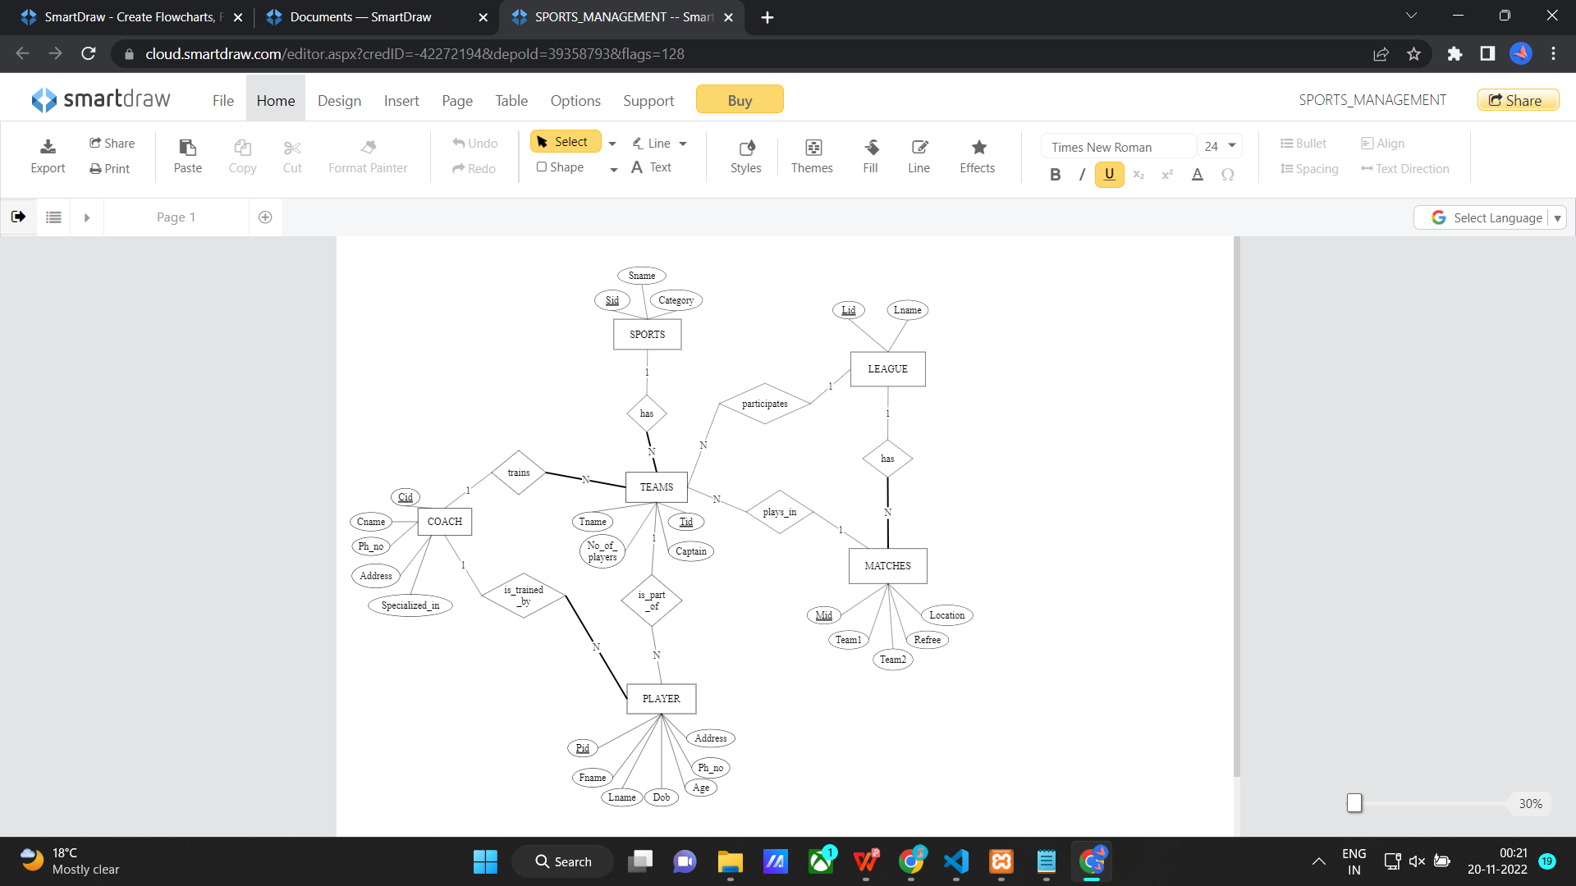

**Relational Schema**

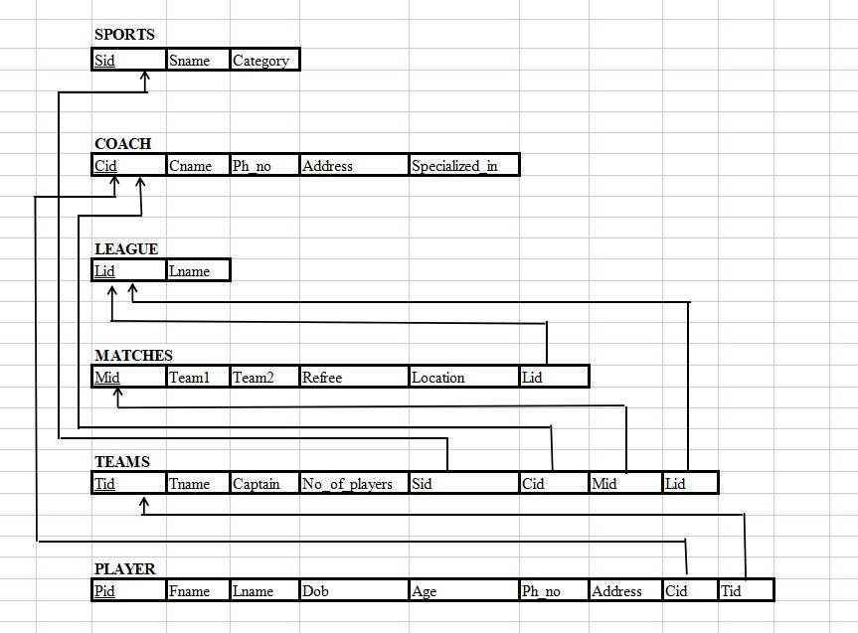

**DDL statements - Building the database**

**Creating a database:**

CREATE DATABASE sports_management_database_system;

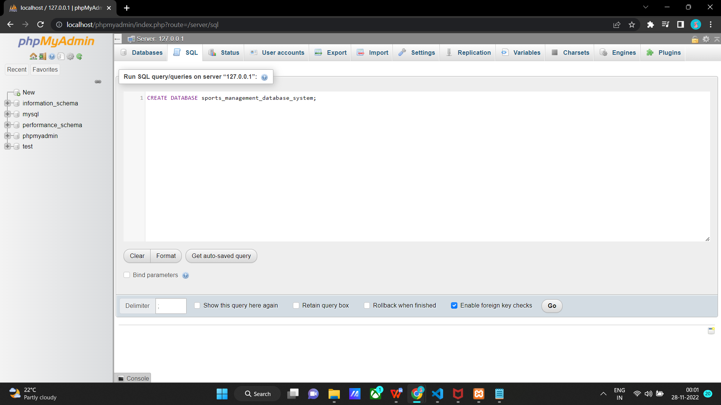

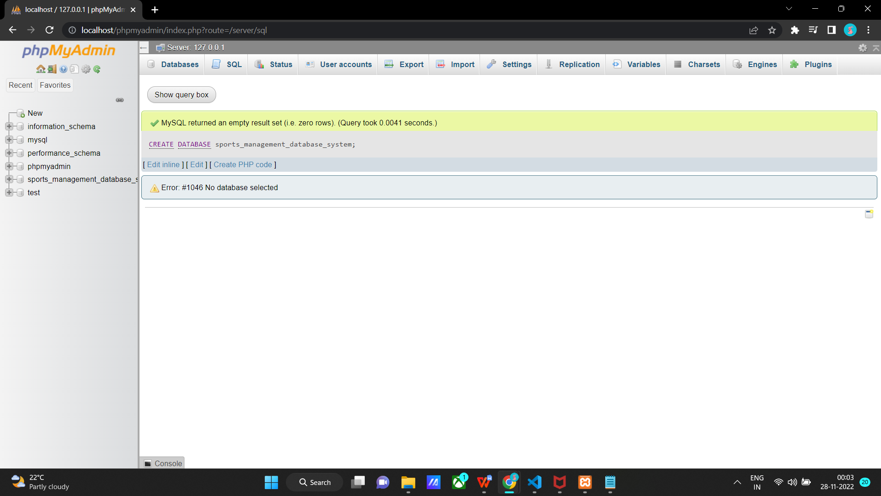

**Creating tables:**

1. **Sports table**

CREATE TABLE sports(

Sid INT NOT NULL,

Sname VARCHAR(30),

Category VARCHAR(35),

PRIMARY KEY(Sid)

);

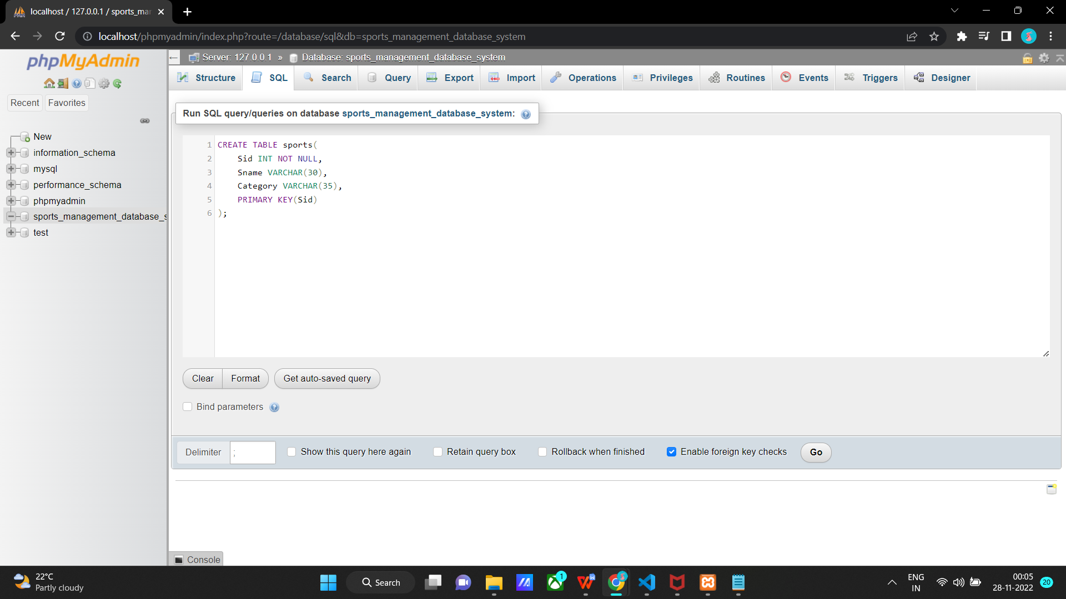

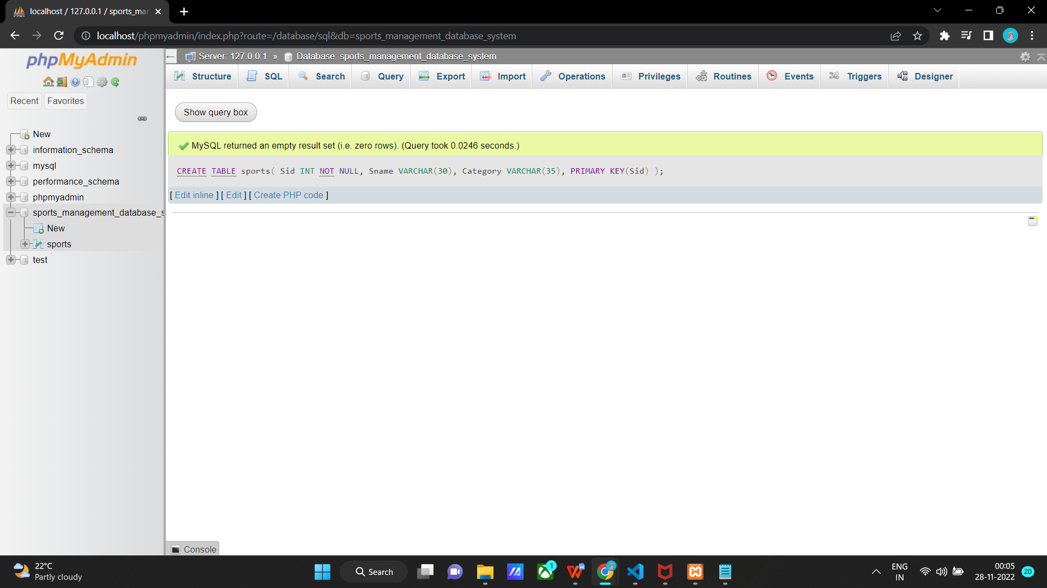

1. **Coach table**

CREATE TABLE coach(

Cid INT NOT NULL,

Cname VARCHAR(20),

Ph_no VARCHAR(10),

Address VARCHAR(30),

Specialized_in VARCHAR(50),

PRIMARY KEY(Cid)

);

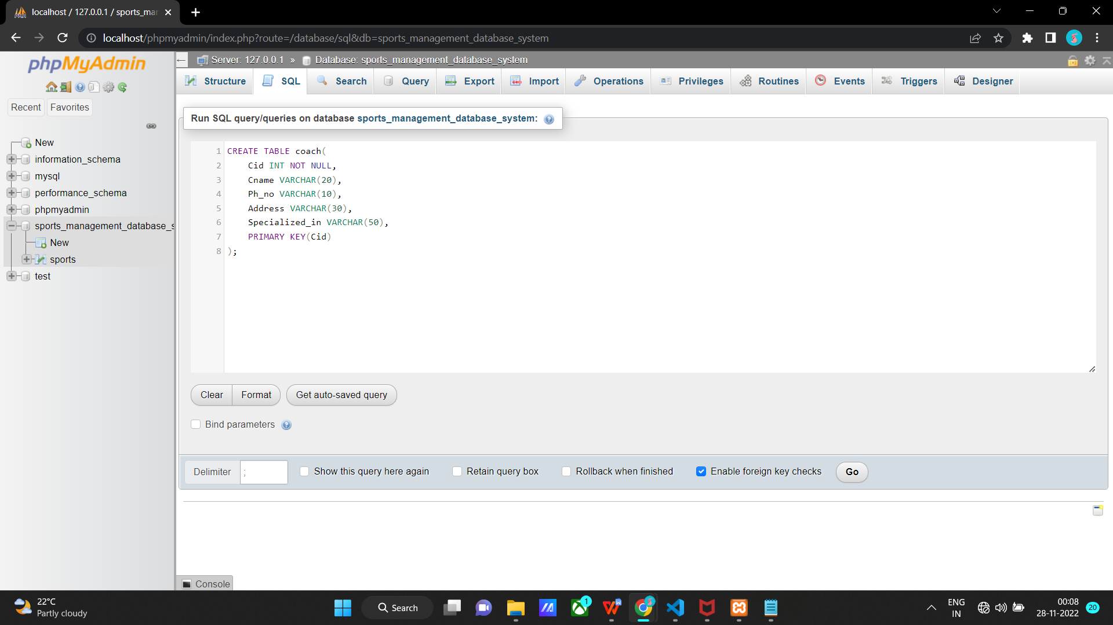

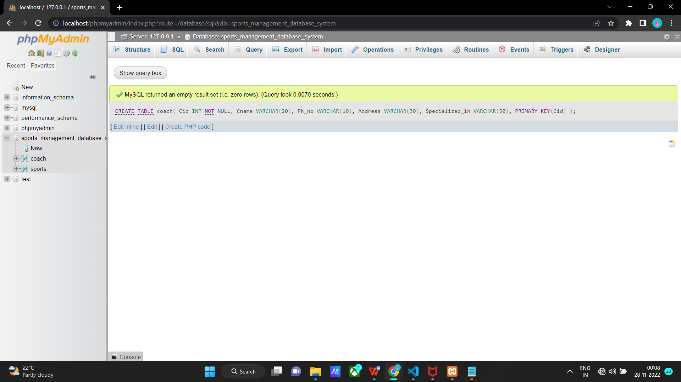

1. **League table**

CREATE TABLE league(

Lid INT NOT NULL,

Lname VARCHAR(50),

PRIMARY KEY(Lid)

);

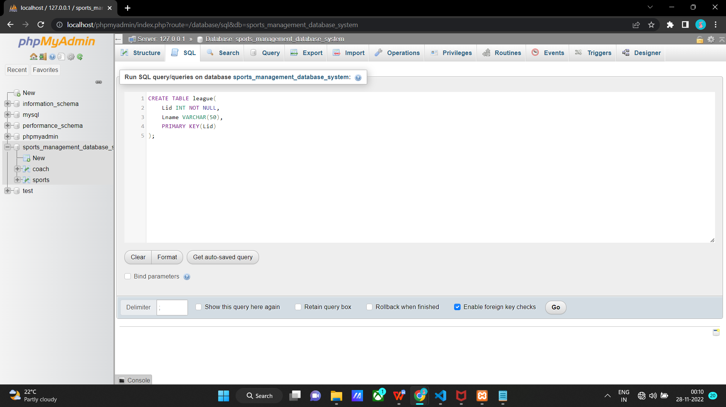

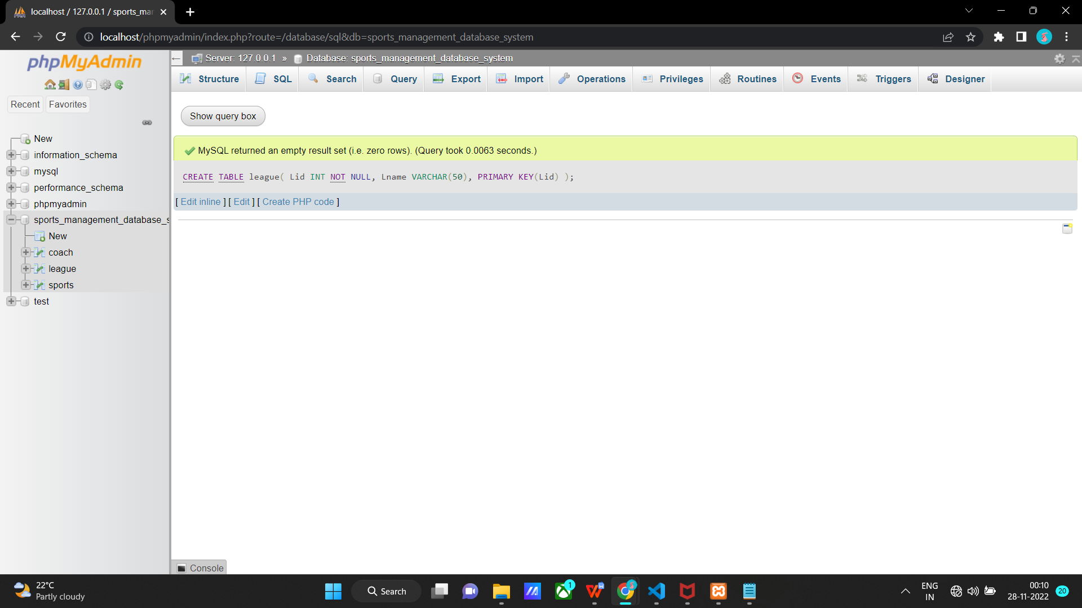

1. **Matches table**

CREATE TABLE matches(

Mid INT NOT NULL,

Team1 VARCHAR(50),

Team2 VARCHAR(50),

Refree VARCHAR(50),

Location VARCHAR(55),

Lid INT,

PRIMARY KEY(Mid),

FOREIGN KEY(Lid) REFERENCES league(Lid) ON DELETE CASCADE

);

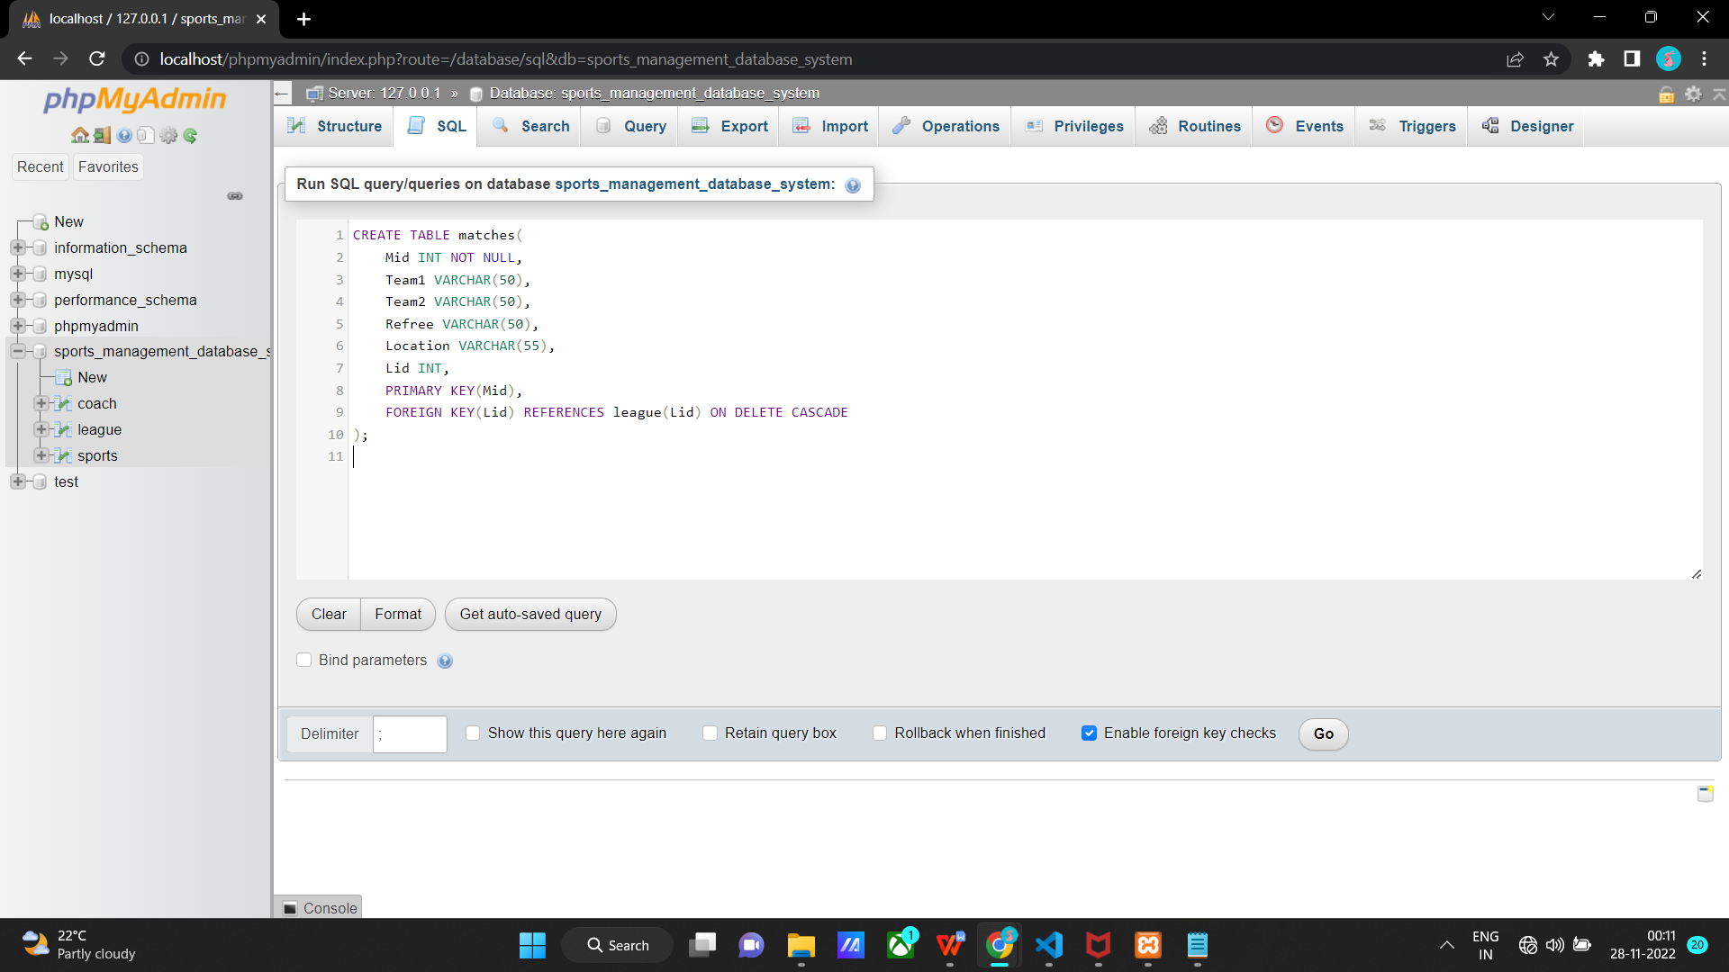

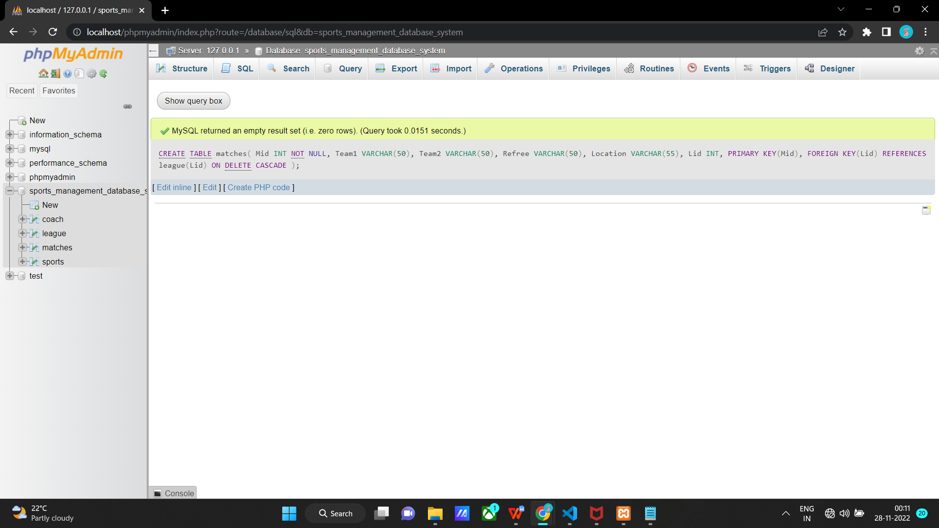

1. **Teams table**

CREATE TABLE teams(

Tid INT NOT NULL,

Tname VARCHAR(50),

Captain VARCHAR(35),

No_of_players INT,

Sid INT,

Cid INT,

Mid INT,

Lid INT,

PRIMARY KEY(Tid),

FOREIGN KEY(Sid) REFERENCES sports(Sid) ON DELETE CASCADE,

FOREIGN KEY(Cid) REFERENCES coach(Cid) ON DELETE CASCADE,

FOREIGN KEY(Mid) REFERENCES matches(Mid) ON DELETE CASCADE,

FOREIGN KEY(Lid) REFERENCES league(Lid) ON DELETE CASCADE

);

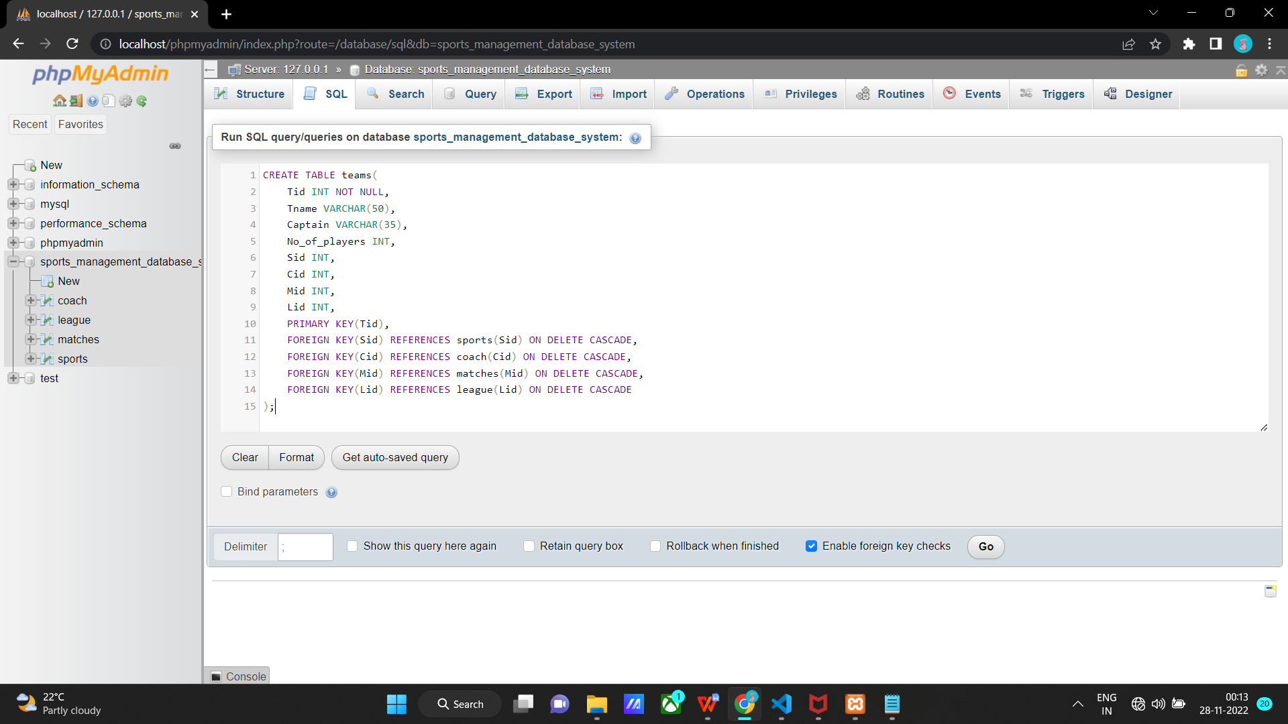

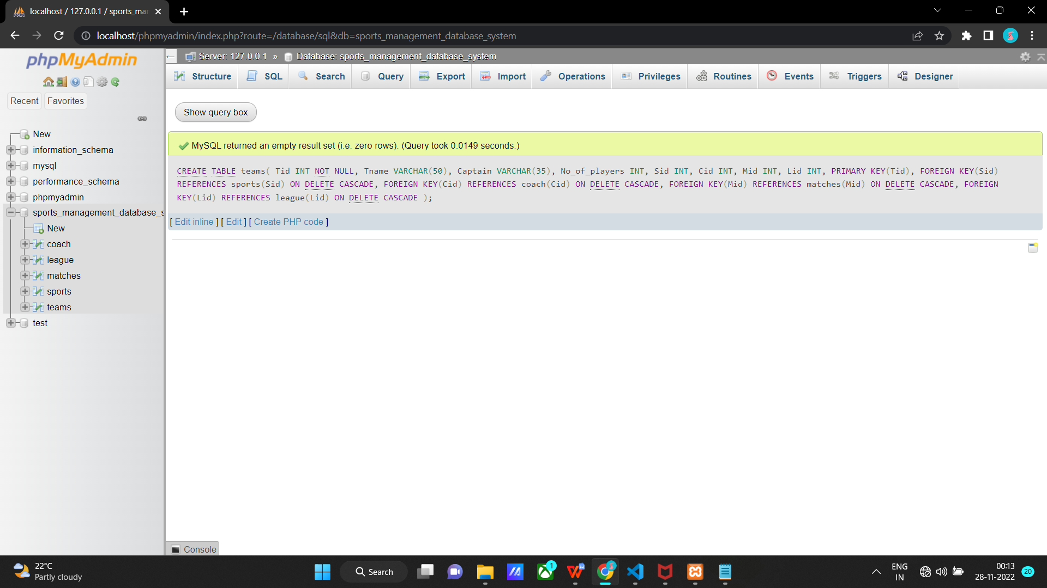

1. **Players table**

CREATE TABLE players(

Pid INT NOT NULL,

Fname VARCHAR(20),

Lname VARCHAR(20),

Dob DATE,

Age INT,

Ph_no VARCHAR(10),

Address VARCHAR(30),

Cid INT,

Tid INT,

PRIMARY KEY(Pid),

FOREIGN KEY(Cid) REFERENCES coach(Cid) ON DELETE CASCADE,

FOREIGN KEY(Tid) REFERENCES teams(Tid) ON DELETE CASCADE

);

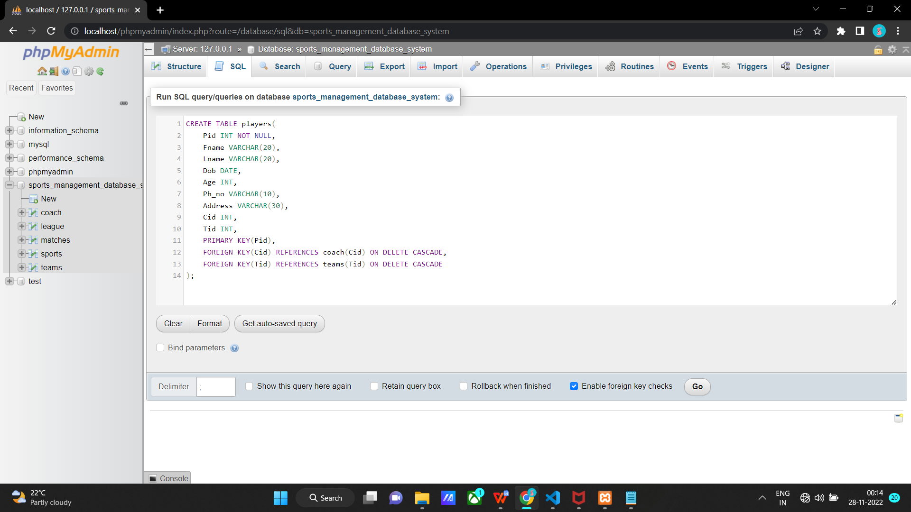

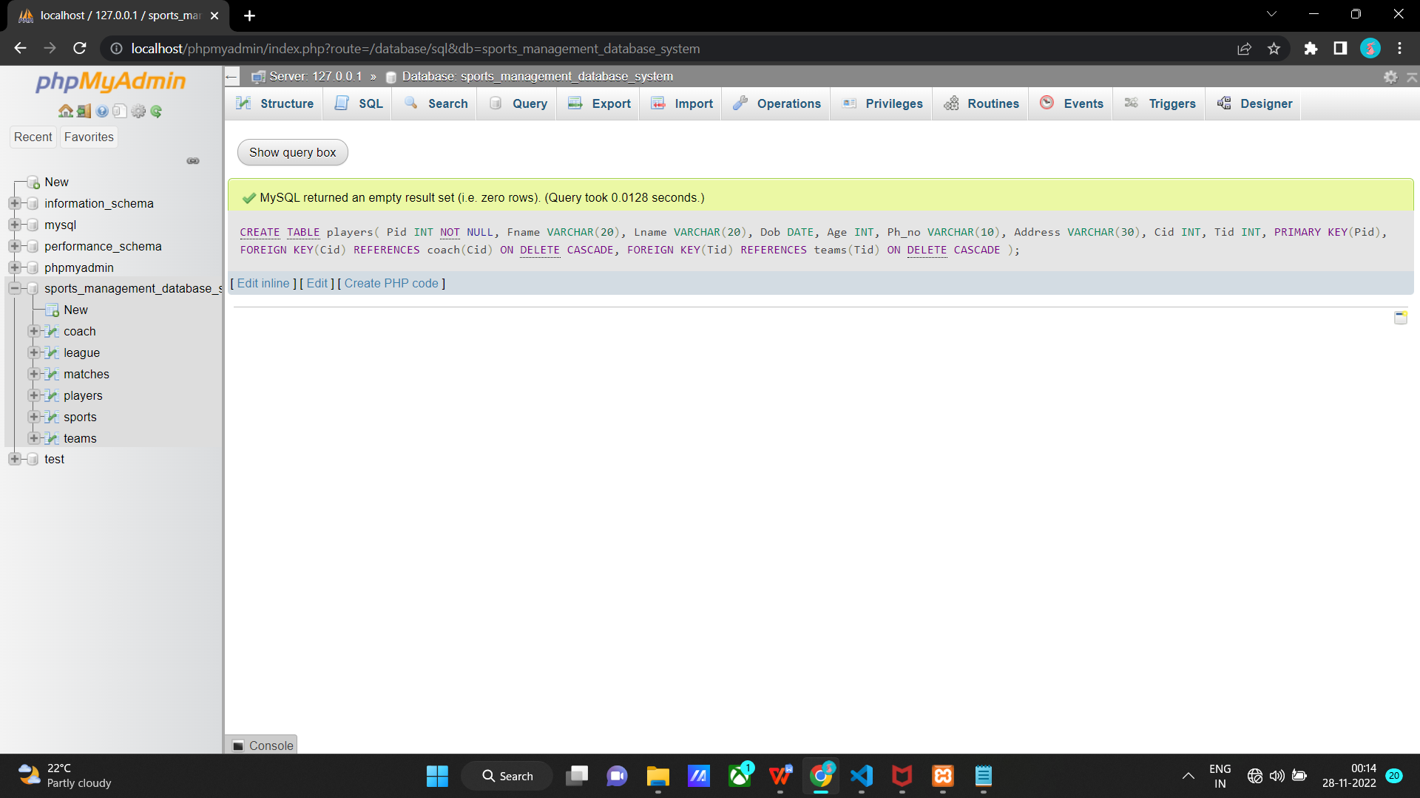

**After creating all the tables:**

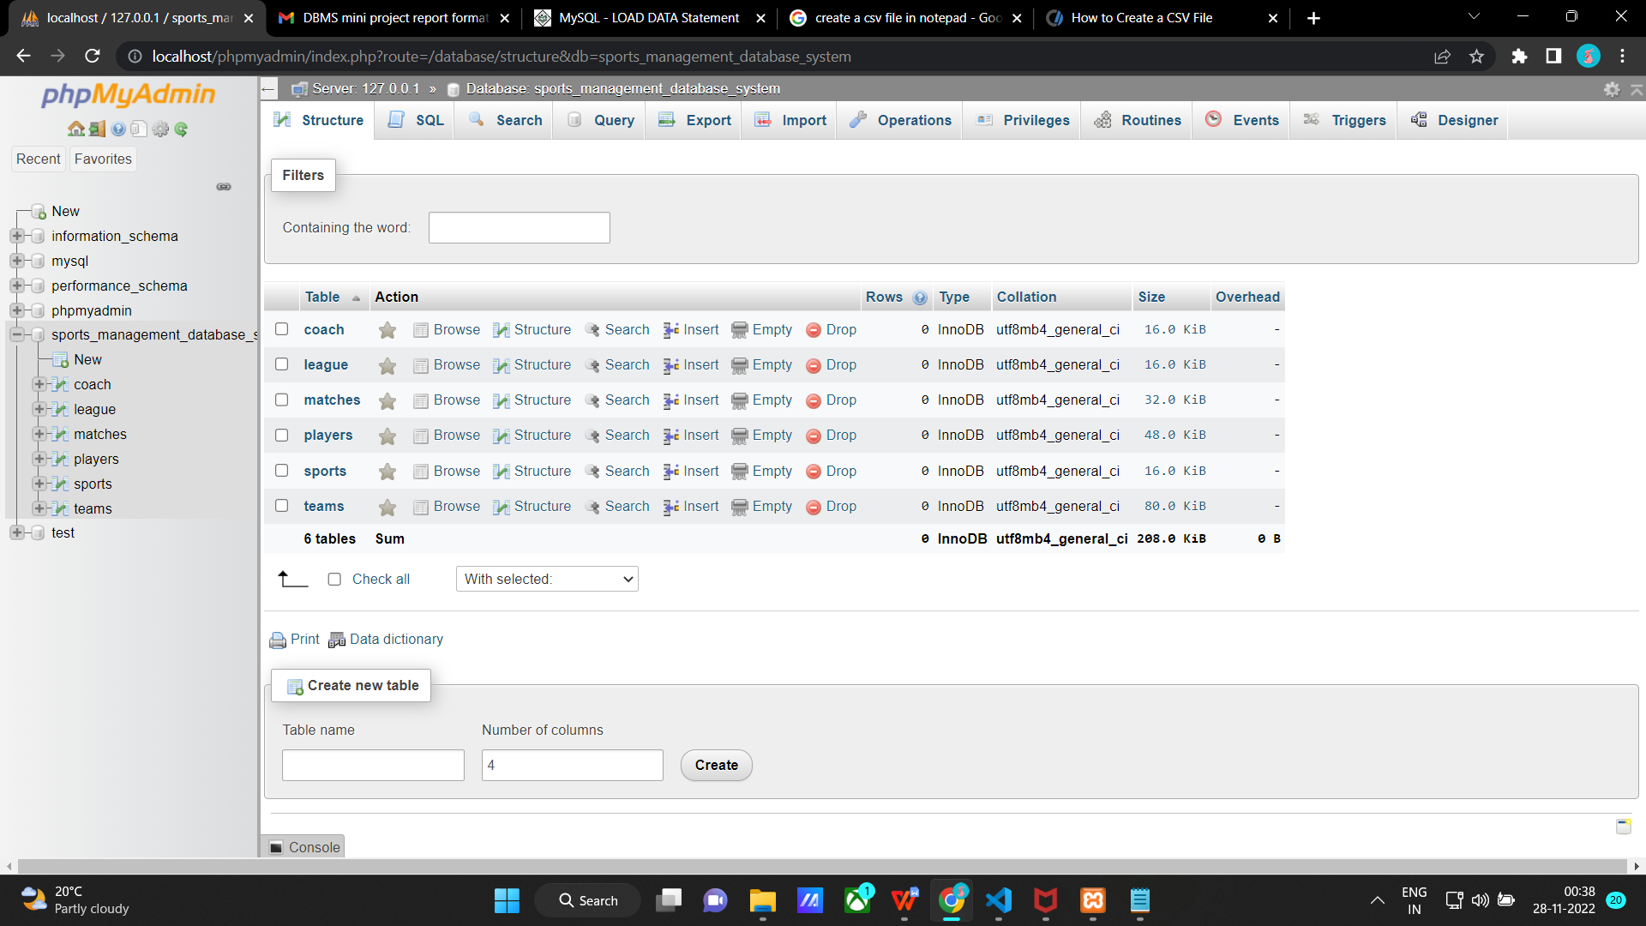

**Populating the Database**

**Inserting values into sports table**

There are 3 ways in which we can insert values into a table

1)

INSERT INTO sports(Sid, Sname, Category)

VALUES

(1, 'Football', 'Men'),

(2, 'Cricket', 'Men'),

(3, 'Basketball', 'Men'),

(4, 'Cricket', 'Women'),

(5, 'Throwball', 'Women'),

(6, 'Volleyball', 'Men'),

(7, 'Kabaddi', 'Men'),

(8, 'Badminton', 'Men'),

(9, 'Badminton', 'Women'),

(10, 'Table Tennis', 'Women');

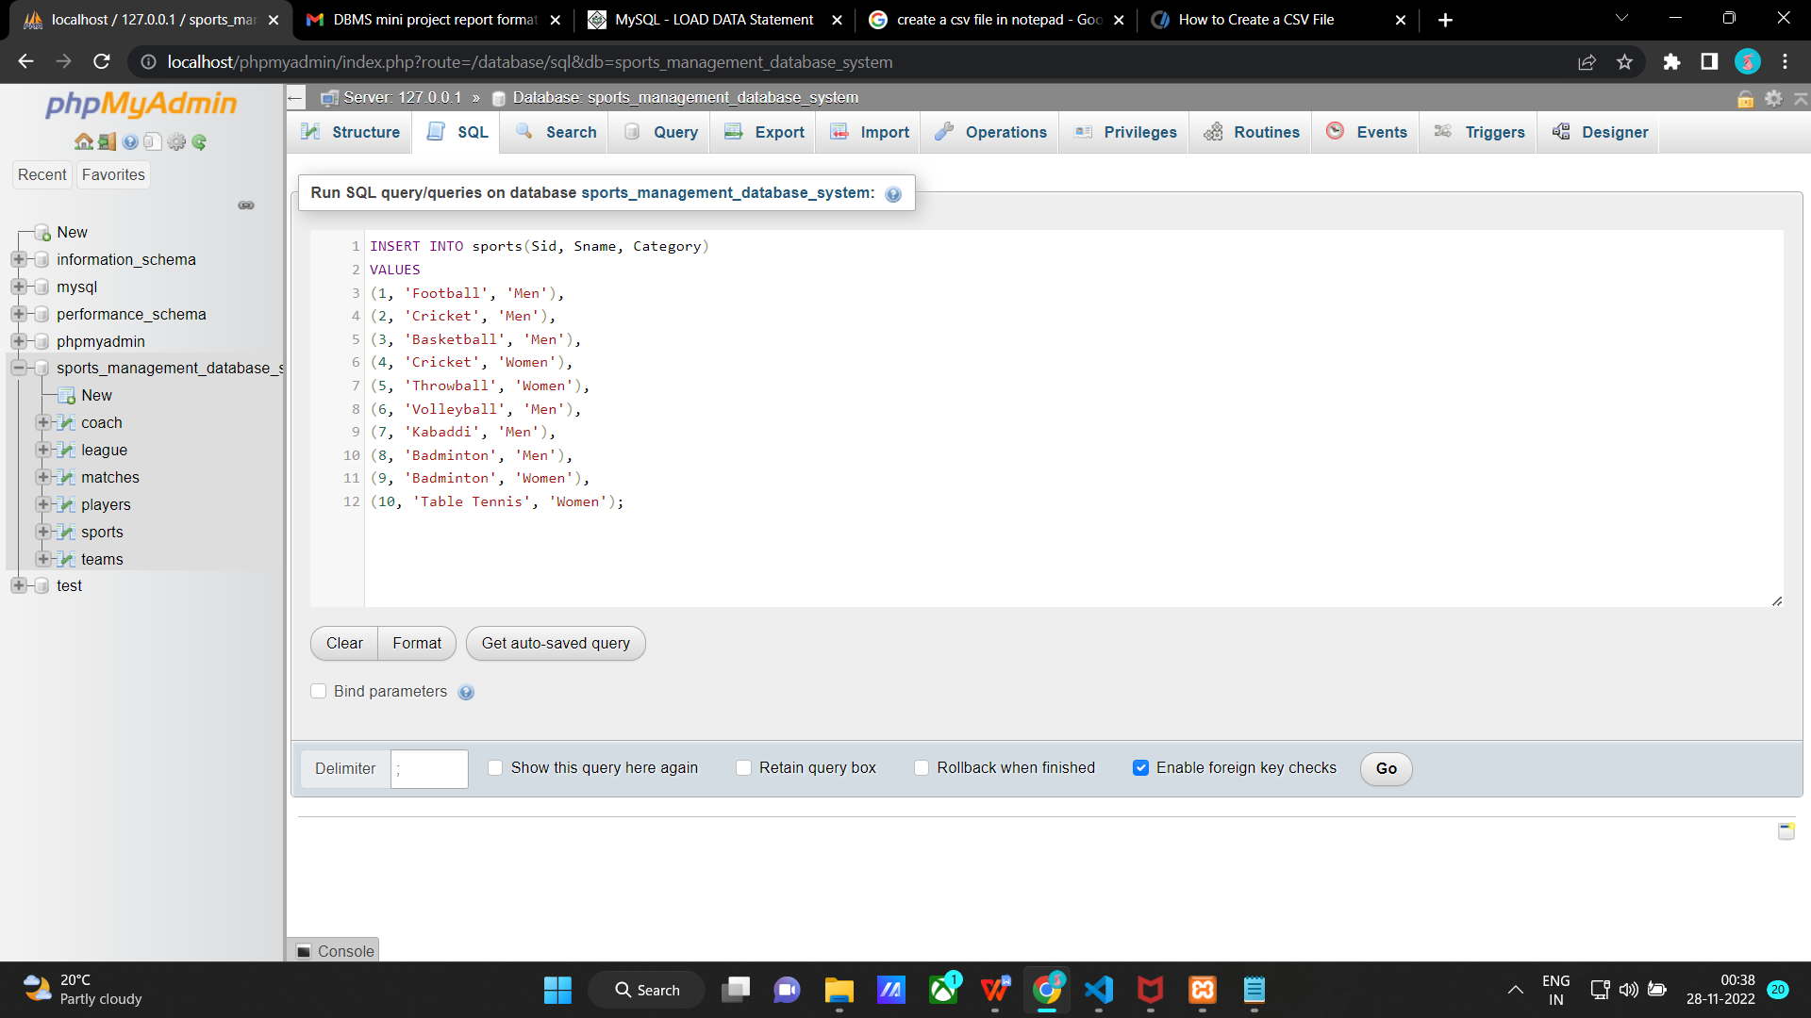

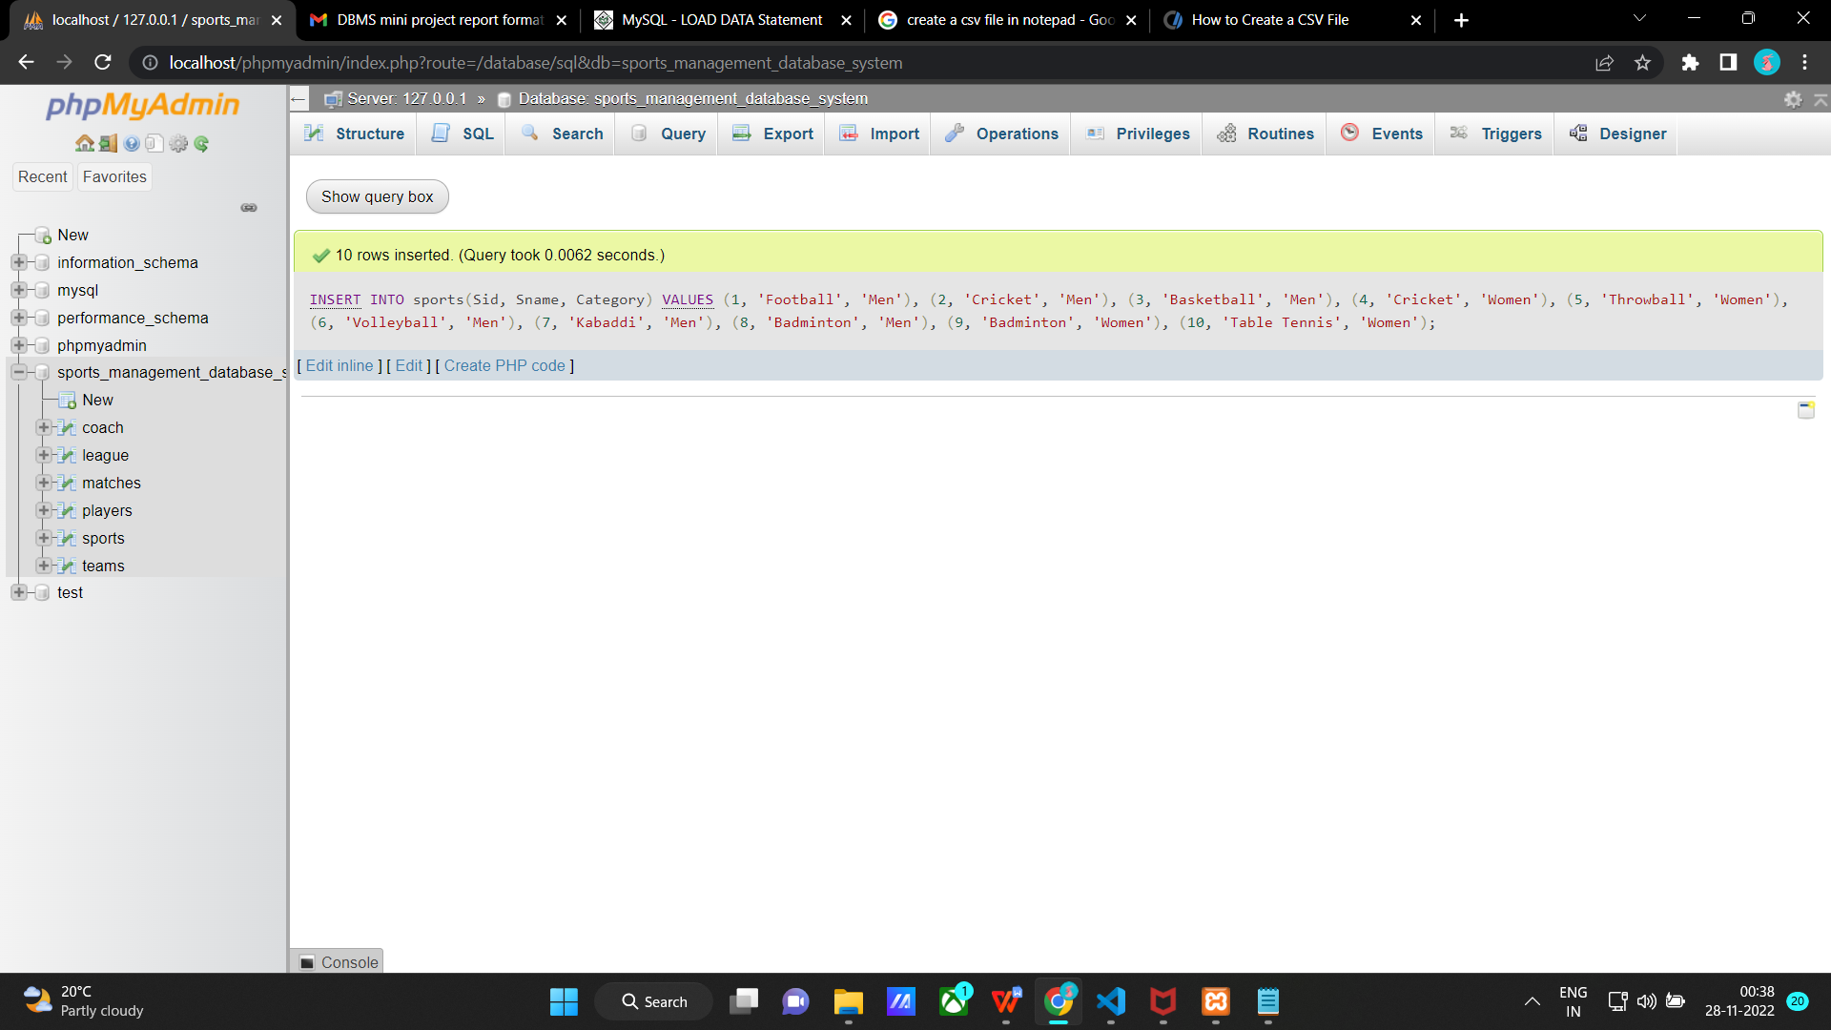

2)

INSERT INTO sports VALUES

(1, 'Football', 'Men'),

(2, 'Cricket', 'Men'),

(3, 'Basketball', 'Men'),

(4, 'Cricket', 'Women'),

(5, 'Throwball', 'Women'),

(6, 'Volleyball', 'Men'),

(7, 'Kabaddi', 'Men'),

(8, 'Badminton', 'Men'),

(9, 'Badminton', 'Women'),

(10, 'Table Tennis', 'Women');

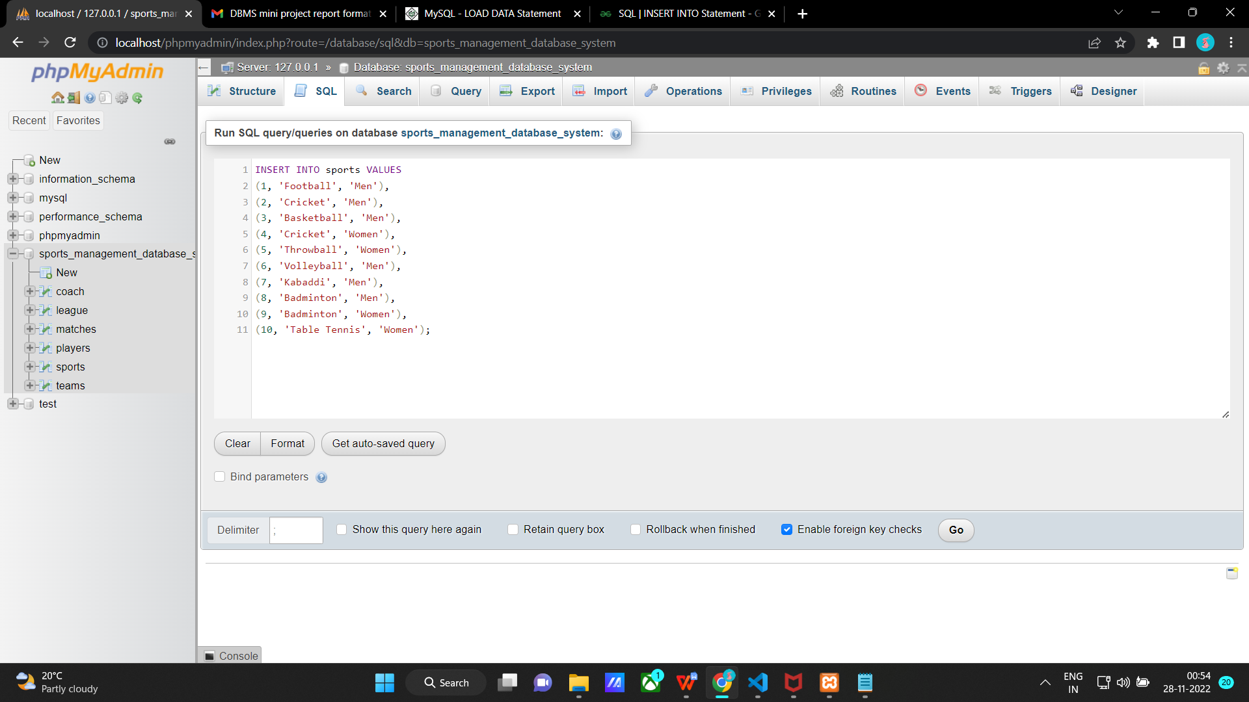

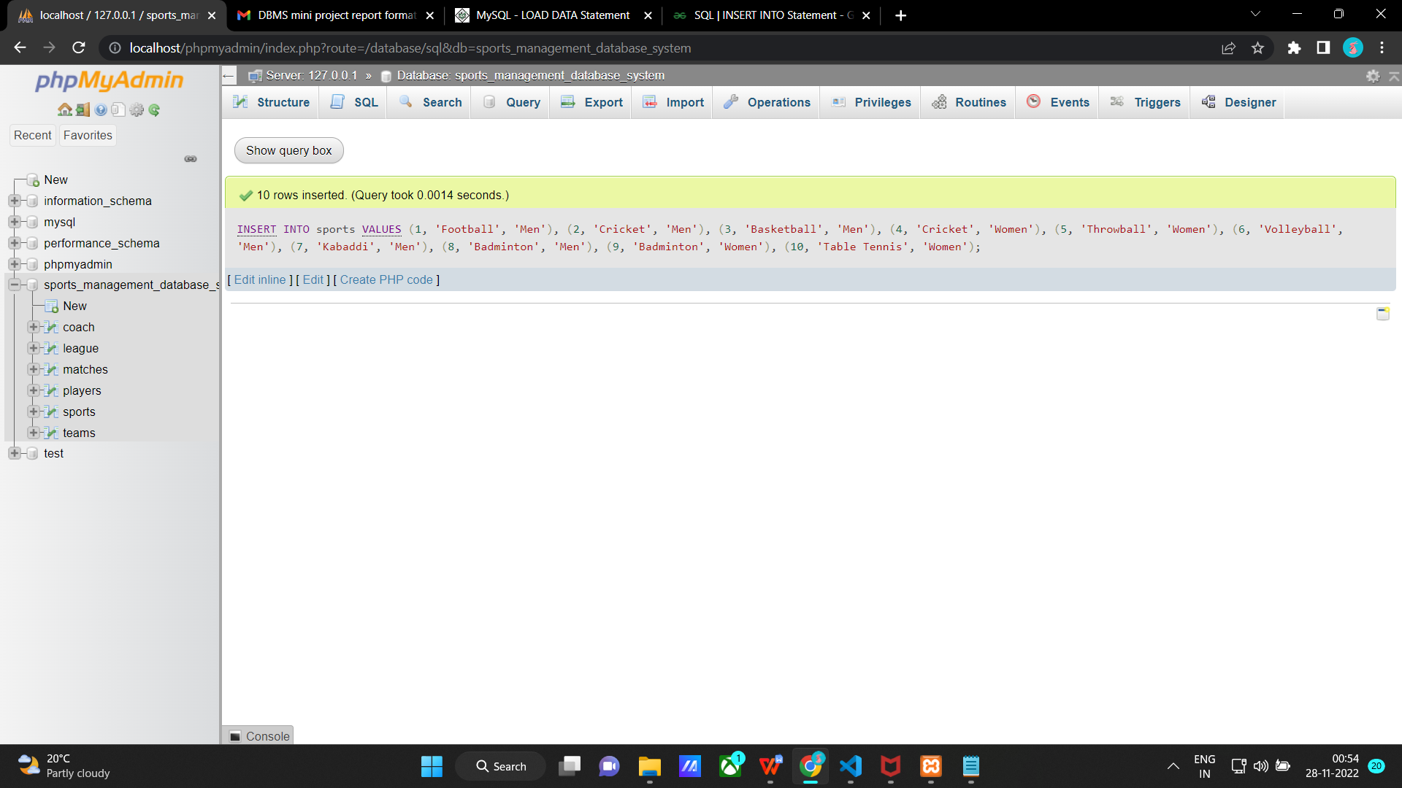

LOAD DATA INFILE "sports.csv"

INTO TABLE sports

COLUMNS TERMINATED BY ','

OPTIONALLY ENCLOSED BY " "

ESCAPED BY " "

LINES TERMINATED BY '\n'

IGNORE 1 LINES;

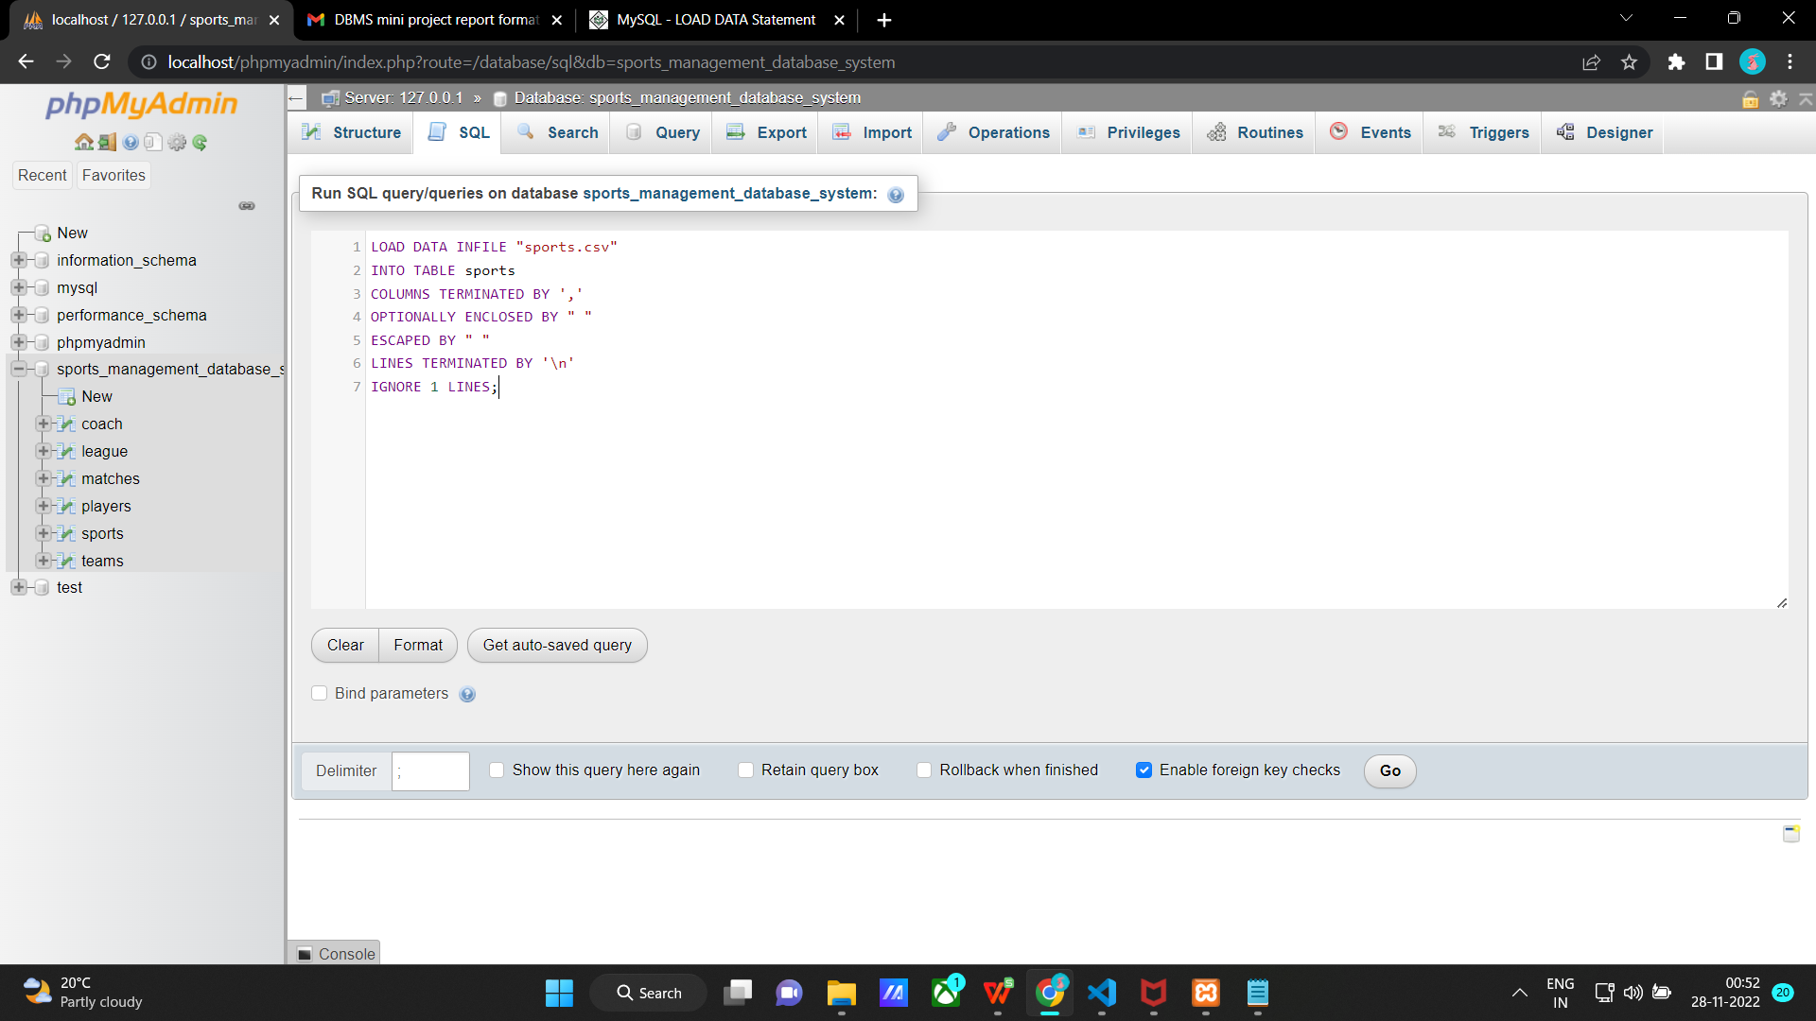

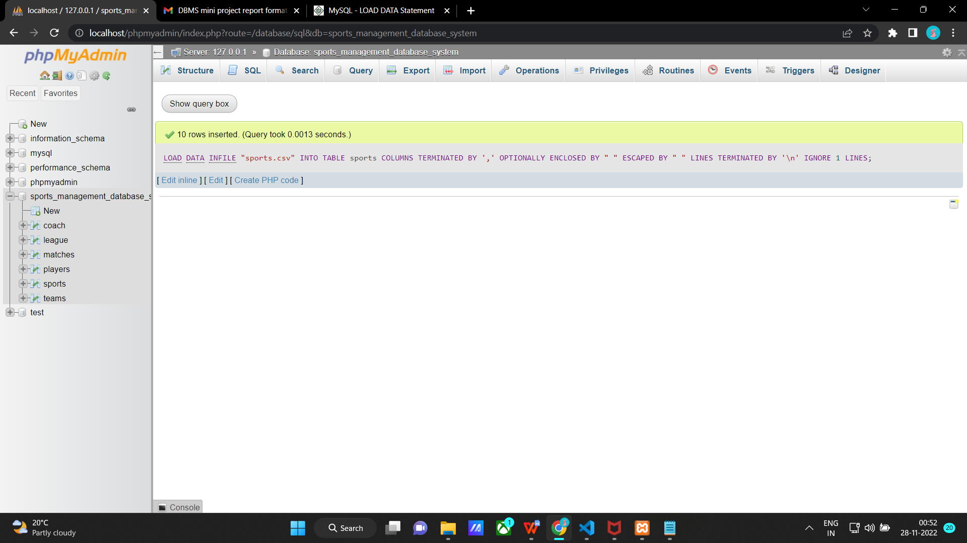

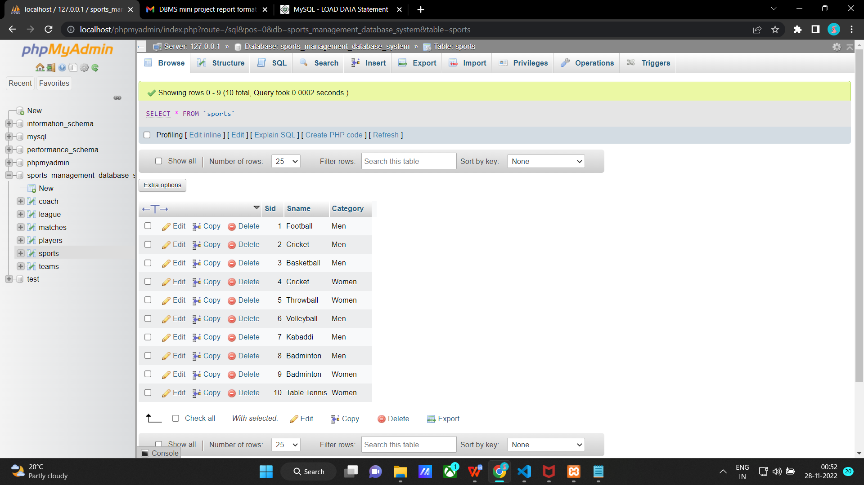

**Inserting values into coach table**

INSERT INTO coach(Cid, Cname, Ph_no, Address, Specialized_in)

VALUES

(2001, 'Alex','9123456781', '#23,2nd main, Bengaluru','Football'),

(2103, 'James','8111456781', '#20,5th main, Delhi','Volleyball'),

(2501, 'Noah', '7123456178','#11,1st main, Mumbai','Badminton'),

(3001, 'Dia', '9123111111','#21,4th main, Bengaluru','Throwball'),

(2344, 'Rose', '9111115678','#38, 3rd main, Bengaluru','Table Tennis'),

(2676, 'Virat', '9000000000','#3,3rd main, Bengaluru','Cricket'),

(2777, 'Sita', '8000000001','#1, 1st main, Delhi','Cricket'),

(2308, 'Alia', '7171777777', '#51,8th main, Mumbai','Volleyball'),

(2199, 'Avni','6345673456', '#17, 17th main, Mumbai', 'Basketball'),

(2710, 'Jack', '8936474646', '#8,5th main, Delhi', 'Pro Kabaddi');

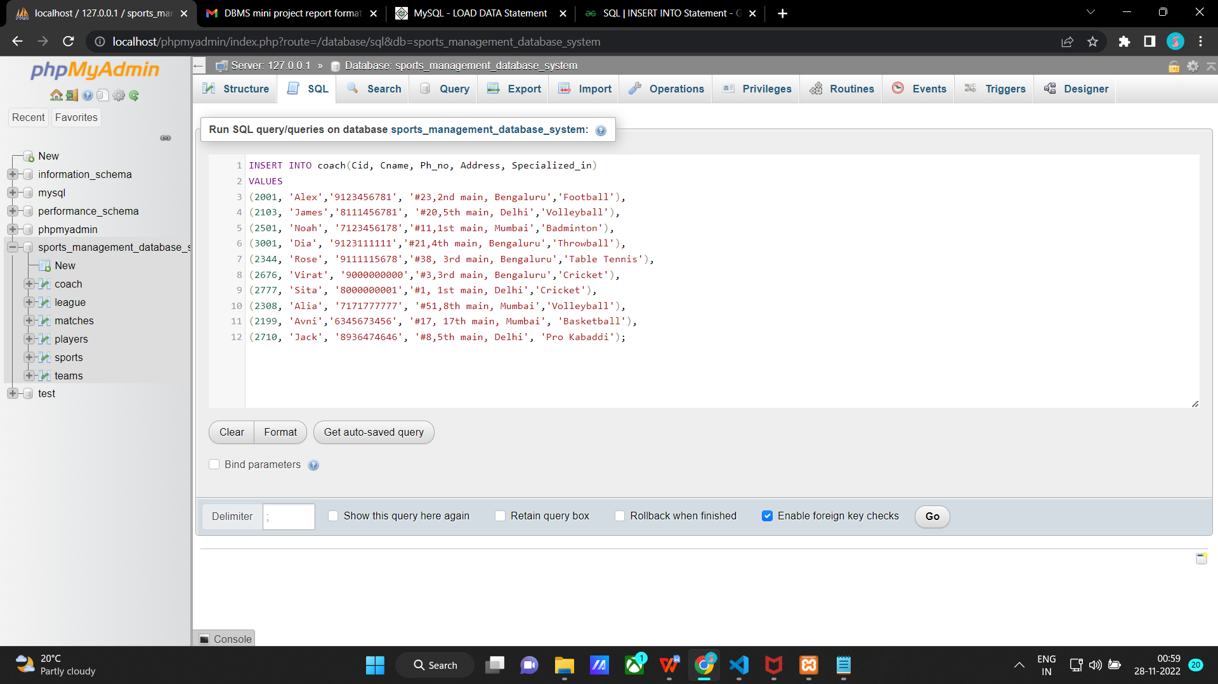

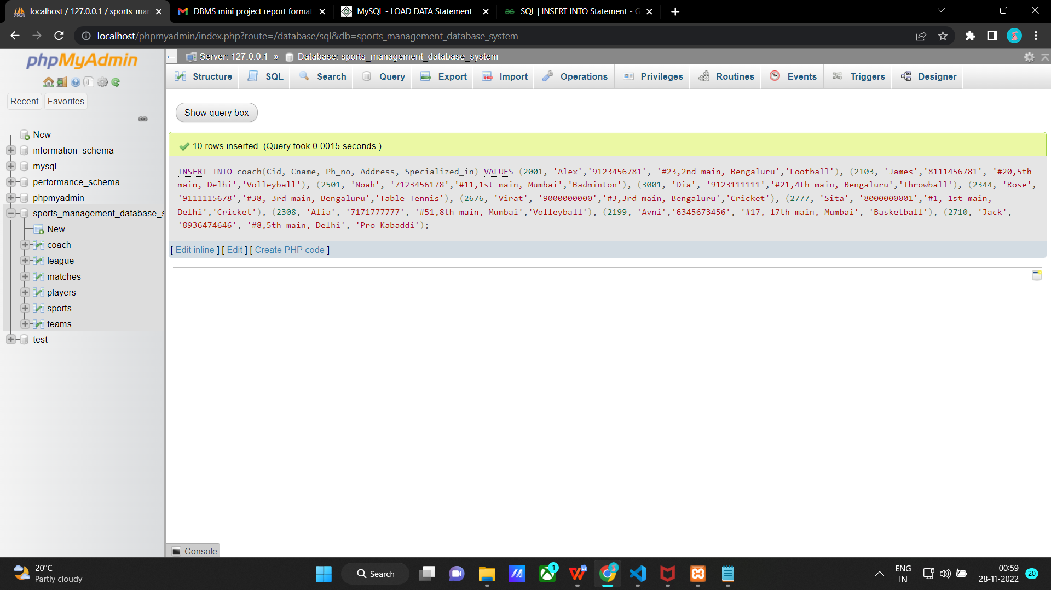

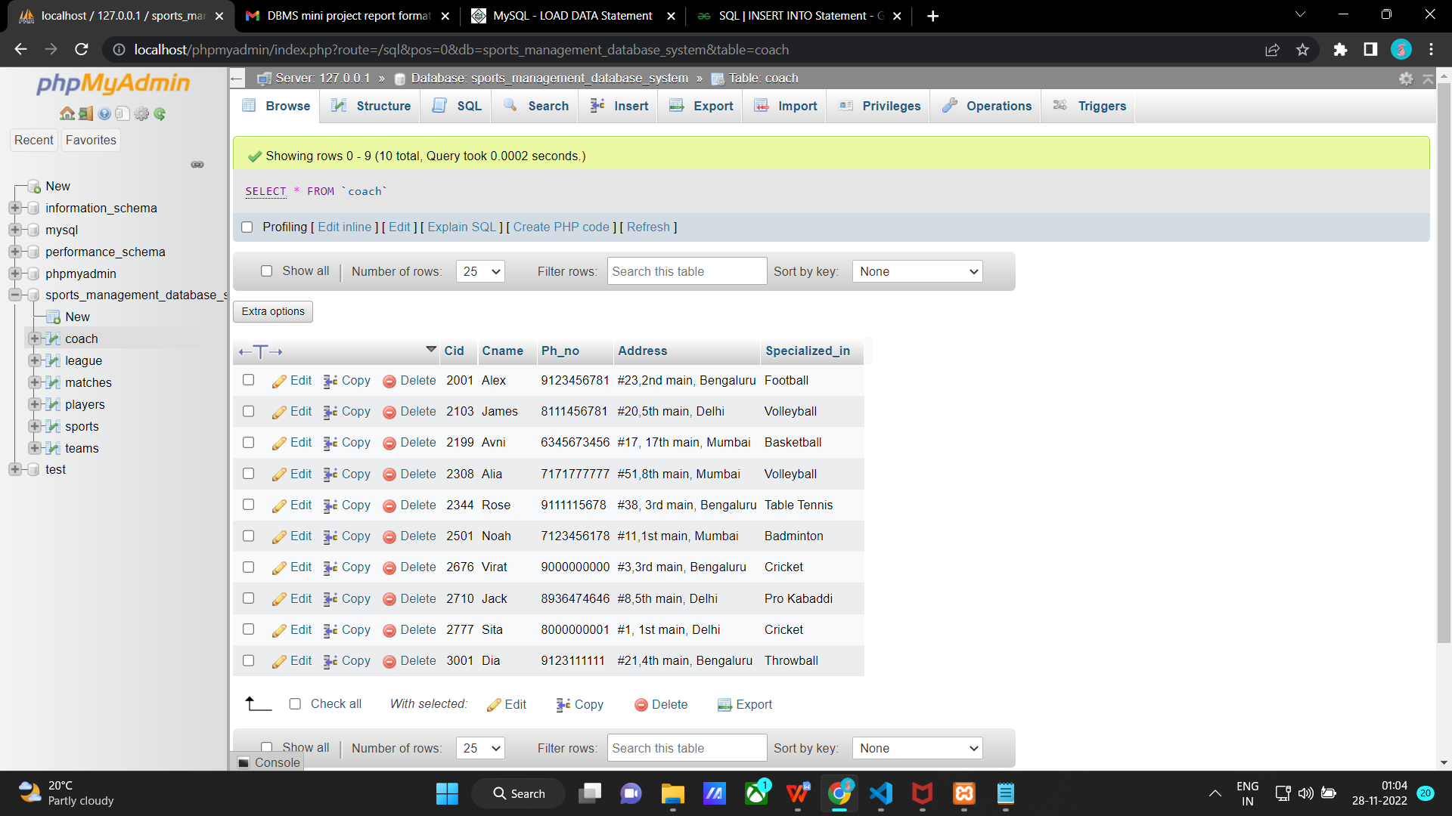

**Inserting values into league table**

INSERT INTO league(Lid, Lname)

VALUES

(10090, 'ICC Men T20 World Cup'),

(11078, 'Pro Kabaddi'),

(12090, 'FIFA'),

(13078, 'All India Women Cricket Tournament'),

(14090, 'IPL'),

(11075, 'All India Volleyball Tournament'),

(14096, 'NBA'),

(19098, 'Badminton League'),

(17770, 'ICC Women T20 World Cup'),

(19978, 'Table Tennis League');

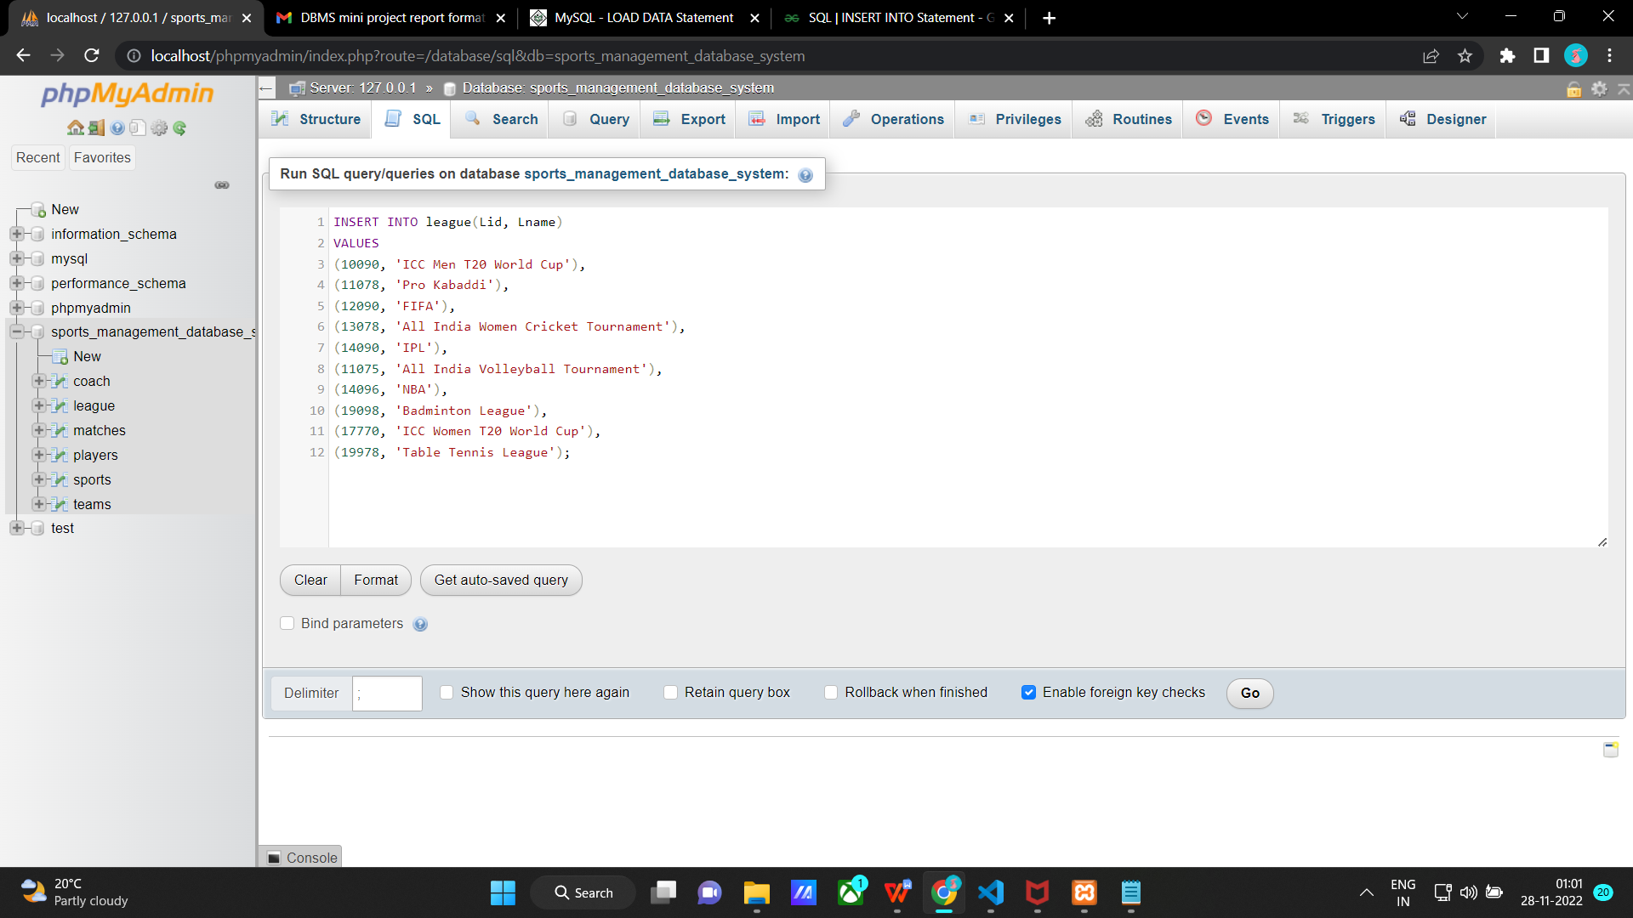

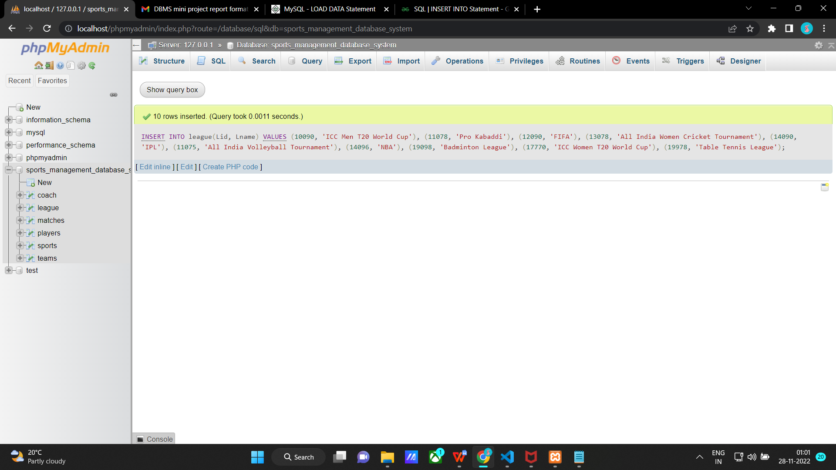

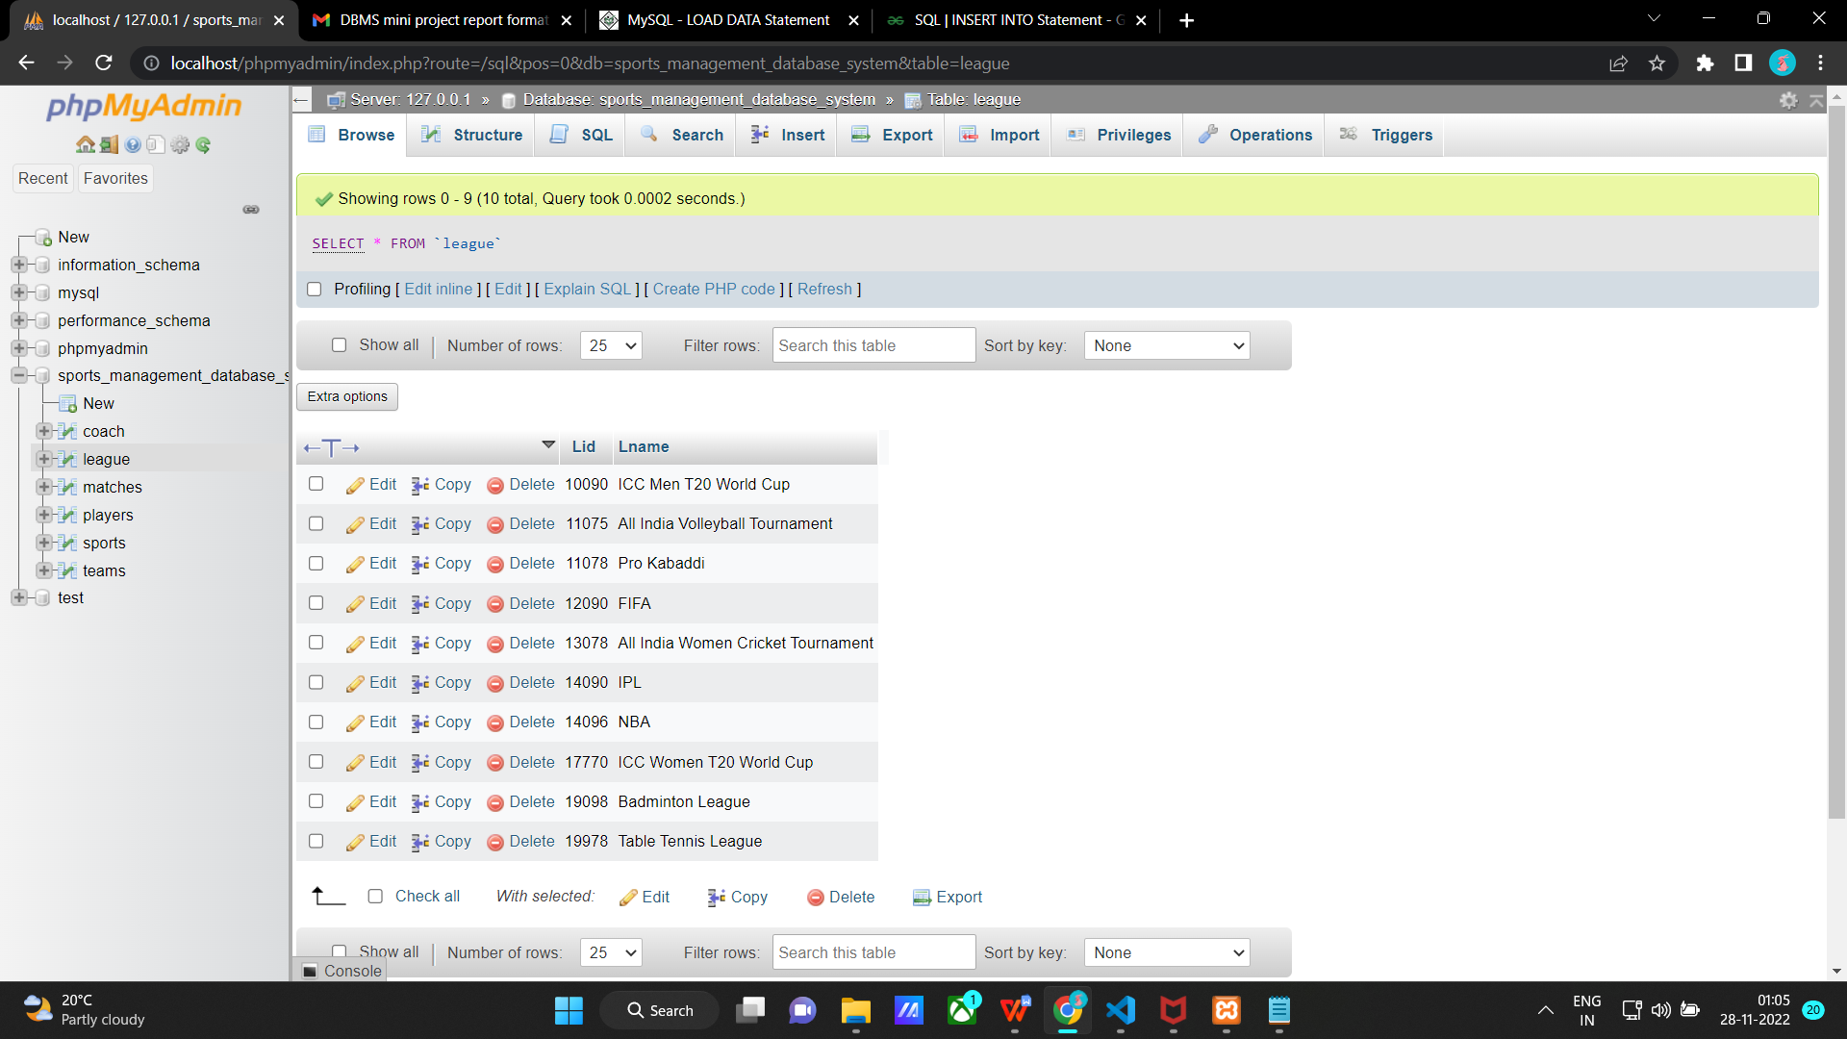

**Inserting values into matches table**

INSERT INTO matches(Mid, Team1, Team2, Refree, Location, Lid)

VALUES

(91, 'Fire', 'Water','Albert','Bengaluru',19098),

(92, 'Alpha', 'Beta','Raj','Mumbai',11078),

(93, 'The Lions','Winners','Roy','Delhi',11075),

(94, 'Tigress','Sparkle','Mina','Bengaluru',13078),

(95, 'Power','Pride','Larry', 'New York',19978),

(96, 'Bravehearts','Royal','Liam','London',19098),

(97, 'India','Pakistan','Rahul','Delhi', 10090),

(98, 'RCB','MI','Lucky','Bengaluru',14090),

(99, 'Royal Family','Rainbow','Ria','Bengaluru',19098),

(100, 'Bengaluru bulls','U Mumba','Ron','Bengaluru',11078);

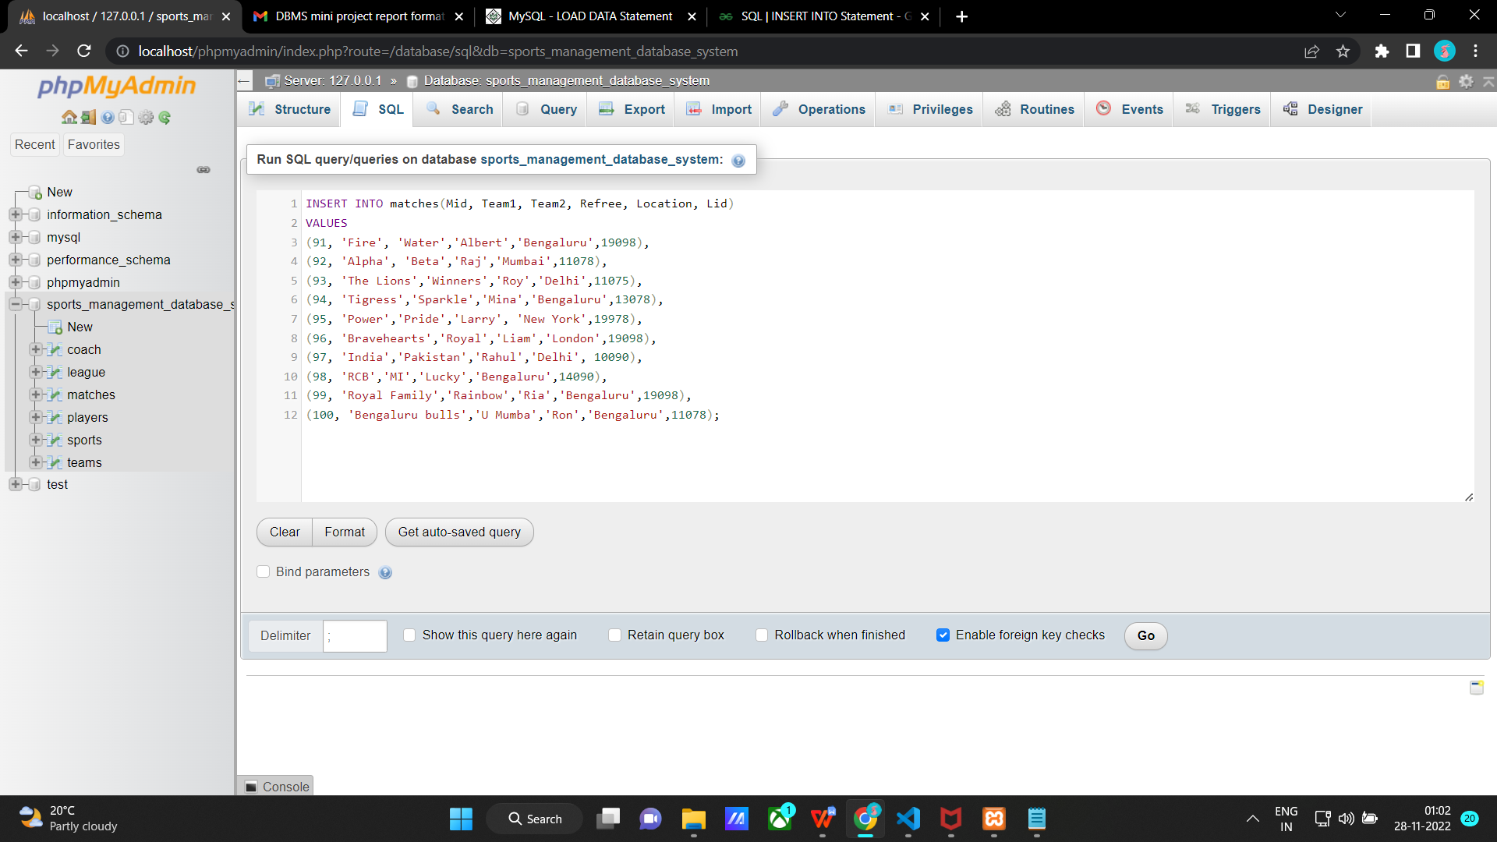

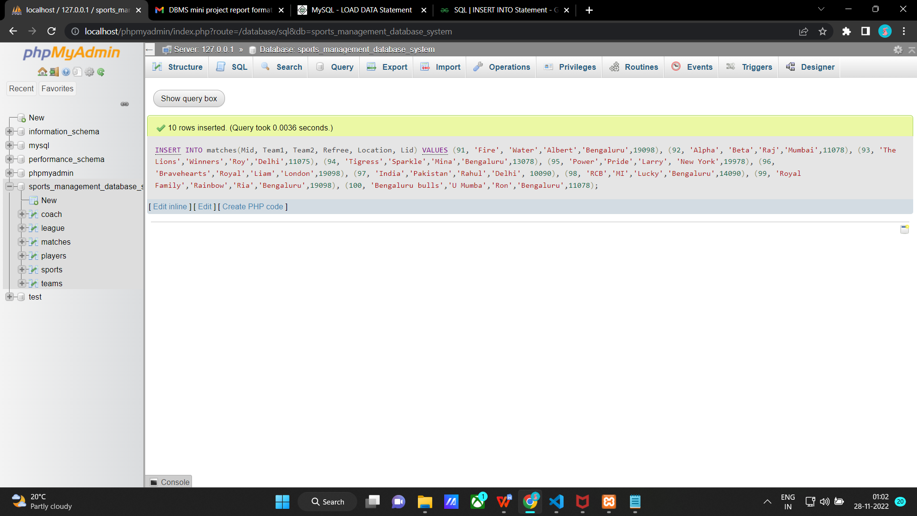

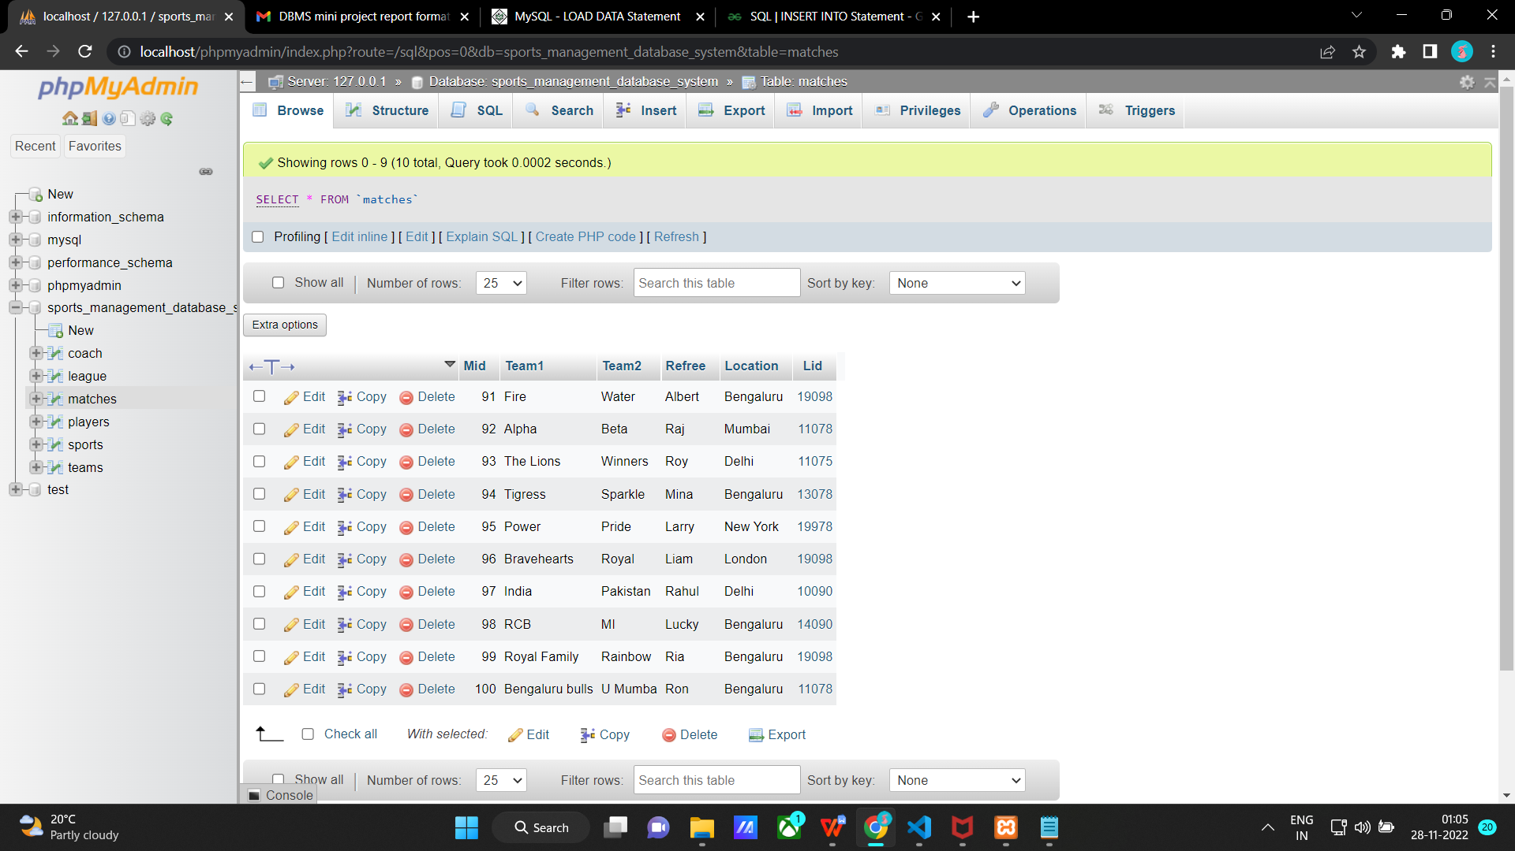

**Inserting values into teams table**

INSERT INTO teams(Tid, Tname, Captain, No_of_players, Sid, Cid, Mid, Lid)

VALUES

(591, 'Fire', 'Riya',4,9,2501,91,19098),

(592, 'Alpha', 'Avi',12,7,2710,92,11078),

(593, 'The Lions','Alvin',9,6,2103,93,11075),

(594, 'Beta','Sandy',11,4,2777,94,13078),

(595, 'Power','Katy',2,10,2344,95,19978),

(596, 'Bravehearts','Harry',4,8,2501,96,19098),

(597, 'India','Virat',11,2,2676,97,10090),

(598, 'RCB','Virat',11,2,2676,98,14090),

(599, 'Royal Family','Tina',4,8,2501,99,19098),

(600, 'Bengaluru bulls','Rohit',12,7,2710,100,11078);

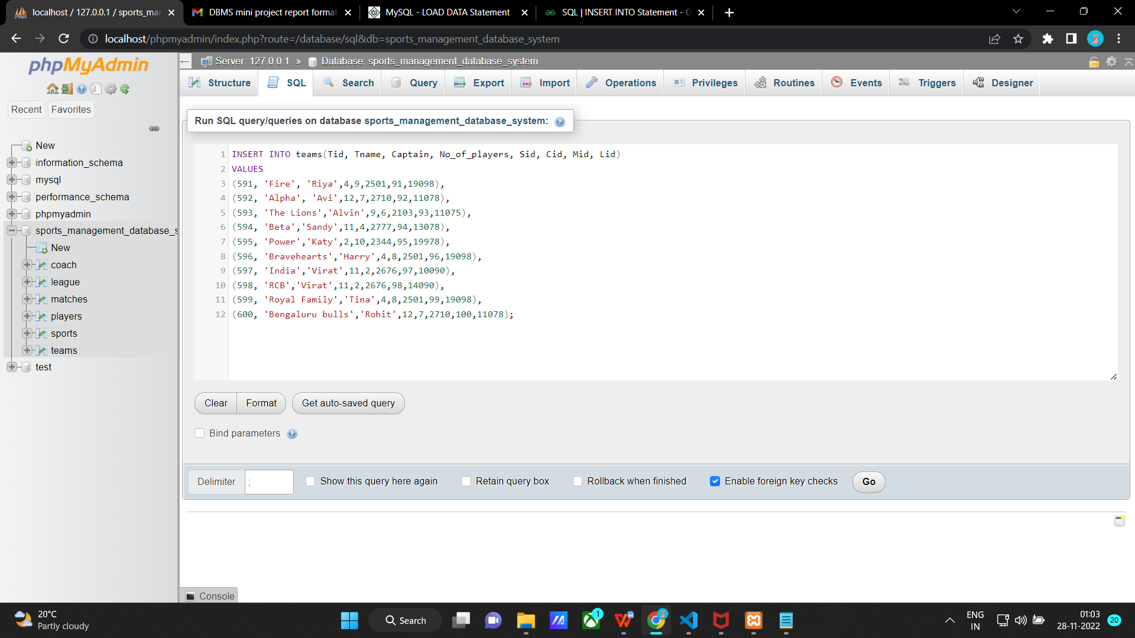

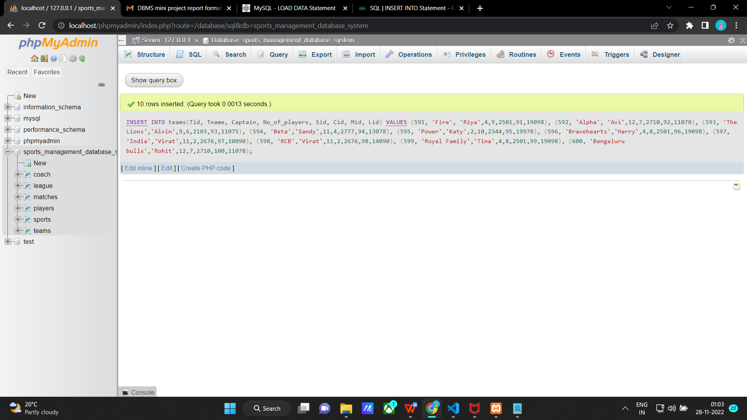

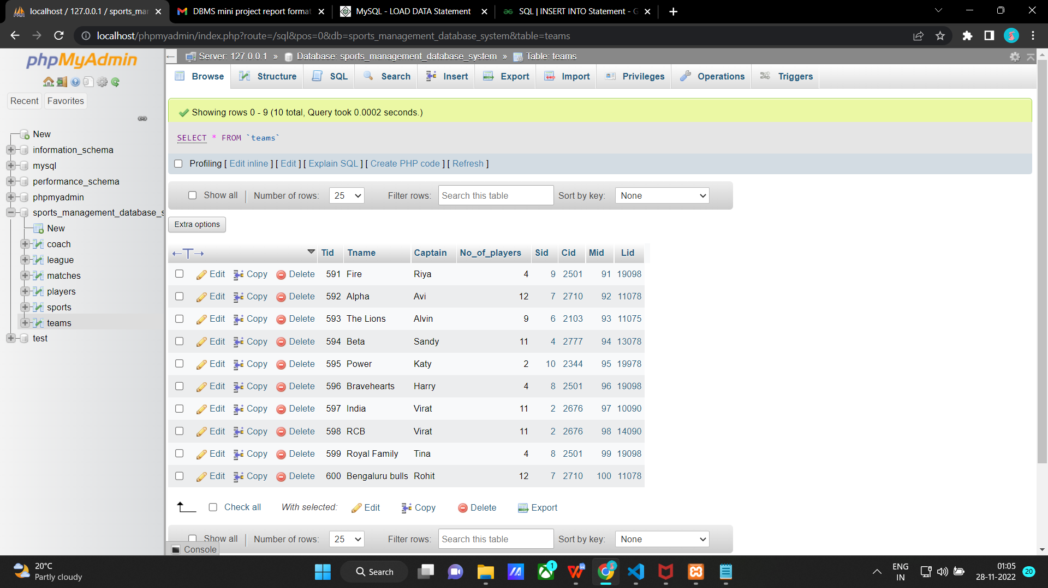

**Inserting values into players table**

INSERT INTO players(Pid, Fname, Lname, Dob, Age, Ph_no, Address, Cid, Tid)

VALUES

(61, 'Alvin','Anderson','1999-07-01',23,'7878787878','#67, 5th main, Bengaluru',2103,593),

(62, 'Avi','Raj','2002-11-20',20,'9676758586','#31, 8th main, Mumbai',2710,592),

(63, 'Rani','Riven','2000-01-11',22,'9000000787','#90, 9th main, Delhi',2344,595),

(64, 'Lucky','Lander','1995-11-01',27,'7090769980','#8, 8th main, Bengaluru',2501,591),

(65, 'Roger','Ran','2002-09-09',20,'9786912121','#77, 7th main, Mumbai',2103,593),

(66, 'David','Dan','1990-08-01',32,'9888888880','#1, 1st main, Bengaluru',2676,598),

(67, 'Harry','Rick','2000-03-05',22,'8777798080','#8, 5th main, Bengaluru',2501,591),

(68, 'Poppy','Pick','2002-07-05',20,'9111454600','#245, 9th main, Delhi',2344,595),

(69, 'Lia','Lerry','2001-04-08',21,'9000055558','#2, 2nd main, Mumbai',2344,595),

(70, 'Katy', 'Jerry','1998-06-19',24,'9115648790','#3, 3rd main, Mumbai',2344,595);

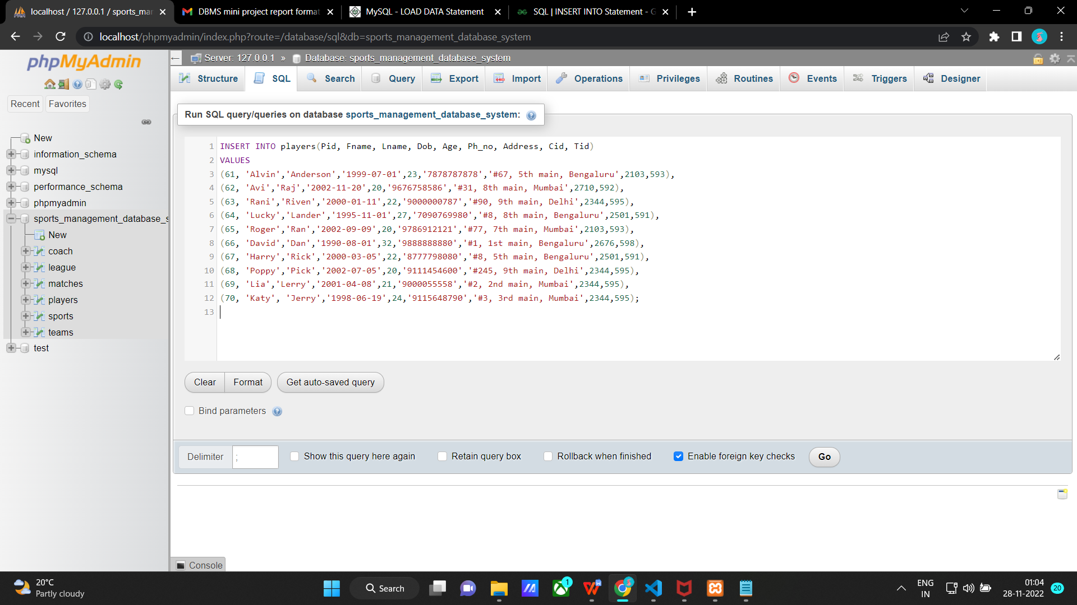

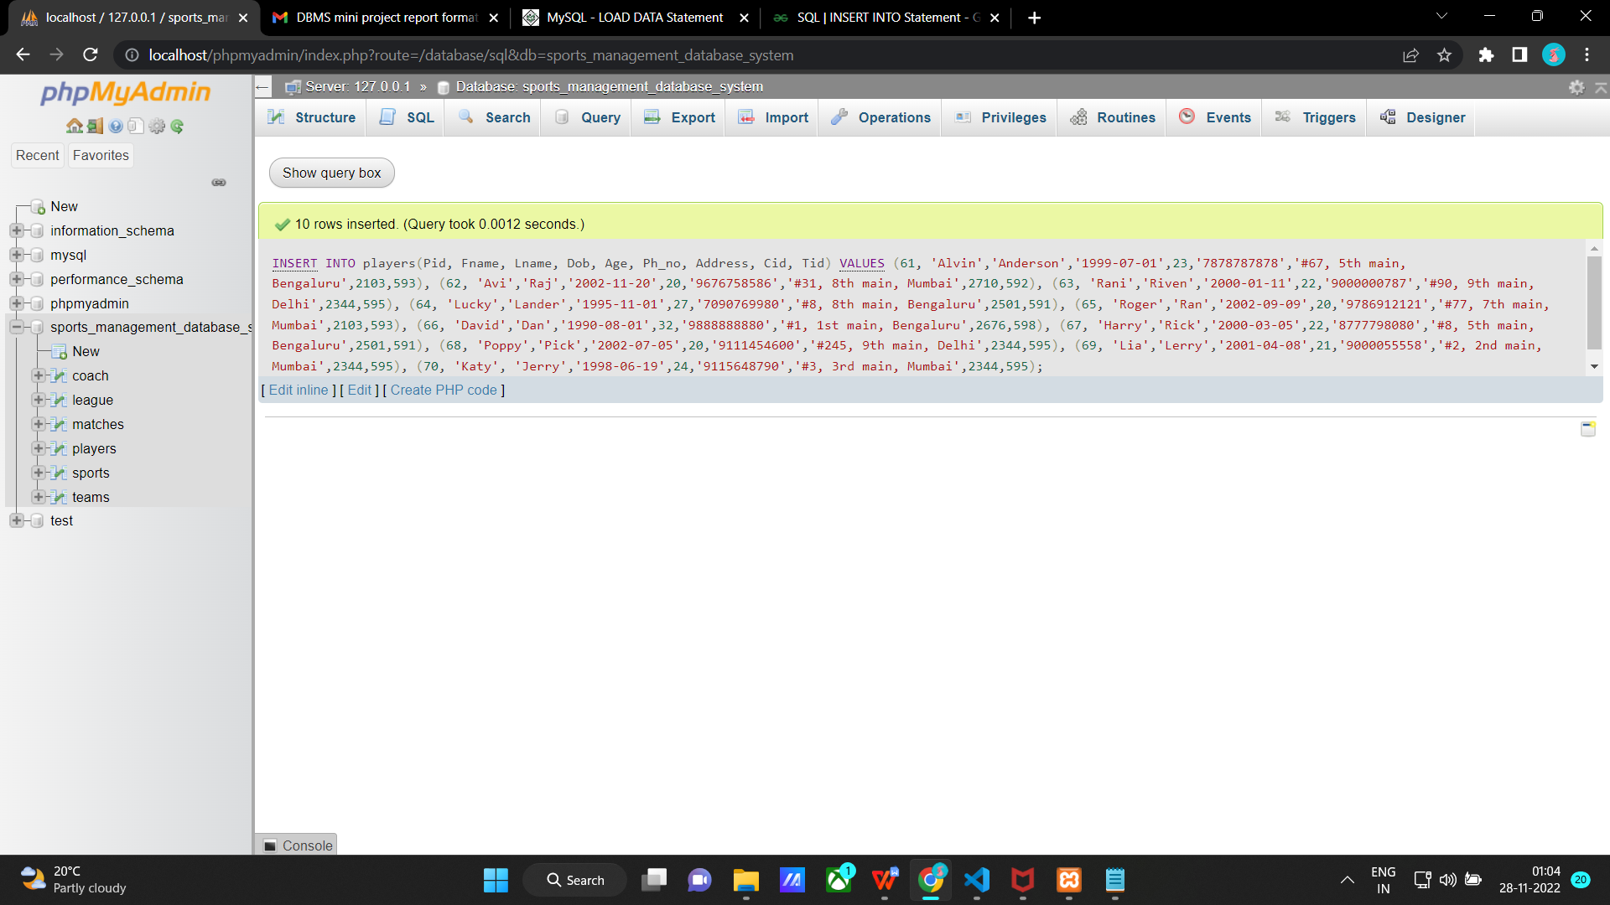

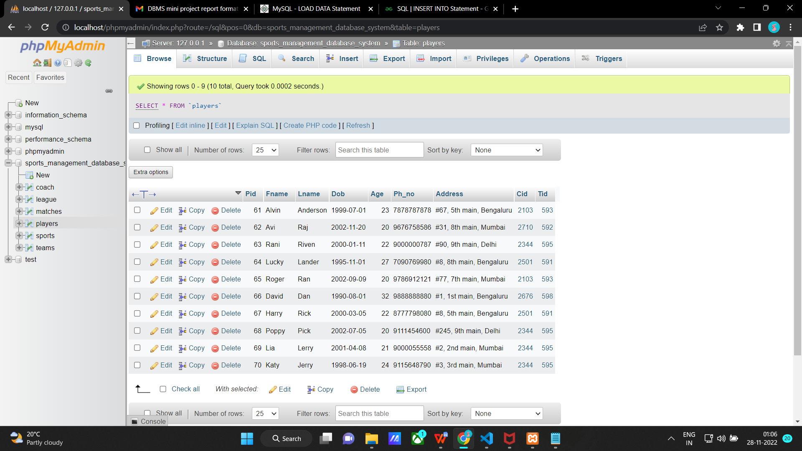

After inserting into all the tables

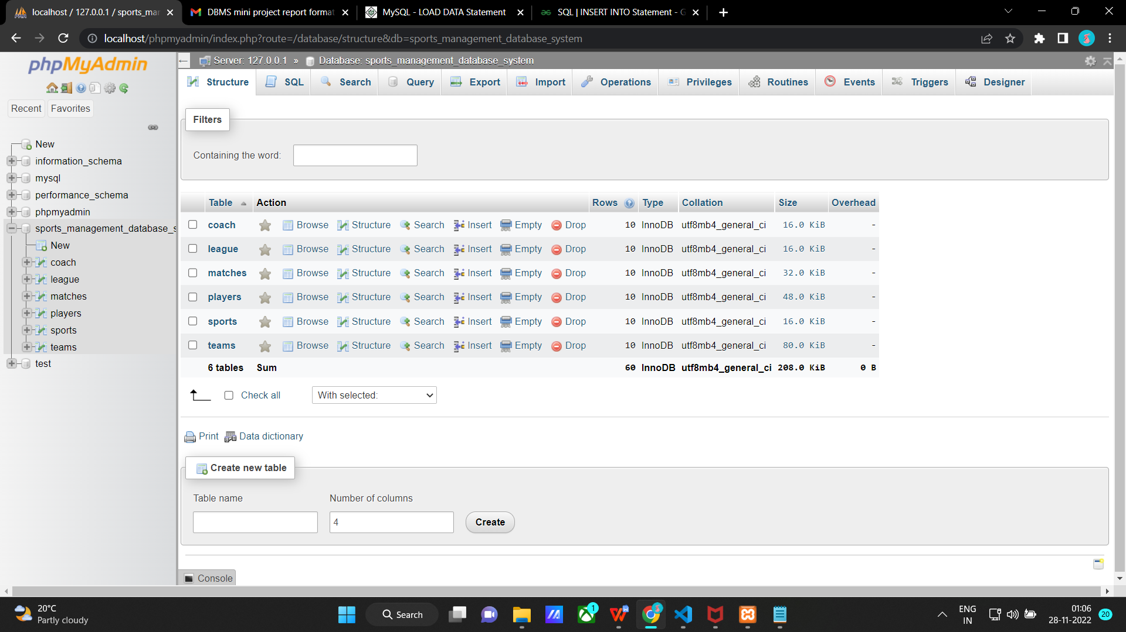

**Join Queries**

**1) Retrieve Player Id and Player name along with their Coach id and coach name**

SELECT players.Pid as "Player Id", players.Fname "Player Name", coach.Cid as "Coach Id", coach.Cname as "Coach name"

FROM players

INNER JOIN coach ON players.Cid = coach.Cid;

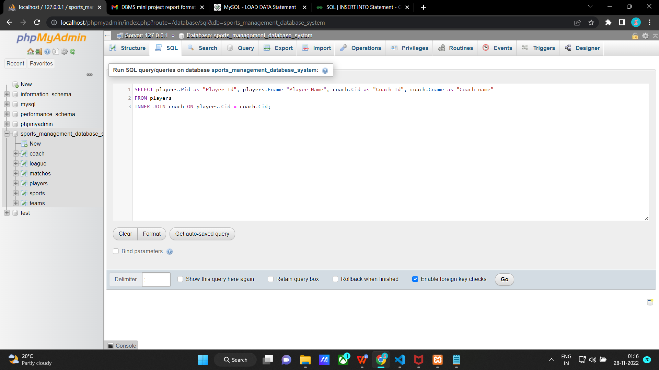

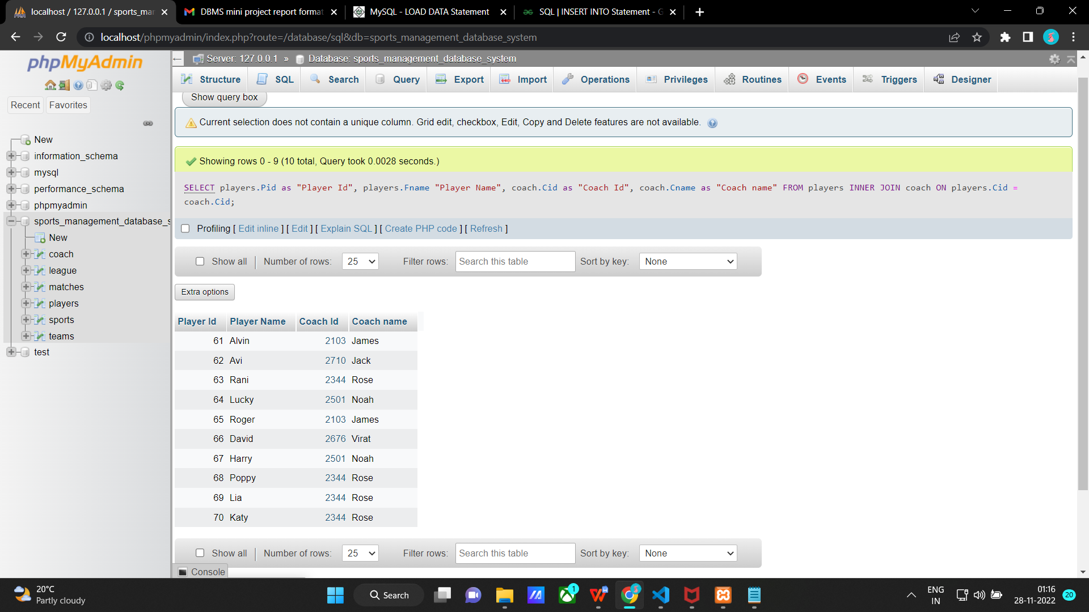

**2) Retrieve MATCH id and location of each Matches corresponding to its league Id and league name.**

SELECT matches.Mid as "Match Id",matches.Location, league.Lid as "League Id", league.Lname as "League Name"

from matches

NATURAL JOIN league;

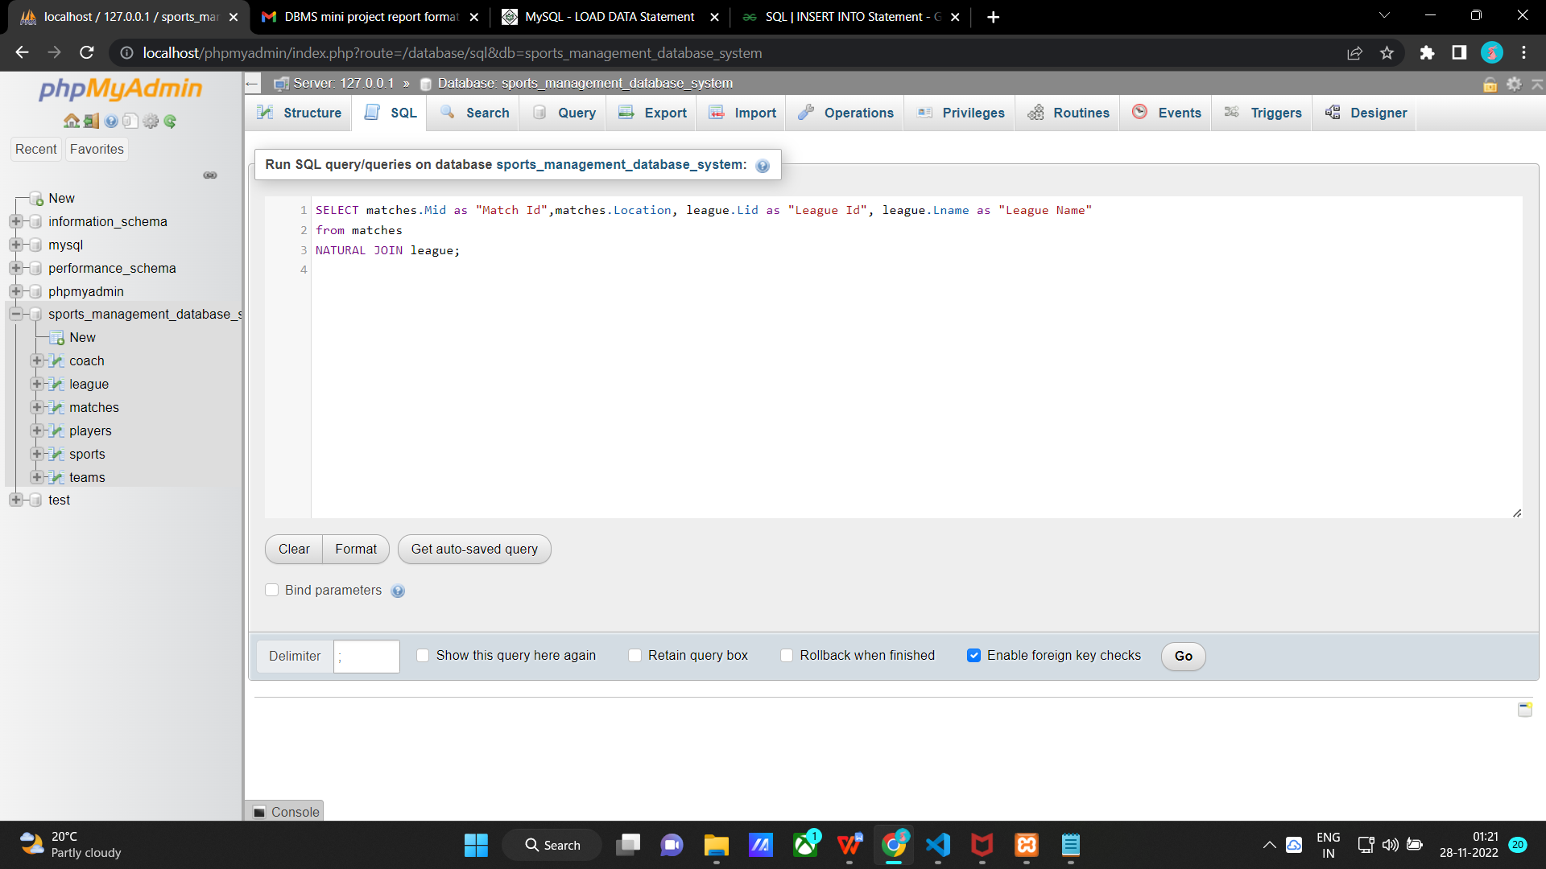

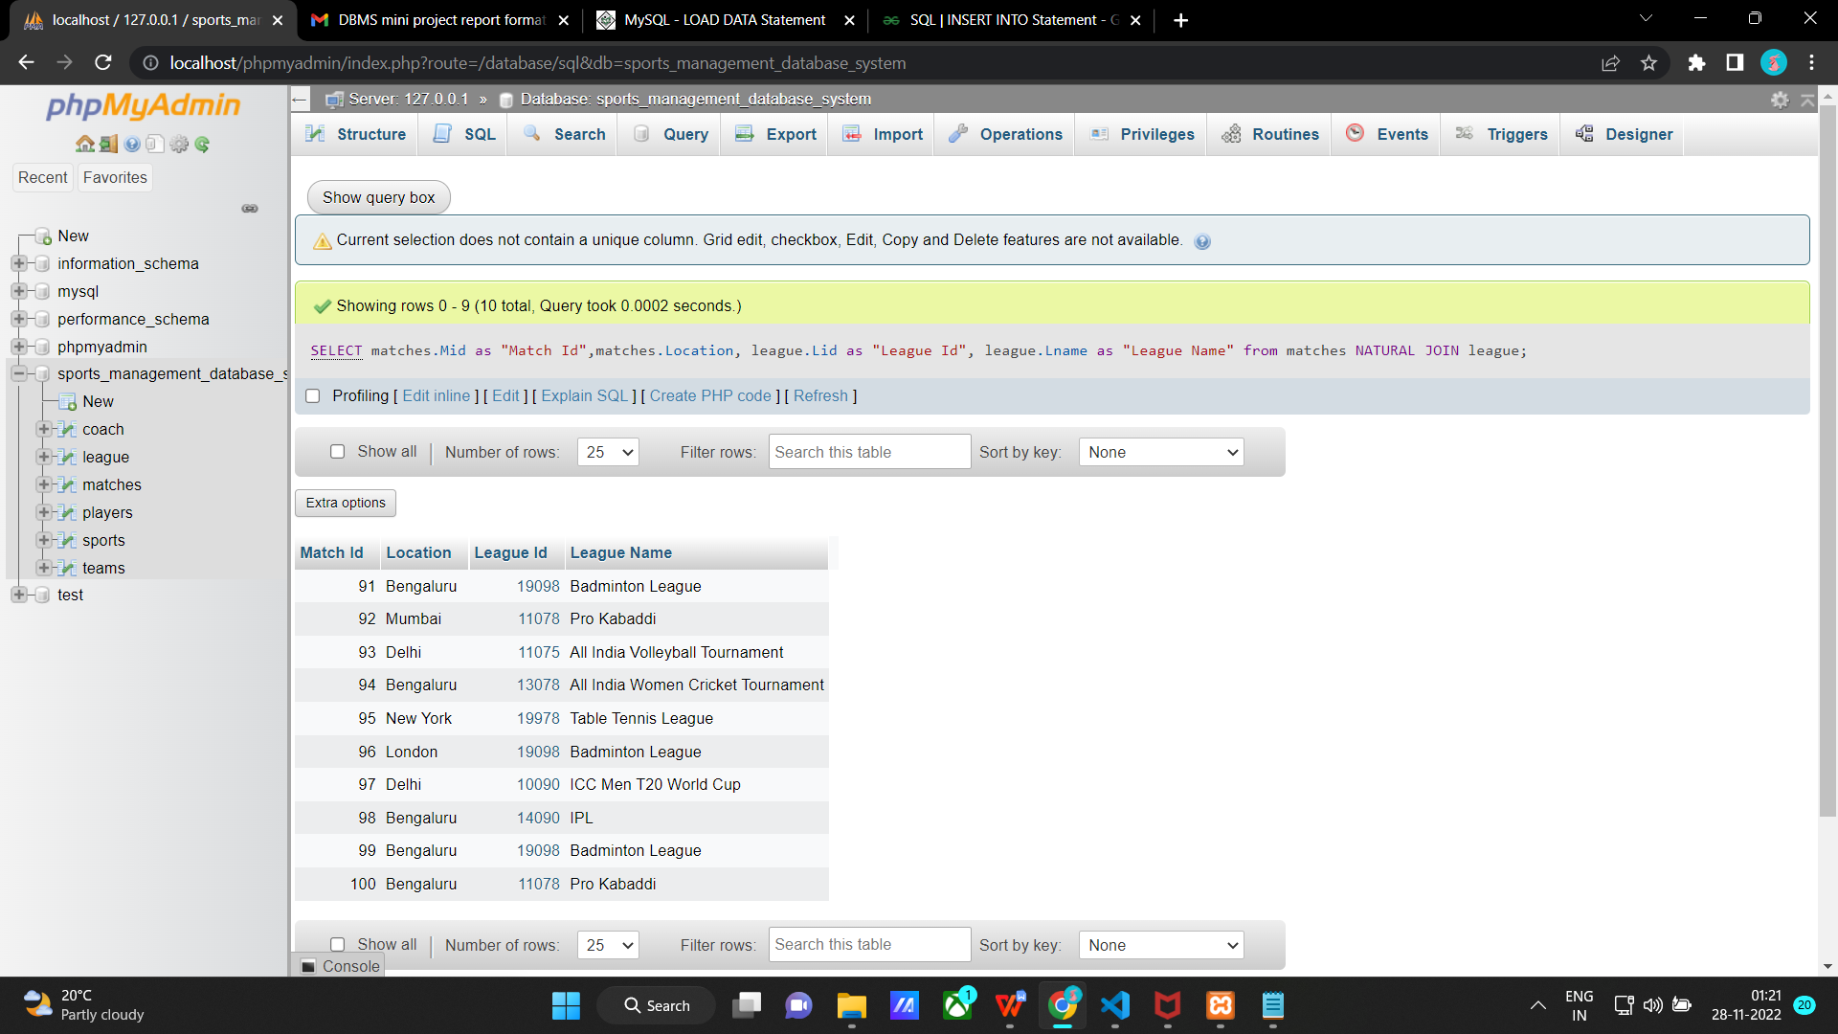

**3)Retrieve Team Id, Team Name of a team along with the number of matches each team is playing.**

SELECT teams.Tid as "Team Id", teams.Tname "Team Name", count(Mid) as "Number of matches"

FROM teams

NATURAL JOIN matches group by teams.tid;

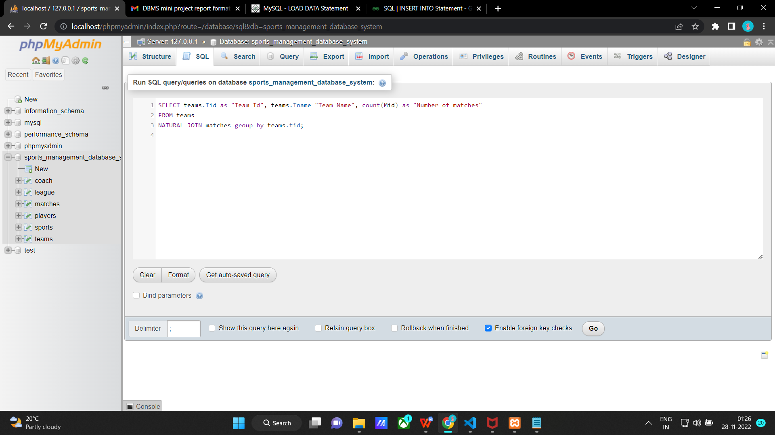

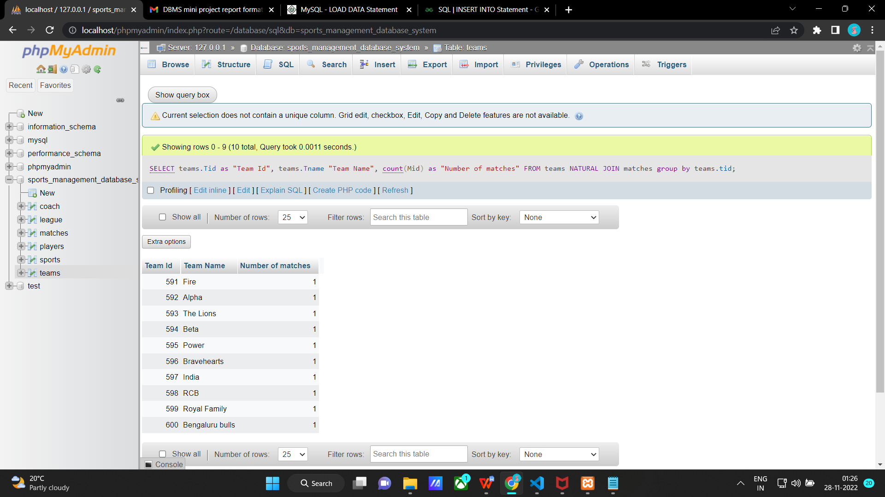

1. **Retrieve Team Id, Team Name along with Maximum number of players in a team and current number of players in a team.**

SELECT teams.Tid as "Team Id", teams.Tname "Team Name", teams.No_of_players as "Maximum number of players", count(Pid) as "Current number of players in a team"

FROM teams

LEFT OUTER JOIN players ON teams.Tid = players.Tid group by teams.tid;

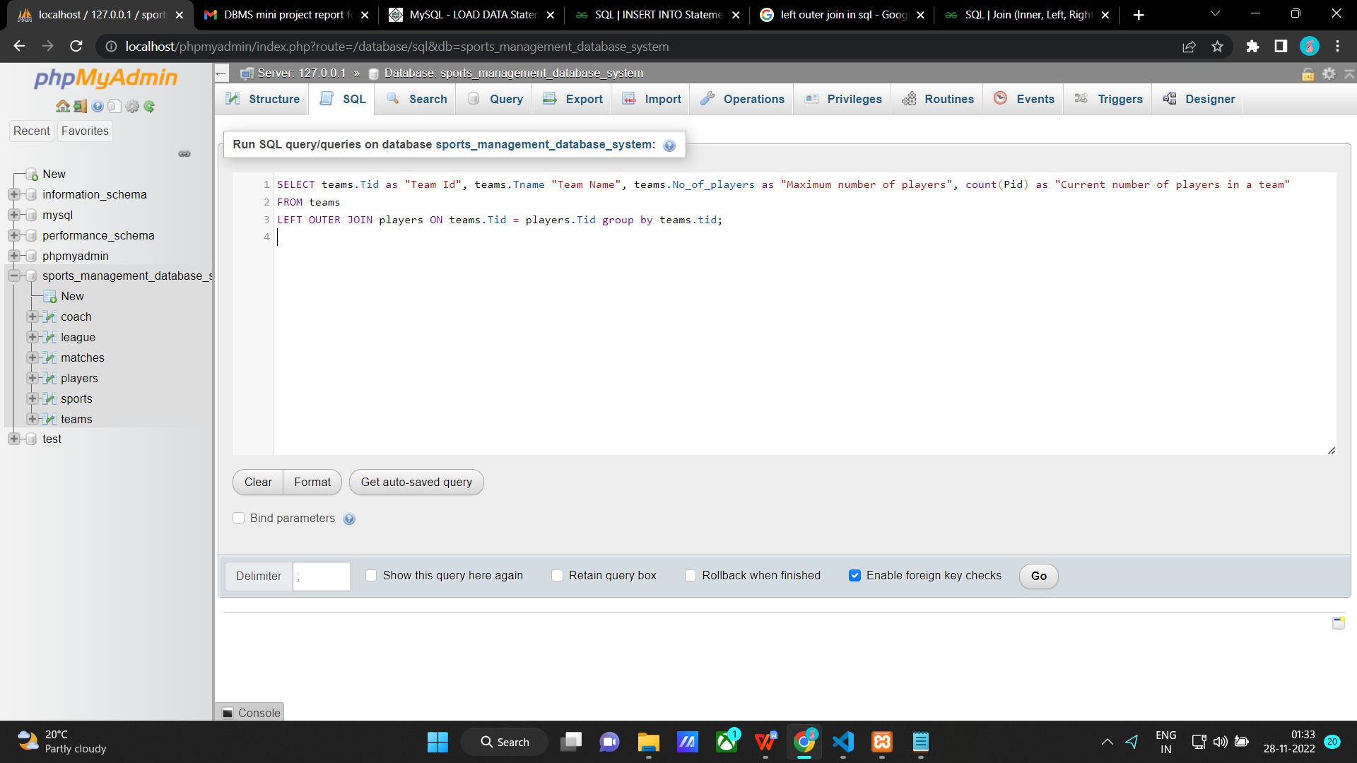

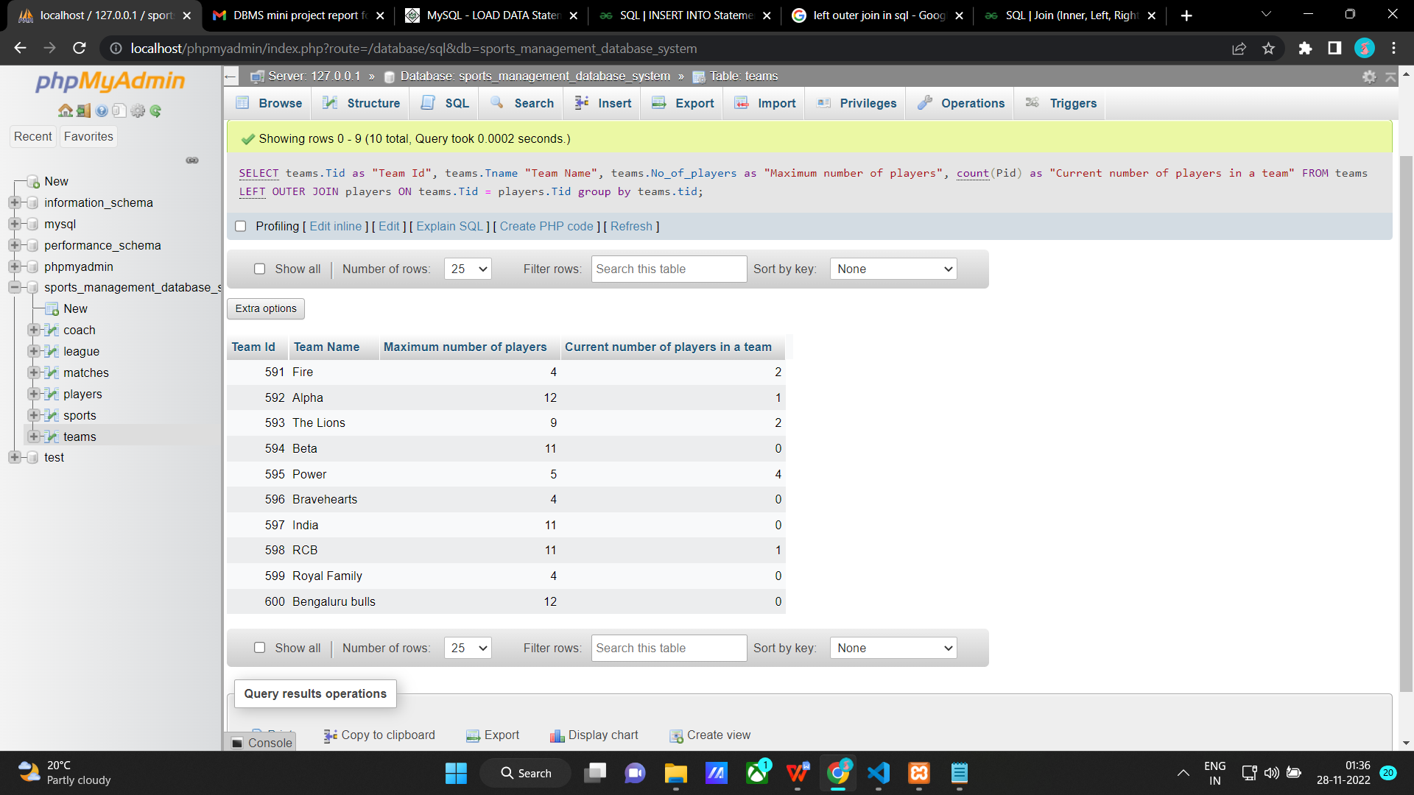

**Aggregate Functions**

**1) Retrieve the most number of players and Least number of players in a team.**

SELECT max(No_of_players) as "Most number of players", min(No_of_players) as "Least number of players" from teams ;

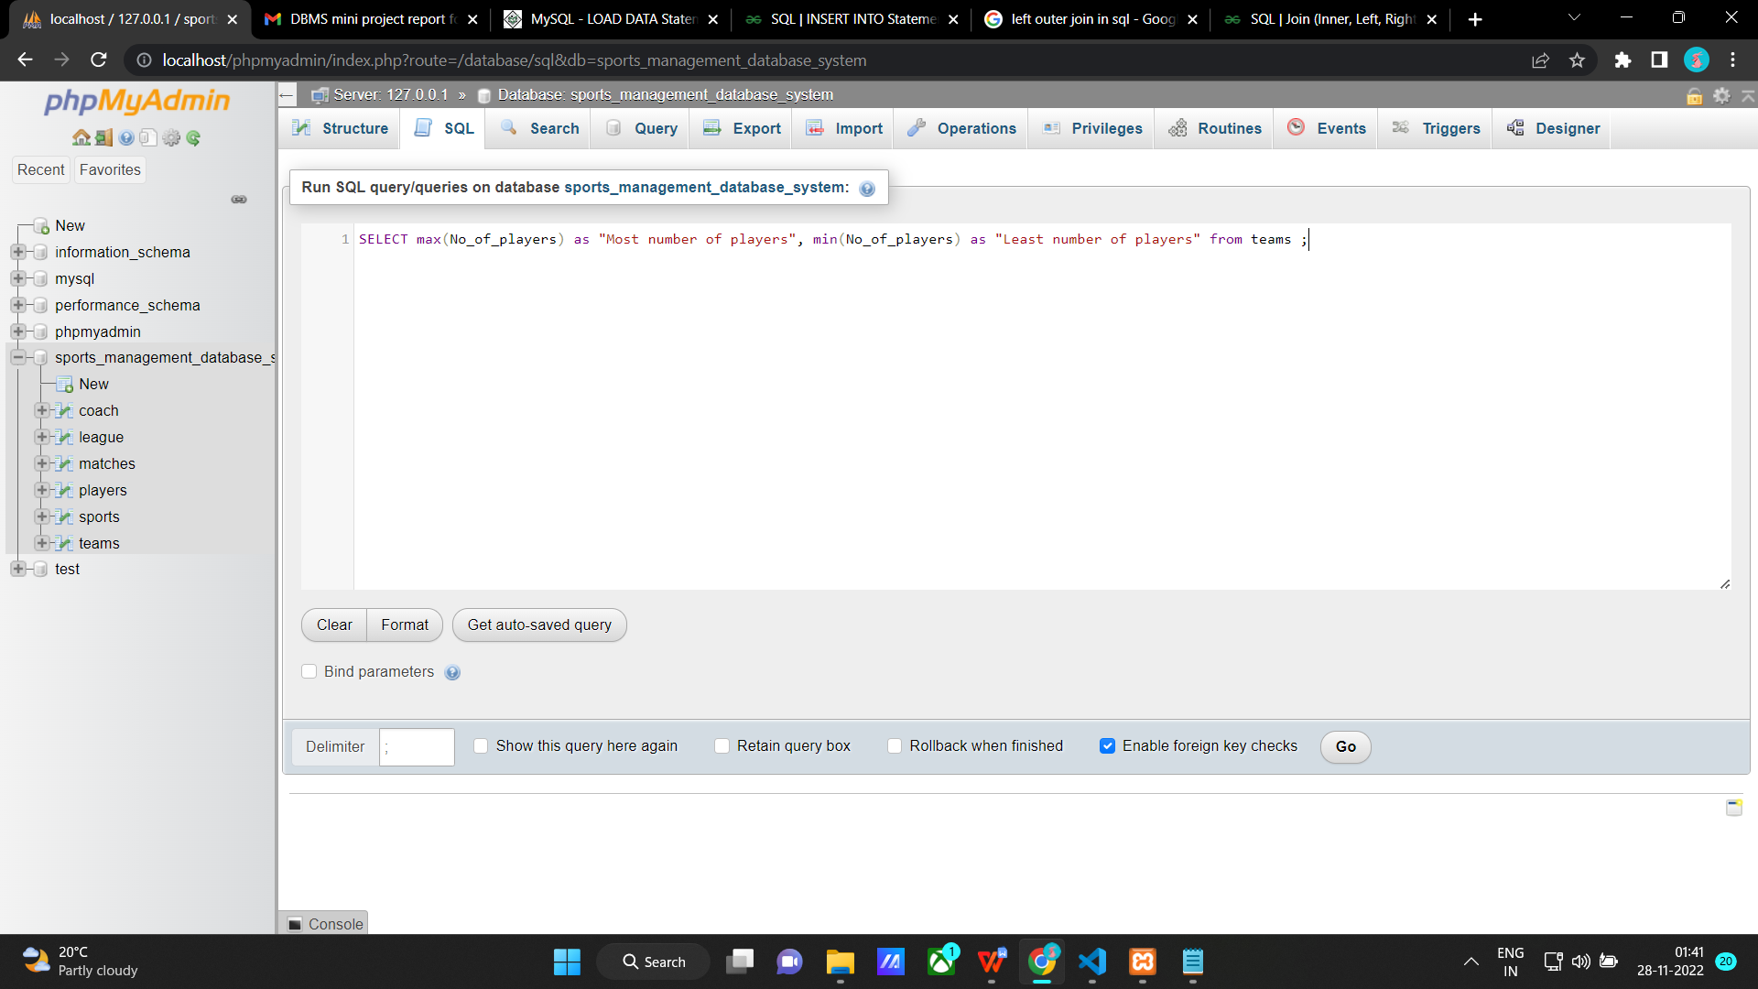

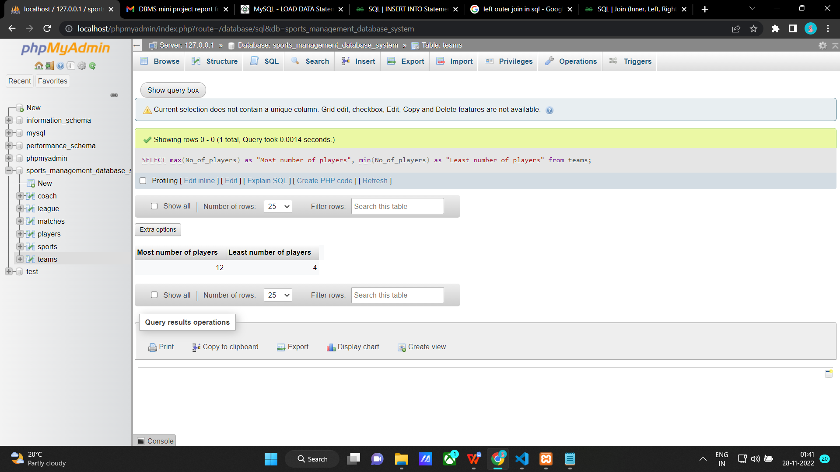

**2) Retrieve the average age of players.**

SELECT AVG(Age) as "Average Age of players" from players;

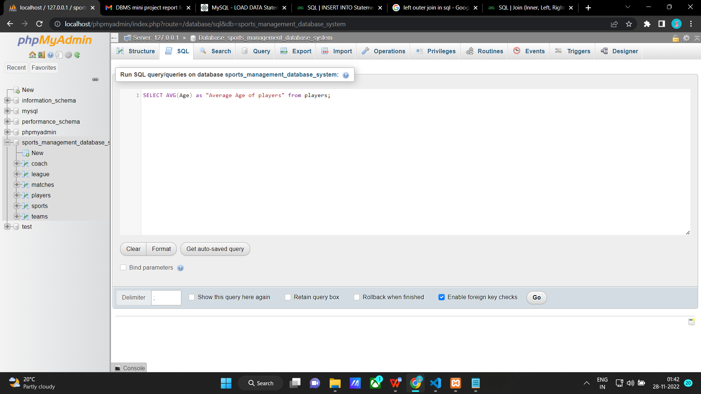

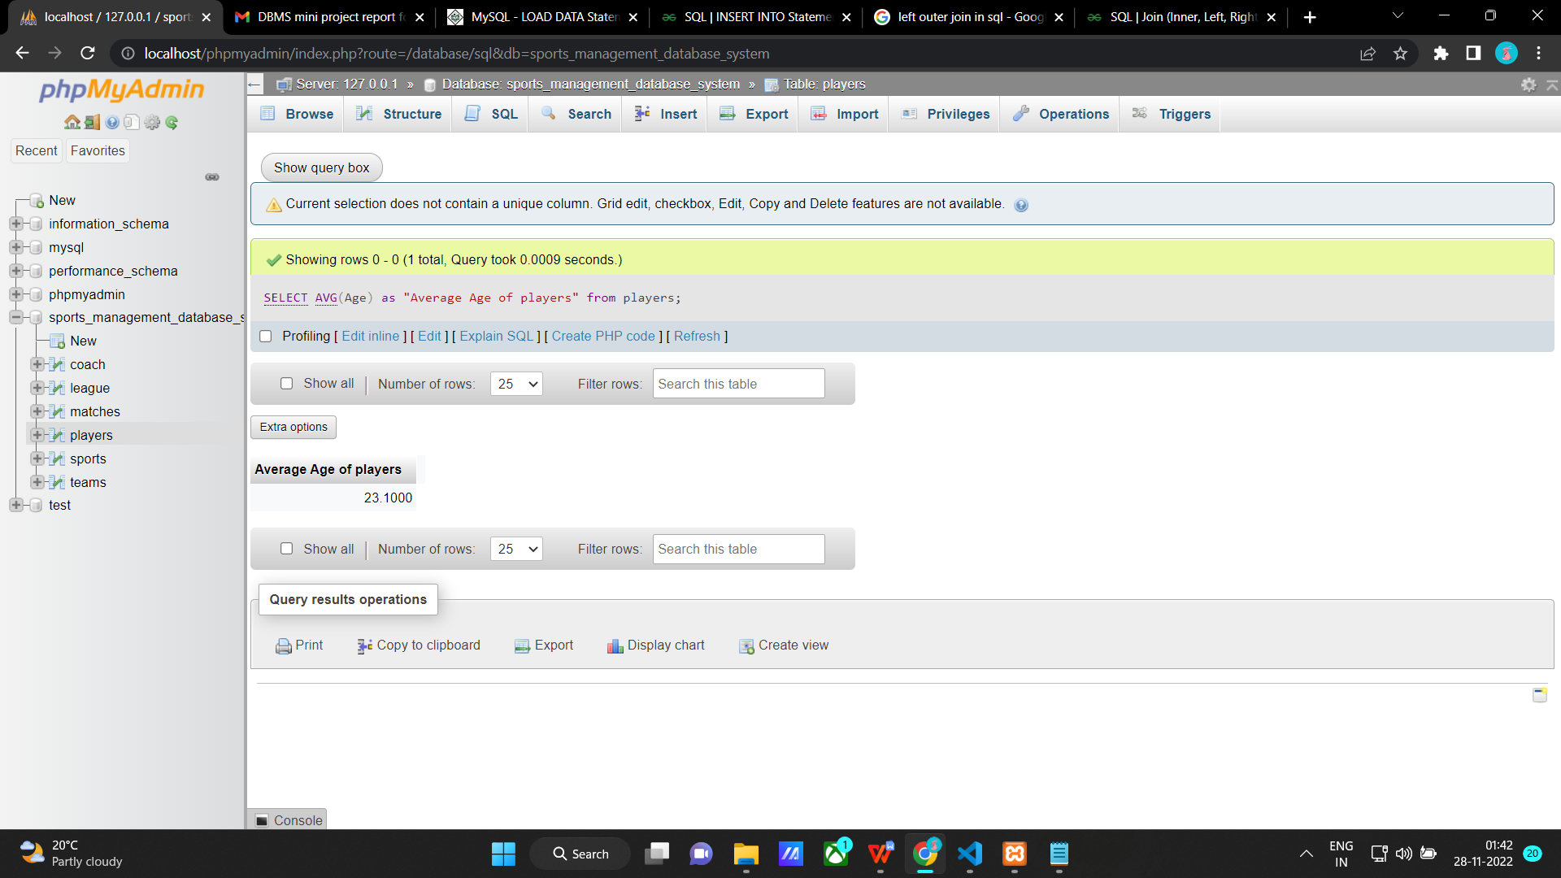

**3) Retrieve the number of coaches who live in Bengaluru.**

SELECT COUNT(*)

FROM coach

WHERE Address like "%Bengaluru";

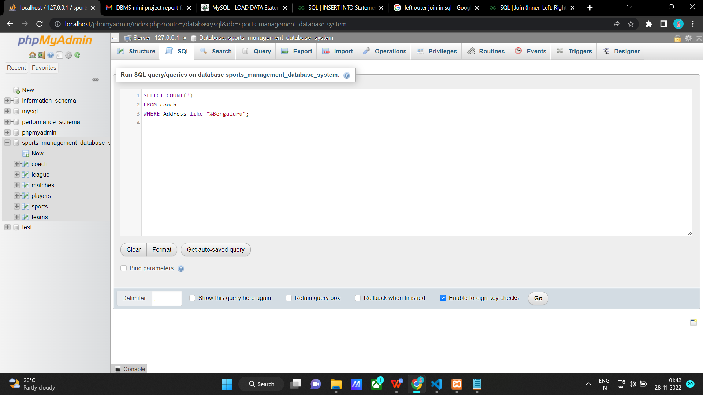

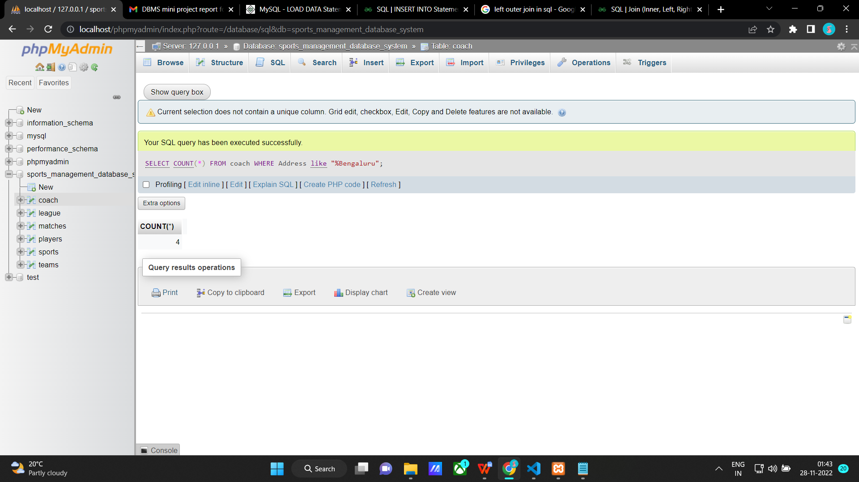

**4) Retrieve the number of different sports available for men and women and order by ascending order.**

SELECT Category, COUNT(*)

from sports

group by Category

ORDER BY COUNT(*) ASC;

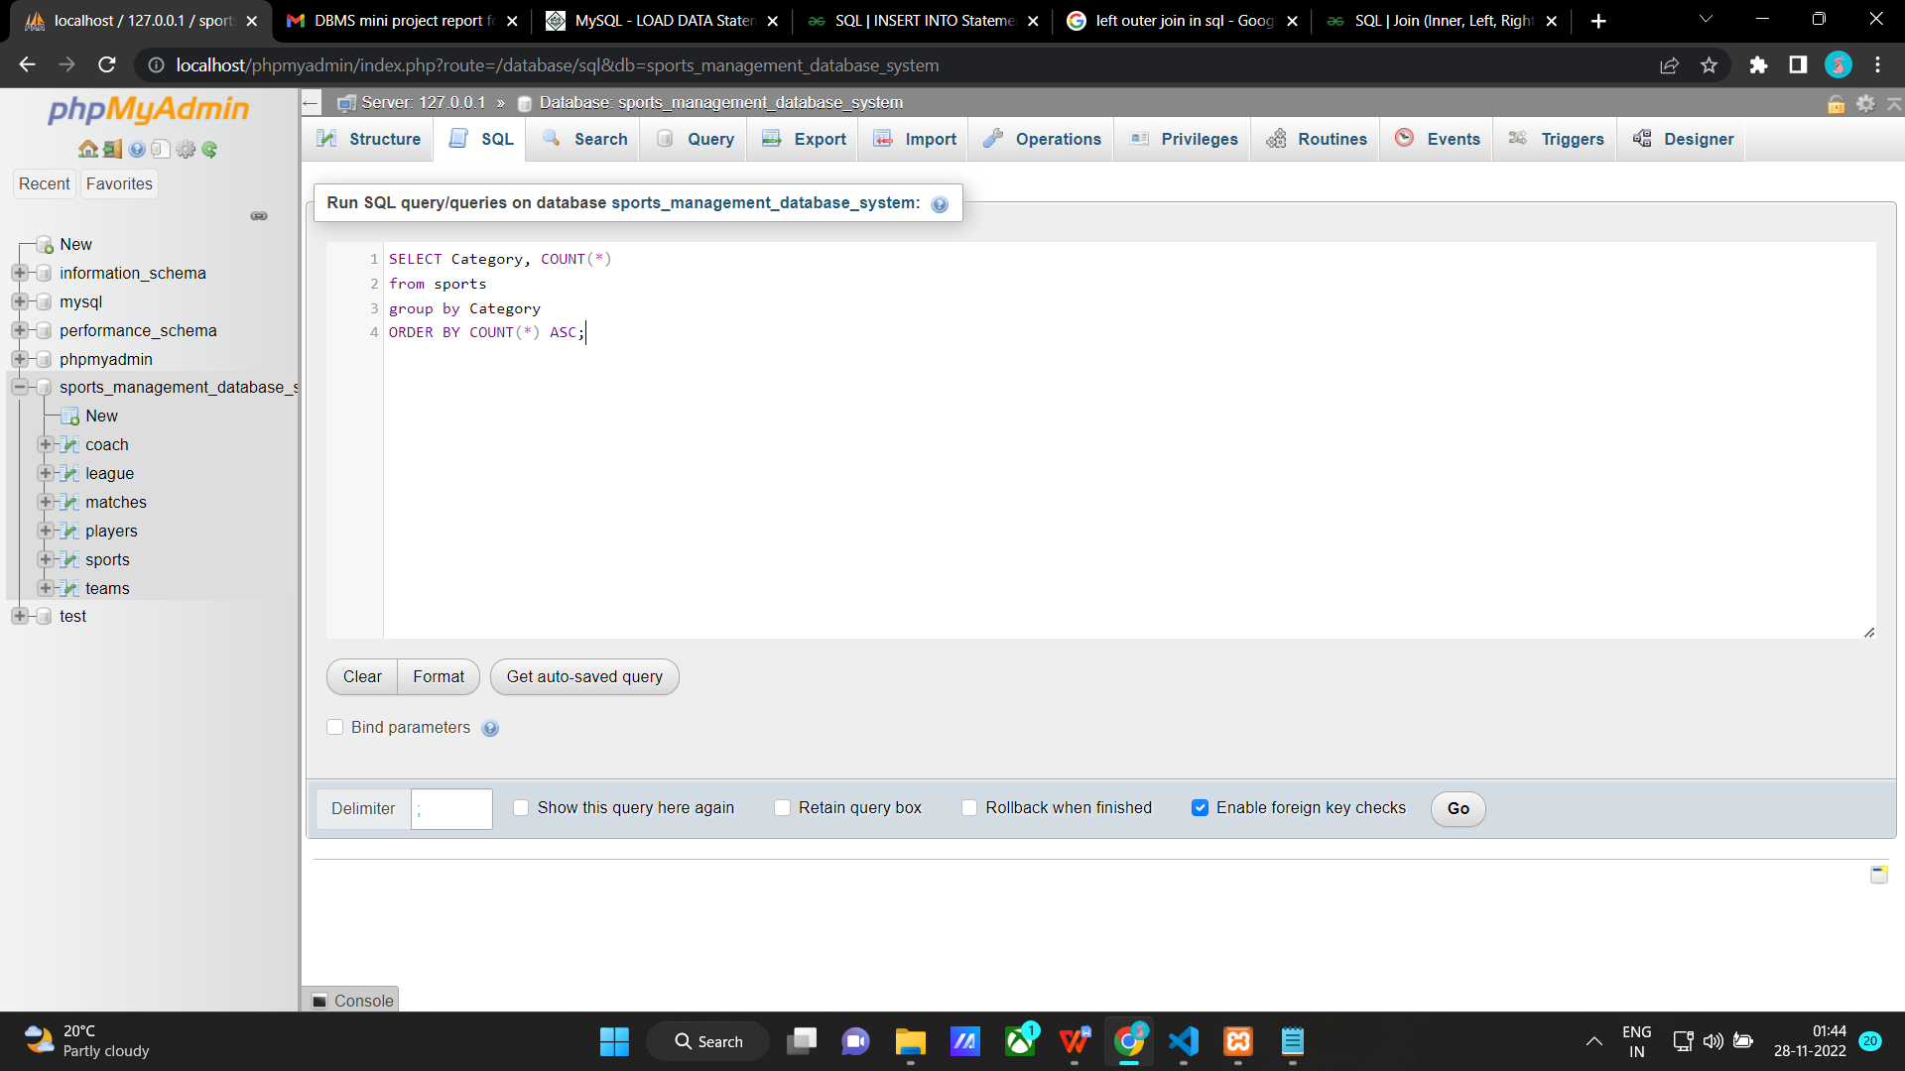

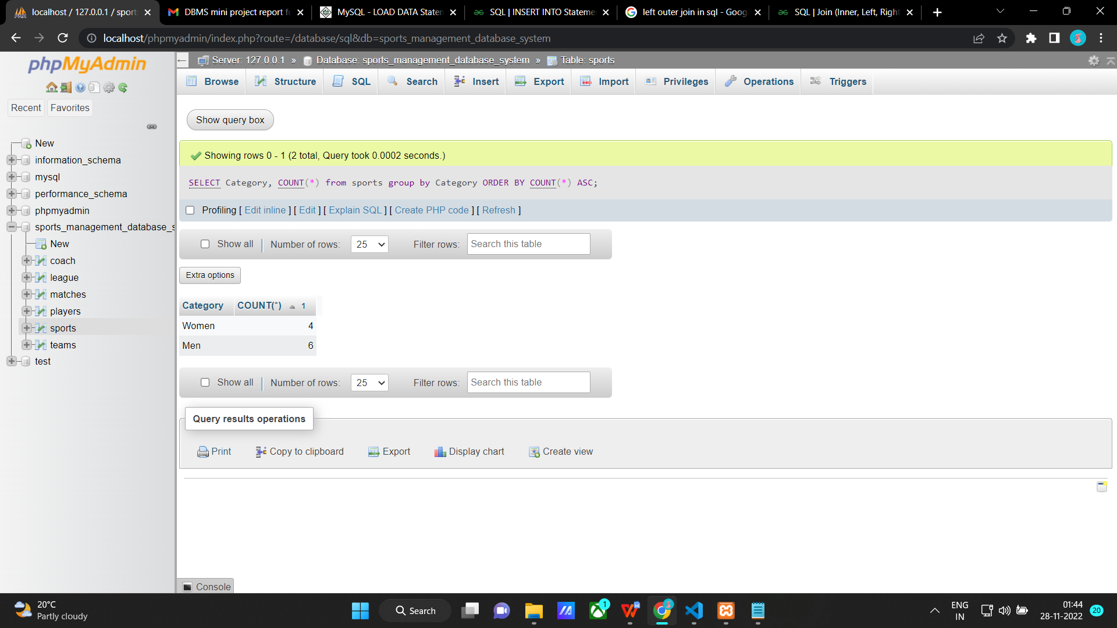

**Set Operations**

**1) Retrieve Player Name with Team Id of all players including the captain.**

SELECT Fname as "Name",Tid as "Team Id" from players

UNION

SELECT Captain,Tid from Teams;

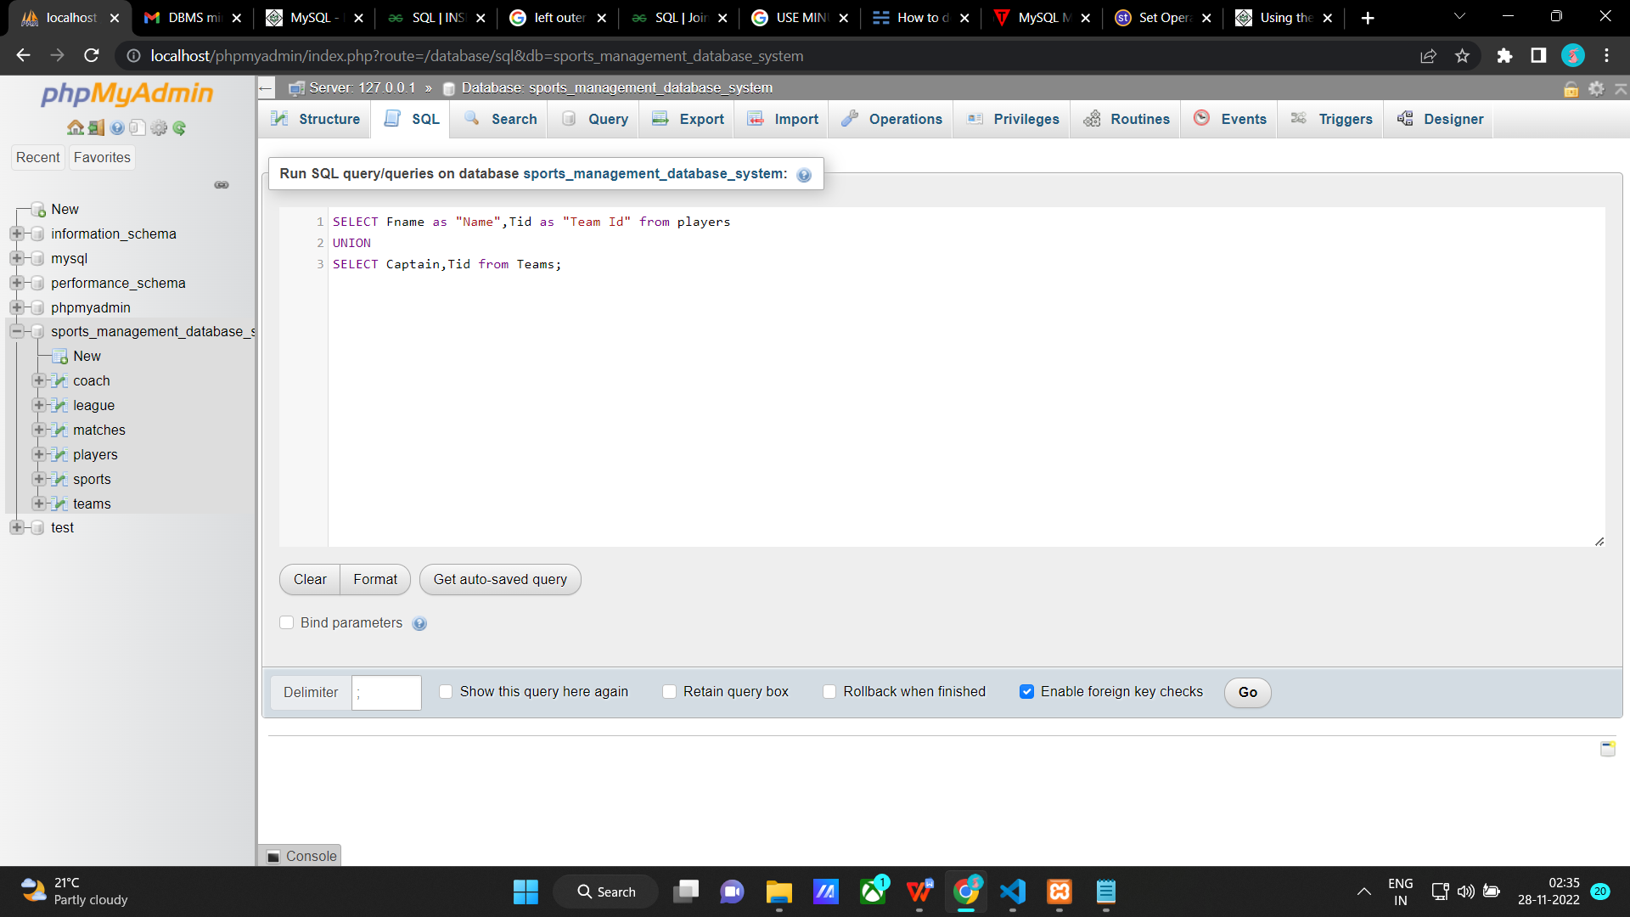

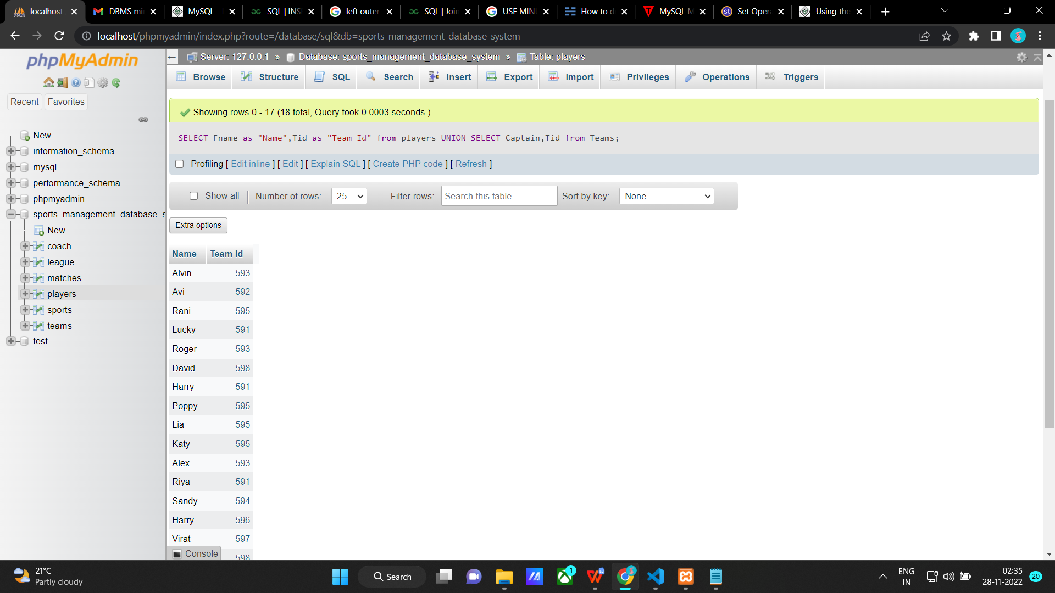

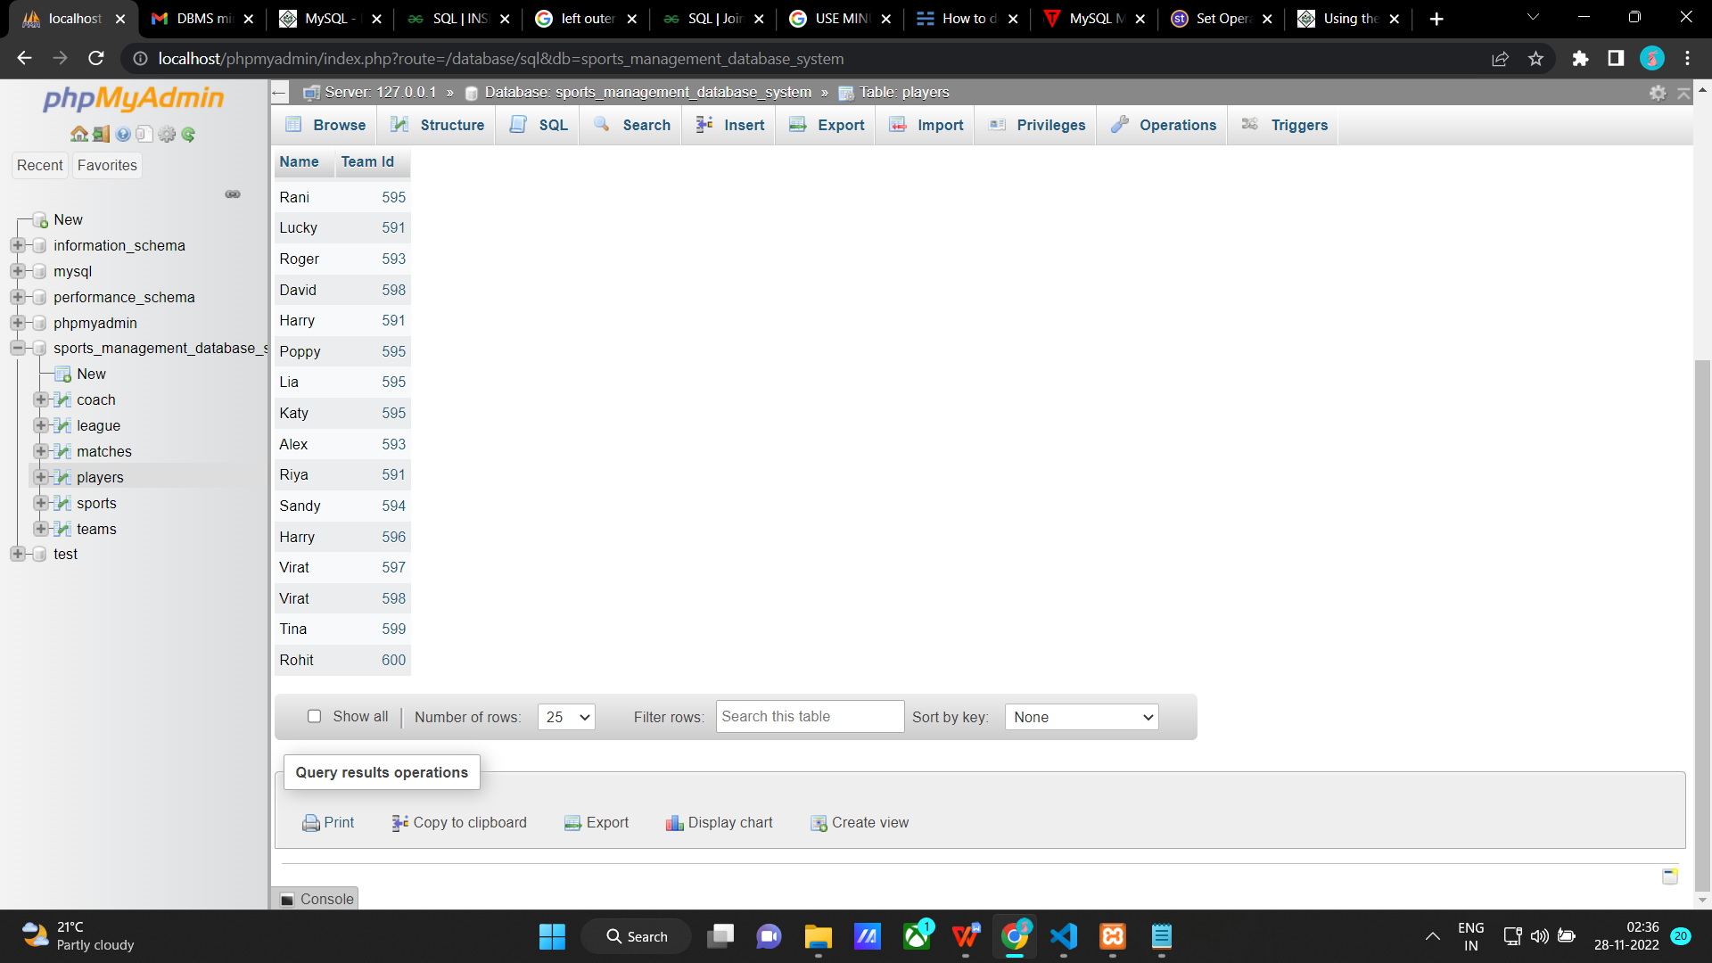

**2) Retrieve Team Id, Team name, Player Id, Firstname and Lastname of players who play for teams with Tid 591, 595.**

Select t.Tid as "Team Id", Tname as "Team Name", Pid as "Player Id", Fname as "First name", Lname as "Last name"

FROM players as p, teams as t

WHERE p.Tid = t.Tid AND p.Tid = 591

UNION

Select t.Tid, Tname, Pid, Fname, Lname

FROM players as p, teams as t

WHERE p.Tid = t.Tid AND p.Tid = 595;

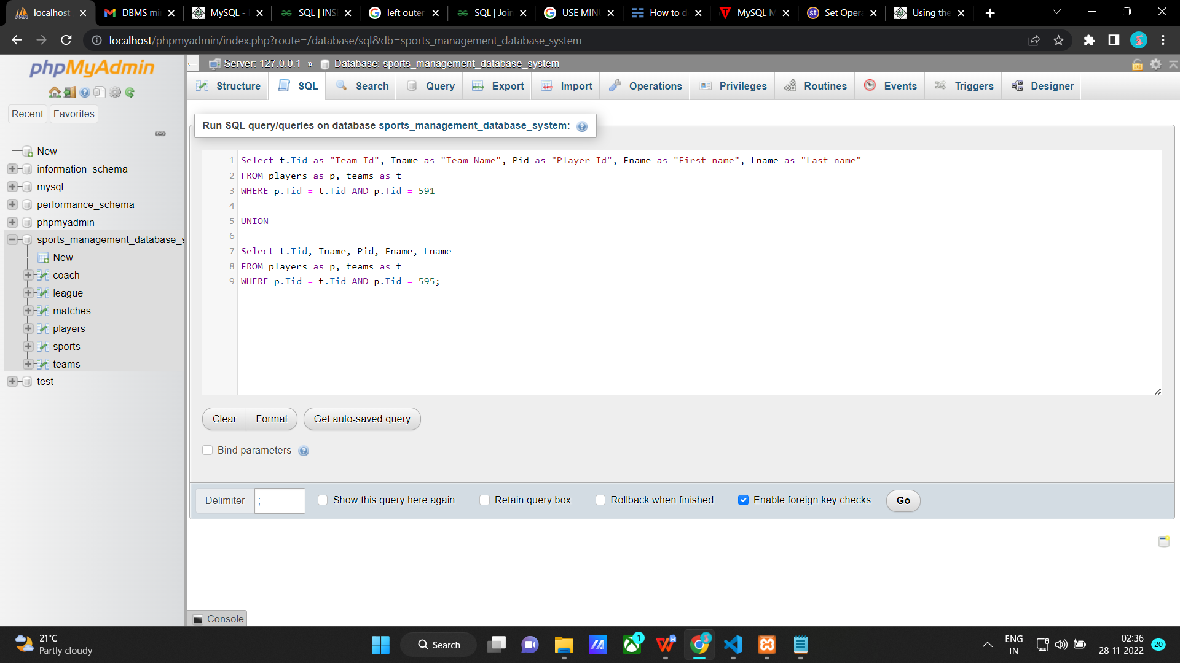

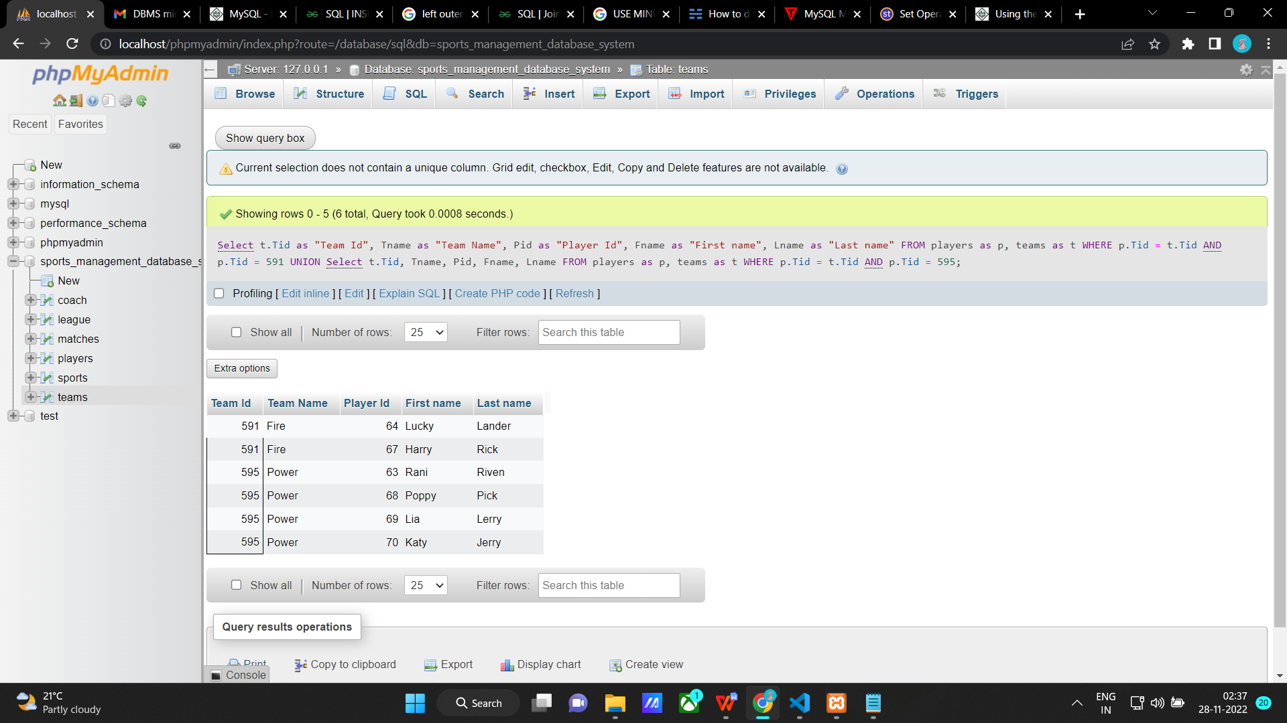

**3)Retrive the Name of player which is same as the coach name.**

SELECT DISTINCT Fname FROM players

WHERE Fname IN (SELECT Cname FROM coach);

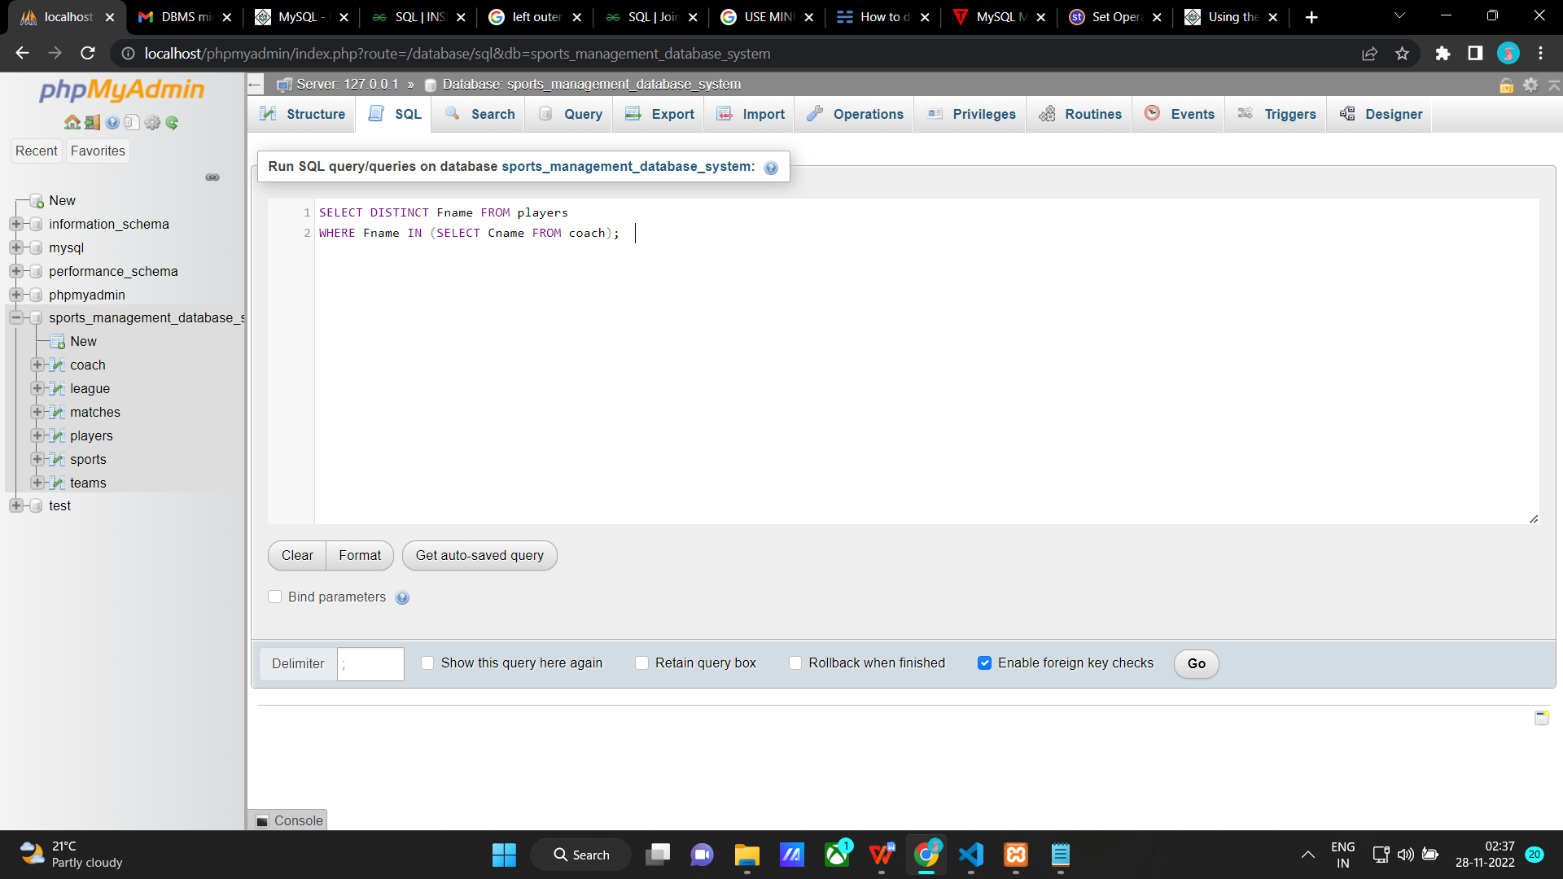

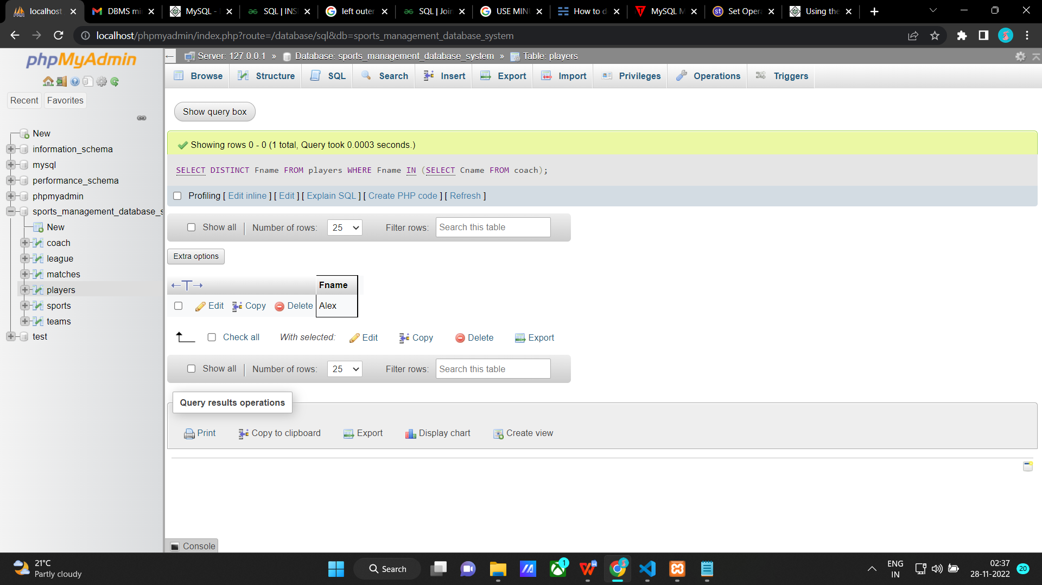

**4) Retrive Team Id and Firstame of Players who play for a team but is not a captain.**

SELECT Fname,Tid from players

EXCEPT

SELECT Captain,Tid from teams;

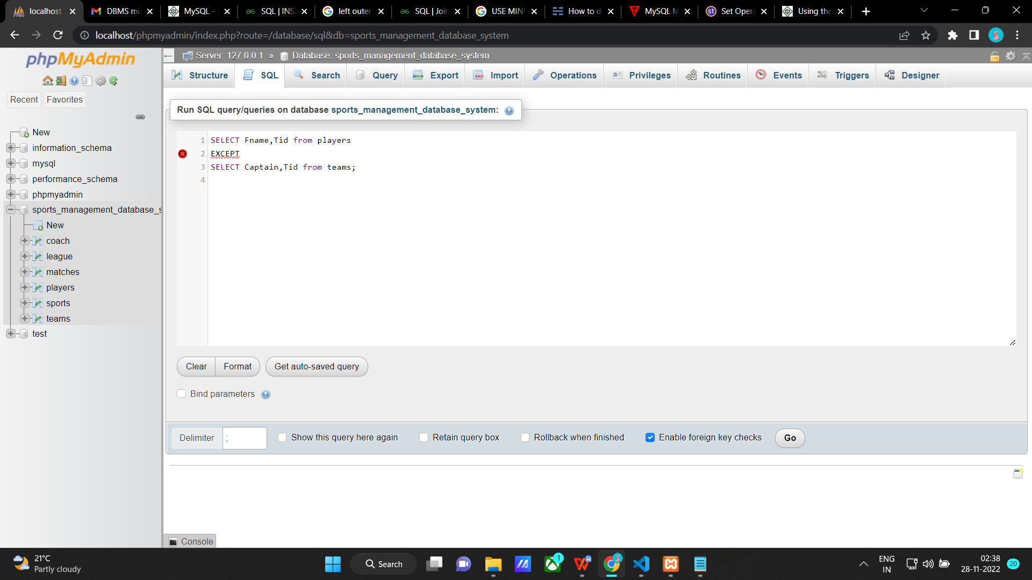

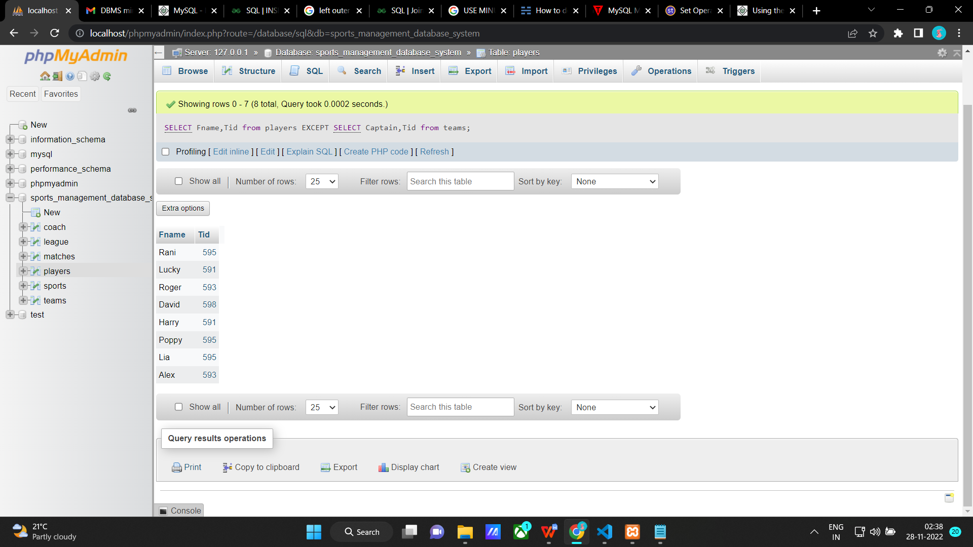

**Function**

Create a function to calculate the age of the player.

DELIMITER $$

CREATE FUNCTION age_of_players(date1 date)

RETURNS INT

DETERMINISTIC

BEGIN

DECLARE date2 DATE;

SELECT current_date()into date2;

RETURN year(date2)-year(date1);

END; $$

DELIMITER ;

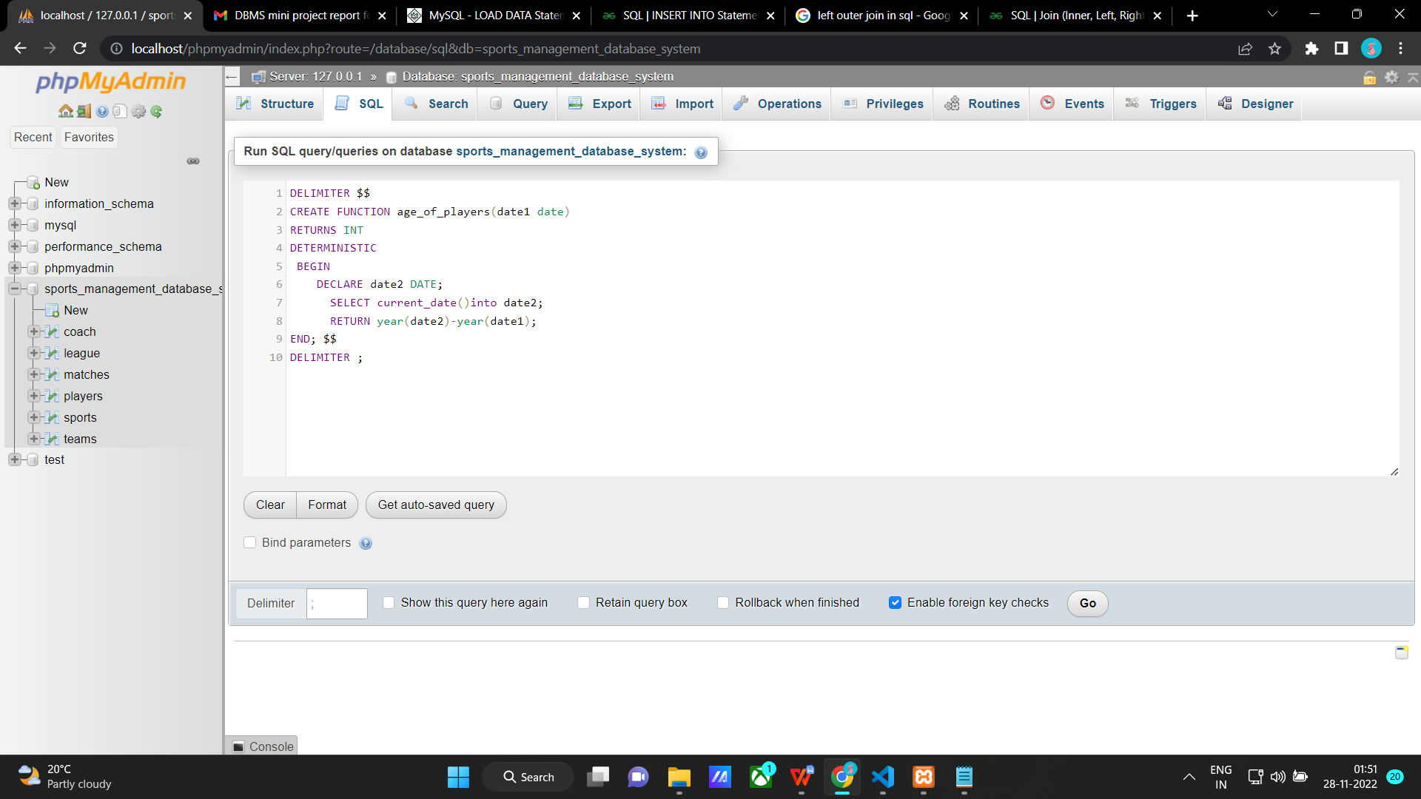

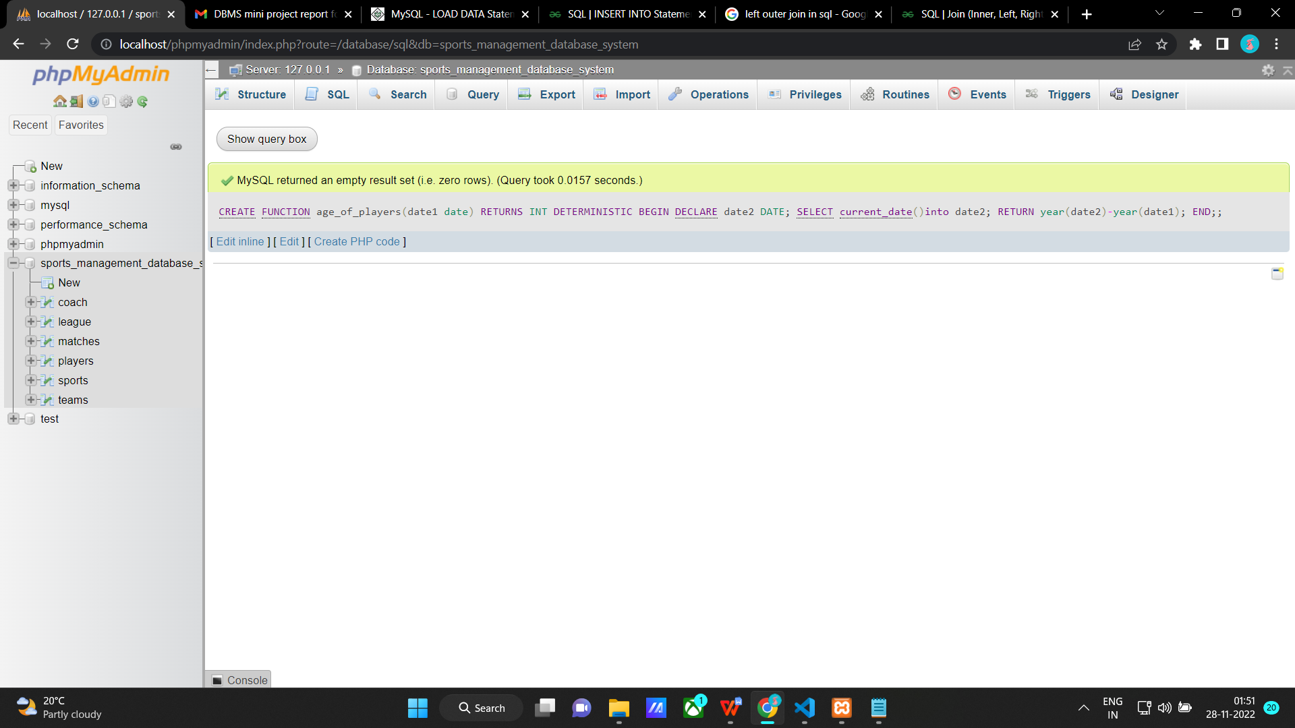

**Enter this to call the function:**

Select Pid, Fname, Lname, age_of_players(Dob) as 'Age' from players;

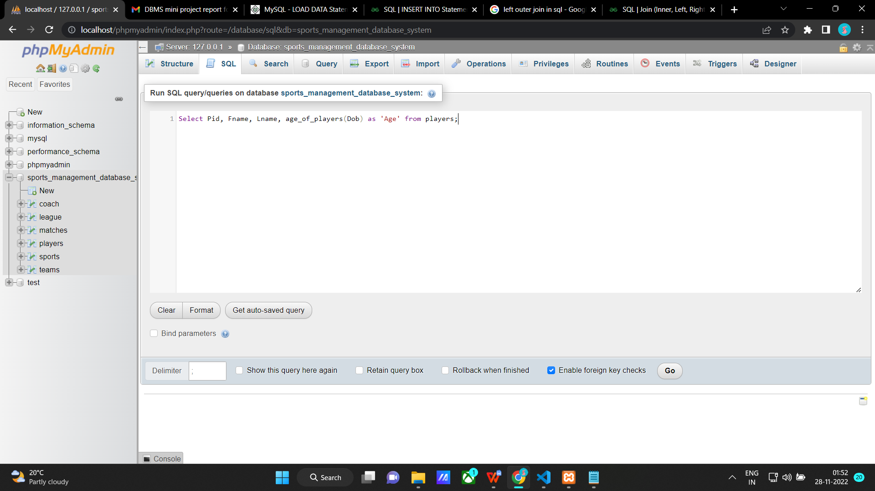

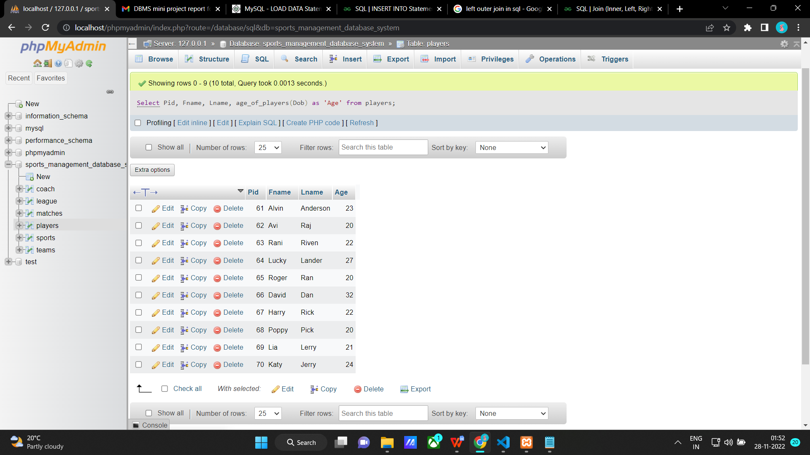

**Procedure**

**Create a procedure to insert a new sport**

DELIMITER $$

CREATE PROCEDURE insert_new_sport(IN new_Sid INT, IN new_Sname VARCHAR(255), IN new_Category VARCHAR(255))

BEGIN

INSERT INTO sports(Sid, Sname, Category)VALUES(new_Sid, new_Sname, new_Category) ;

END $$

DELIMITER ;

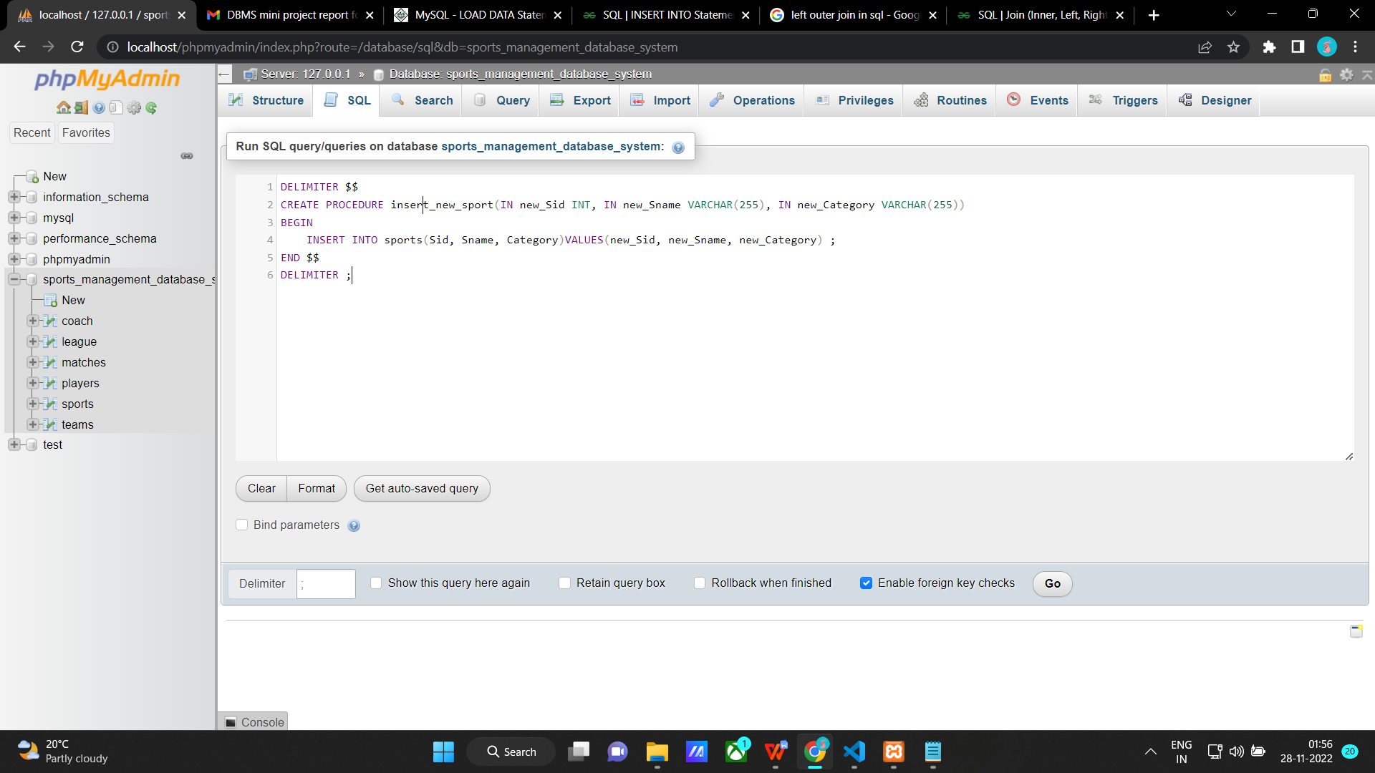

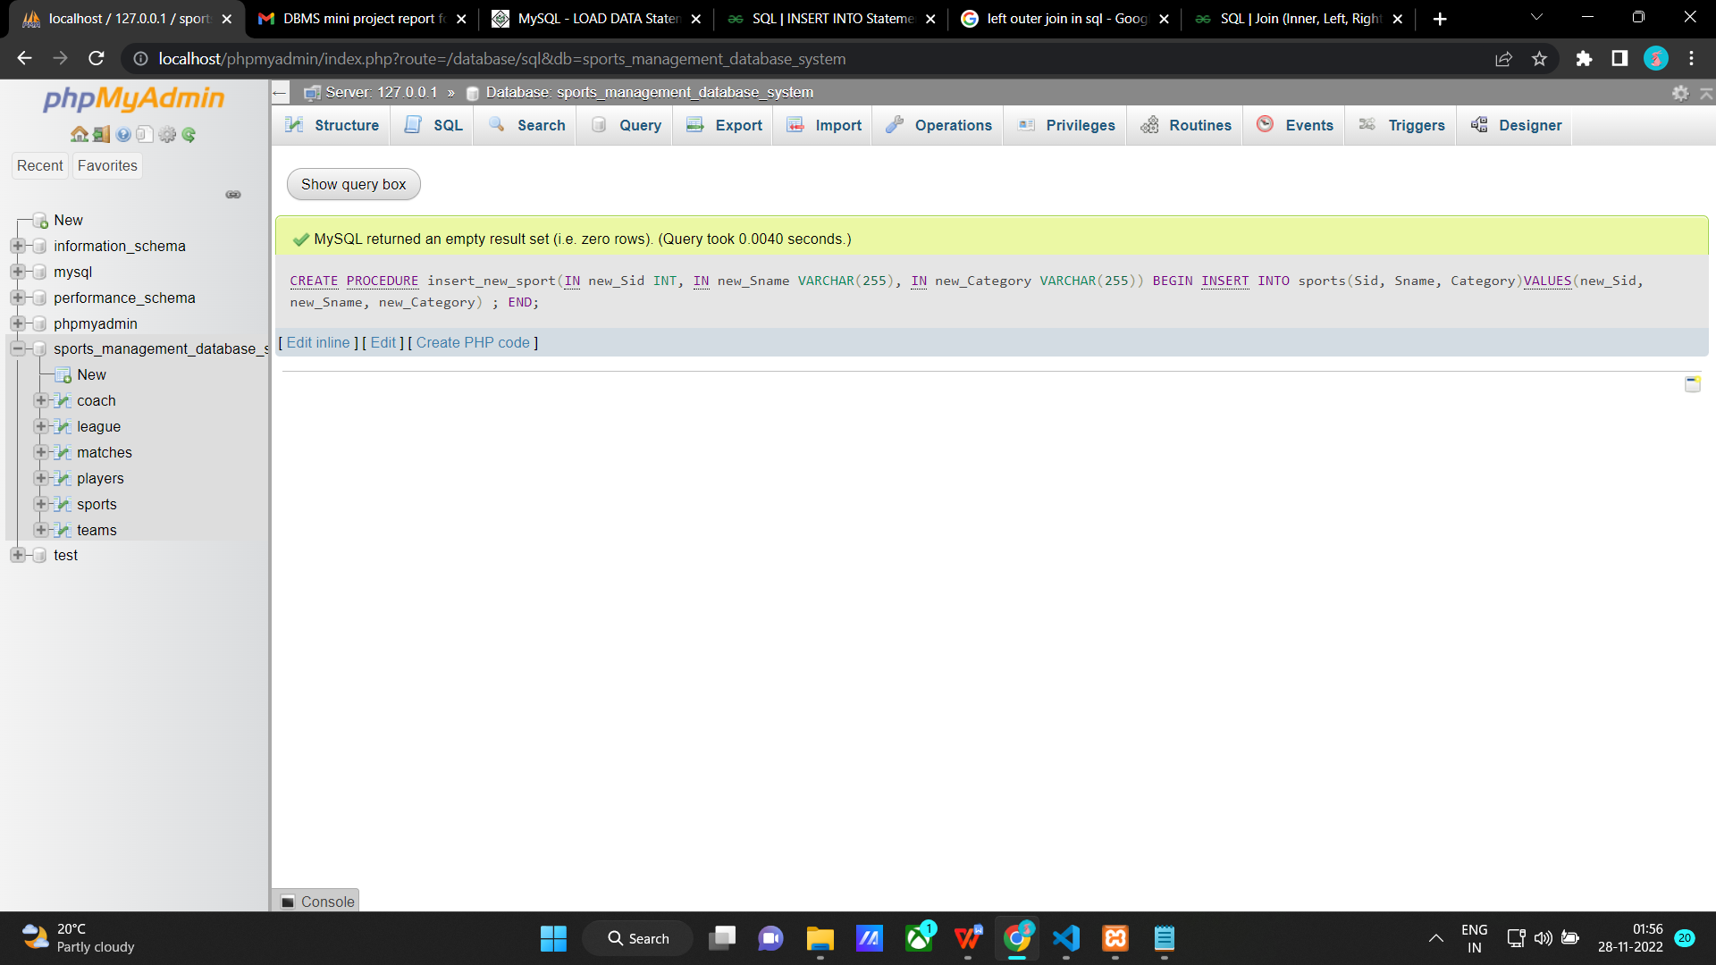

**Enter this to call the procedure:**

CALL insert_new_sport("10101", "High jump", "Women");

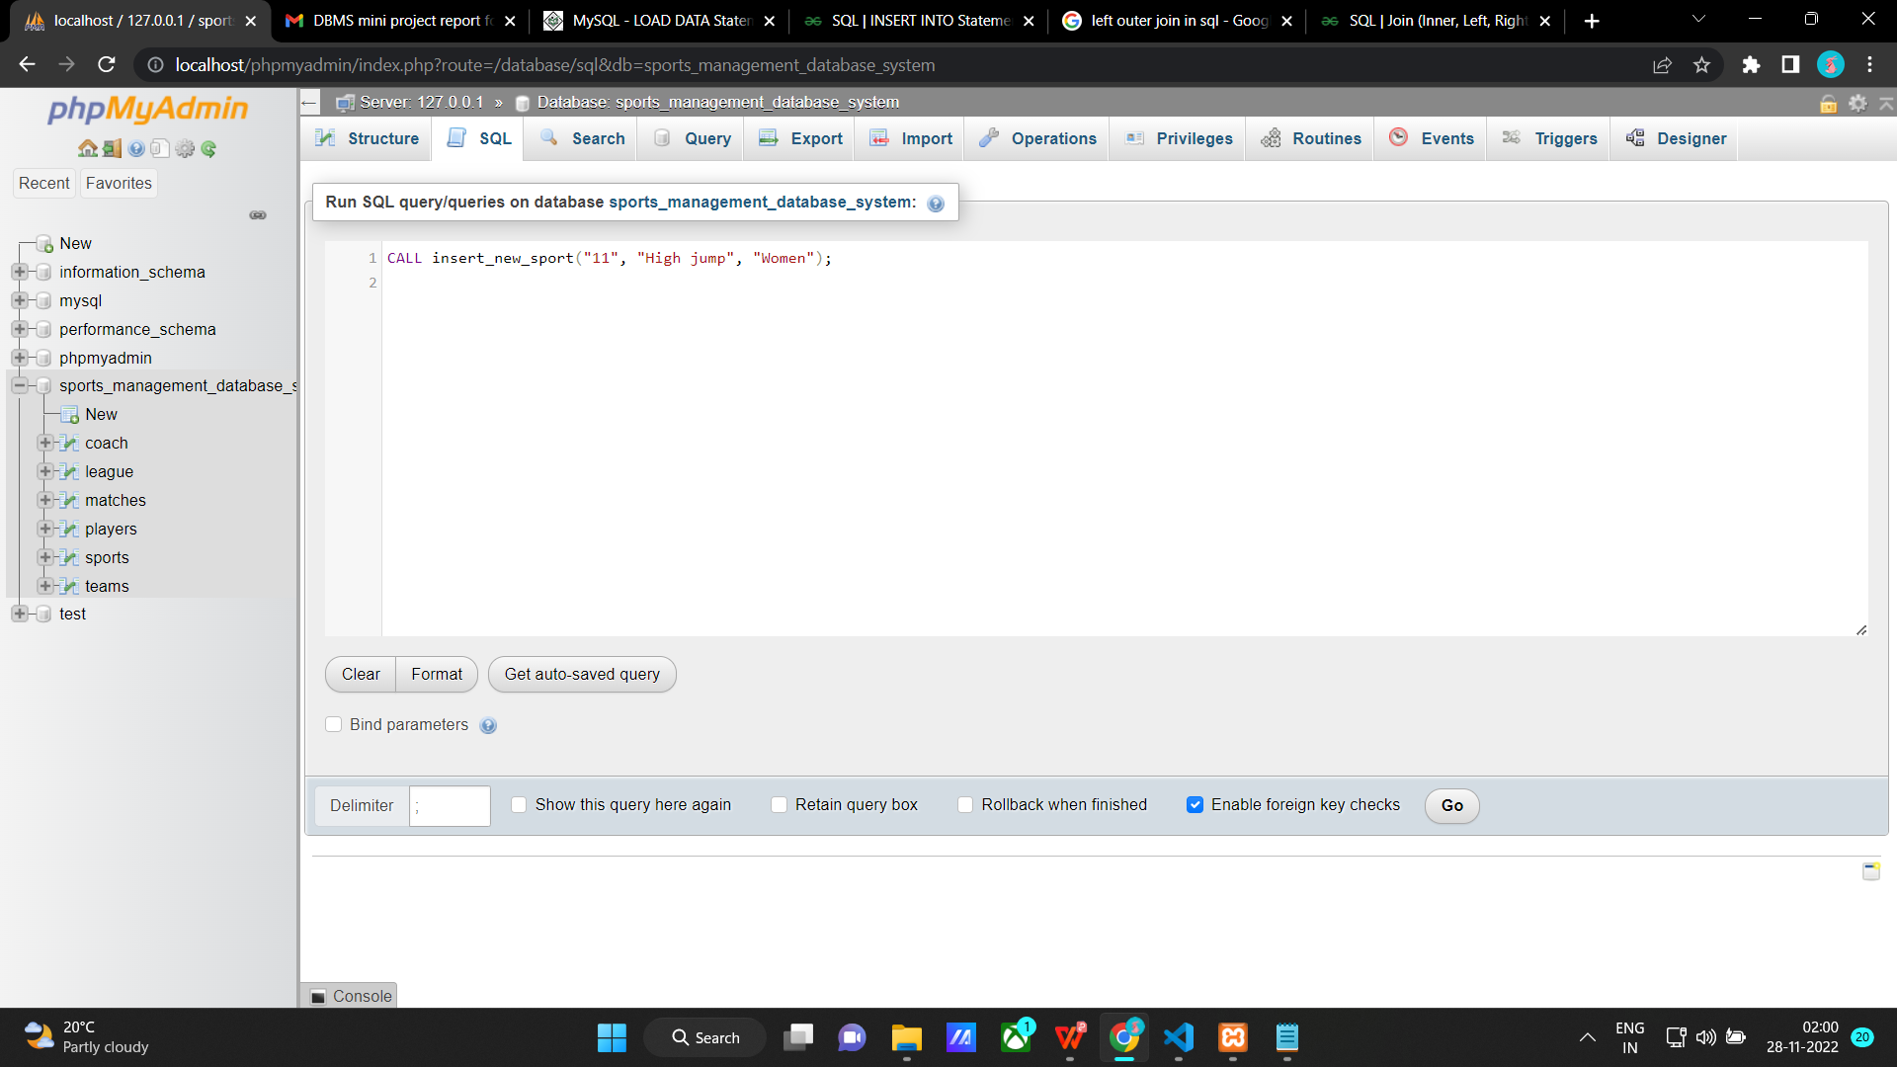

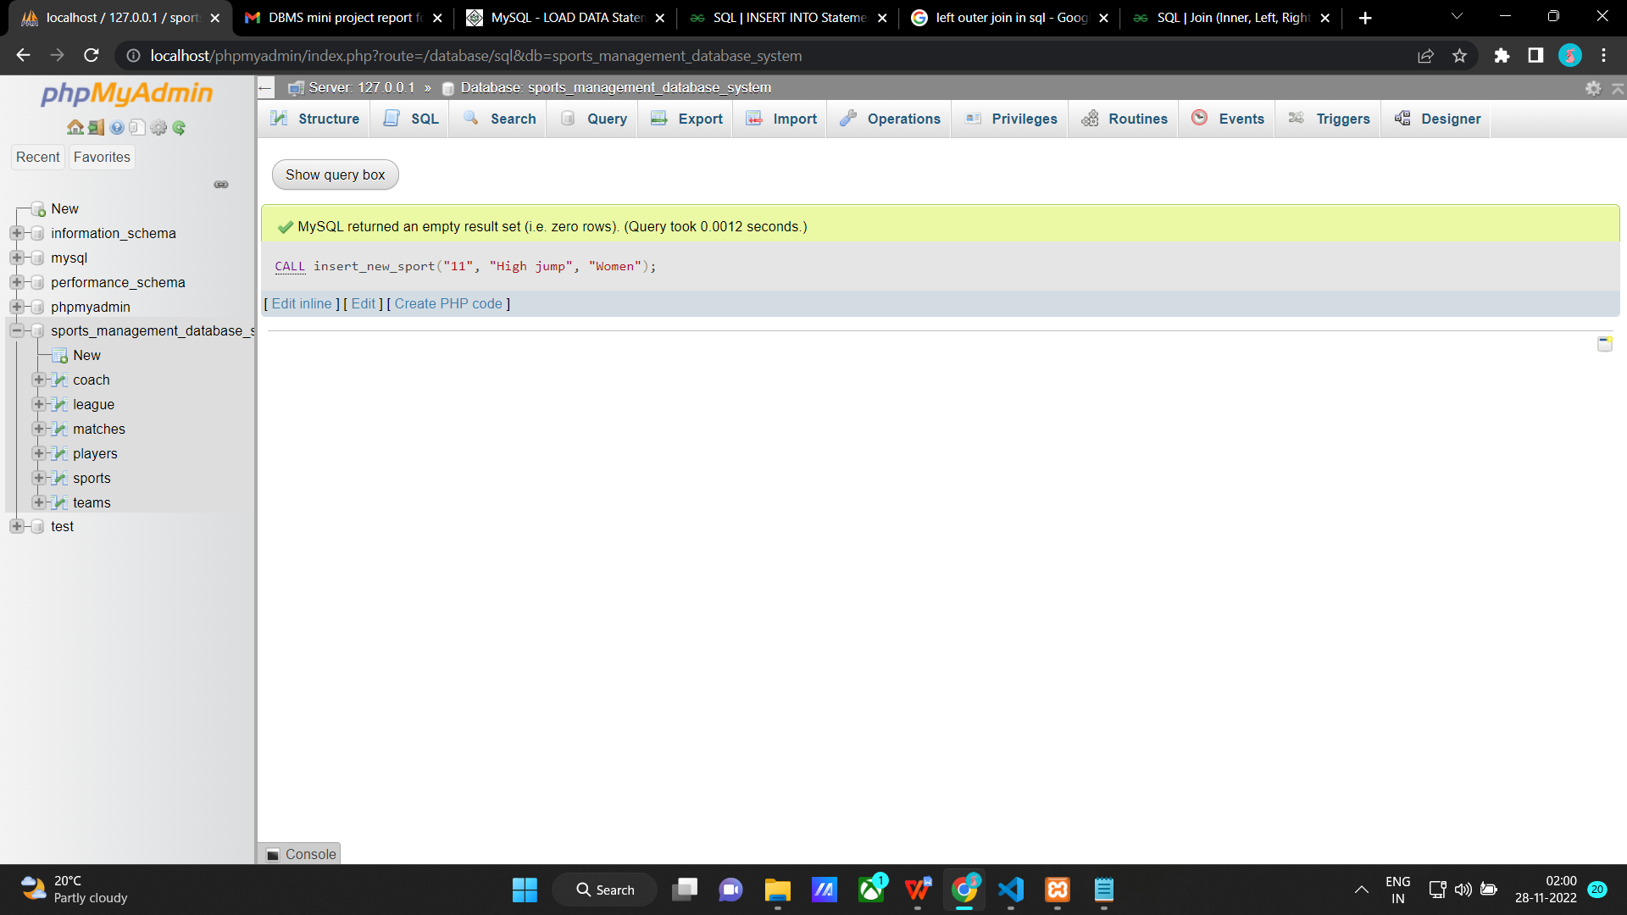

Sports table after inserting

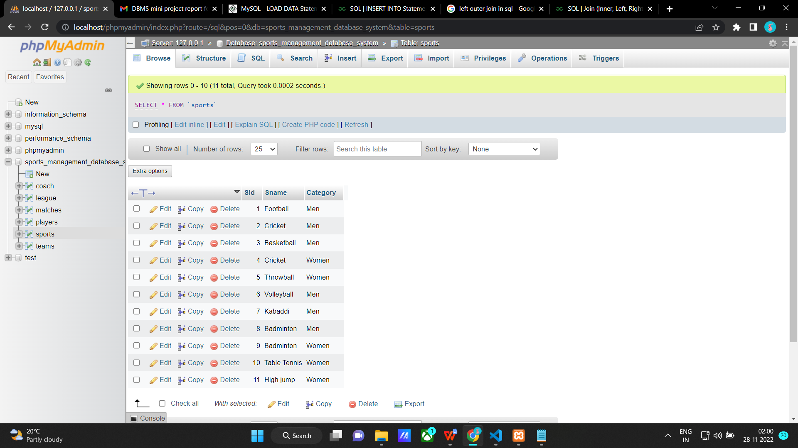

**Triggers**

**Create a trigger to show an error message if the age of a new player while inserting is below 18 years**

DELIMITER $$

CREATE TRIGGER age_restriction BEFORE INSERT ON

players FOR EACH ROW

BEGIN

DECLARE error_msg VARCHAR(255) ;

IF new.Age < 18 THEN

SET error_msg = ('The player should be 18 or above 18 years old') ;

SIGNAL SQLSTATE '45000' SET MESSAGE_TEXT = error_msg ;

END IF ;

END $$

DELIMITER ;

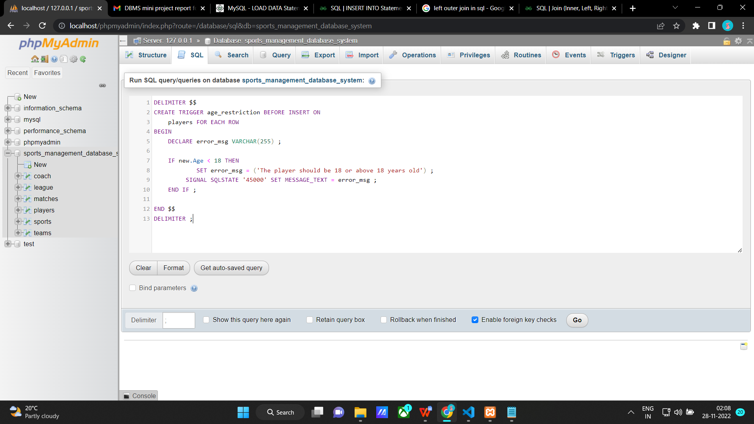

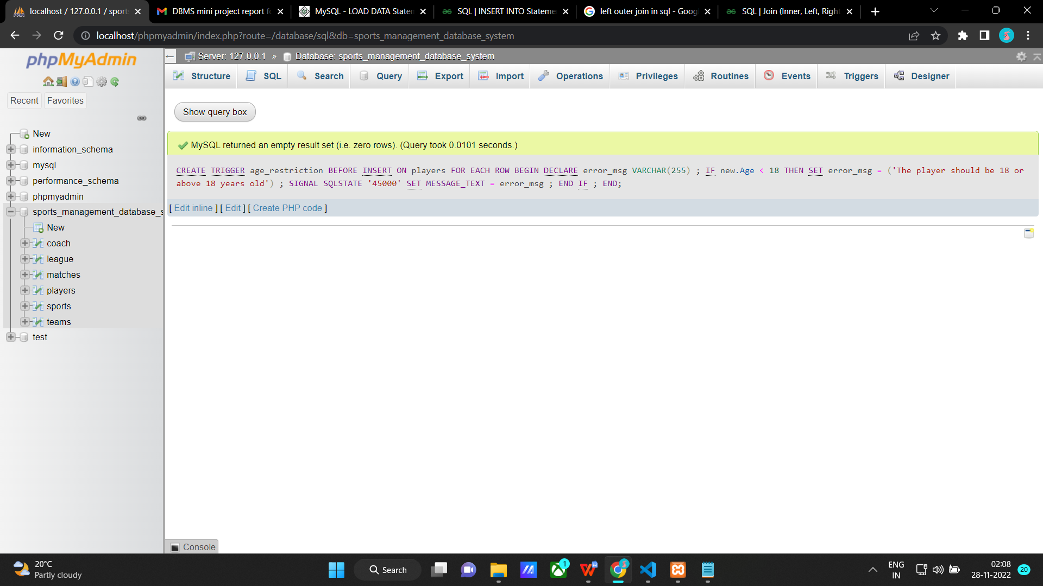

**Valid input**

INSERT INTO players(Pid, Fname, Lname, Dob, Age, Ph_no, Address, Cid, Tid)

VALUES

(72, 'Alex','Bush','1998-07-01',24,'7878787000','#37, 9th main, Bengaluru',2103,593);

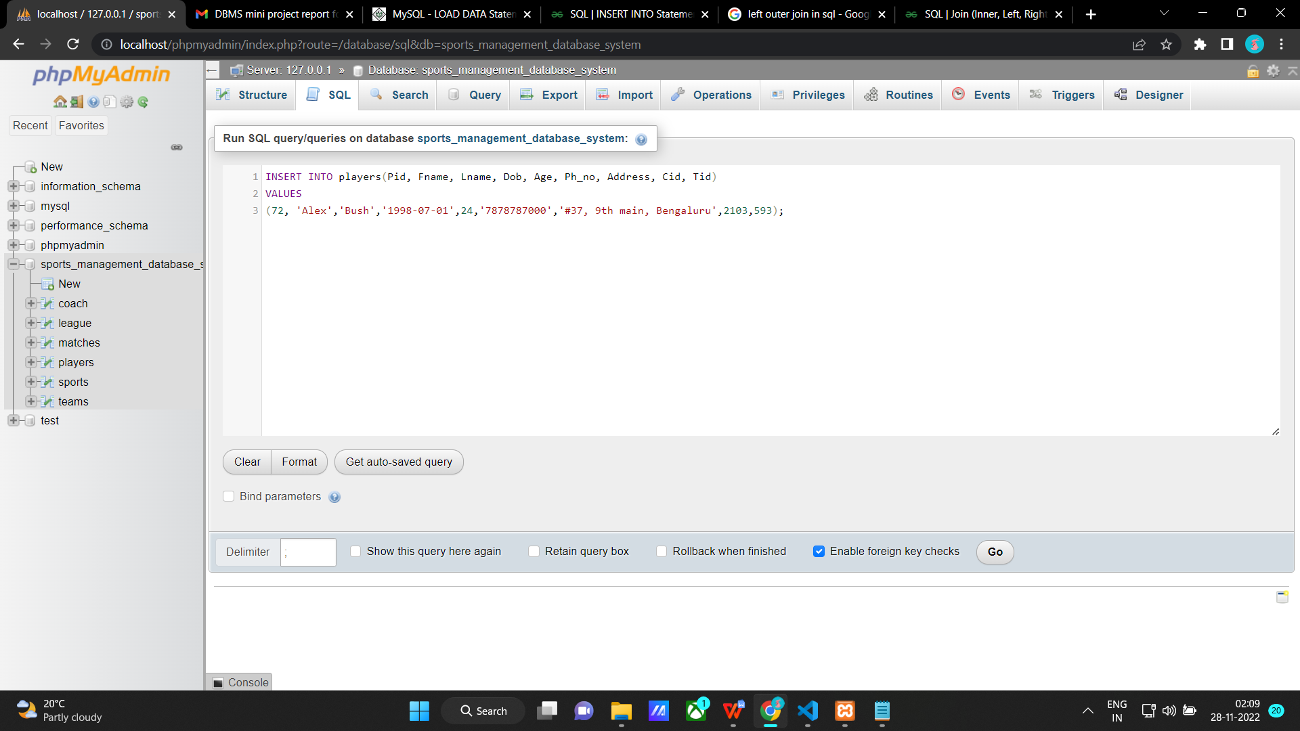

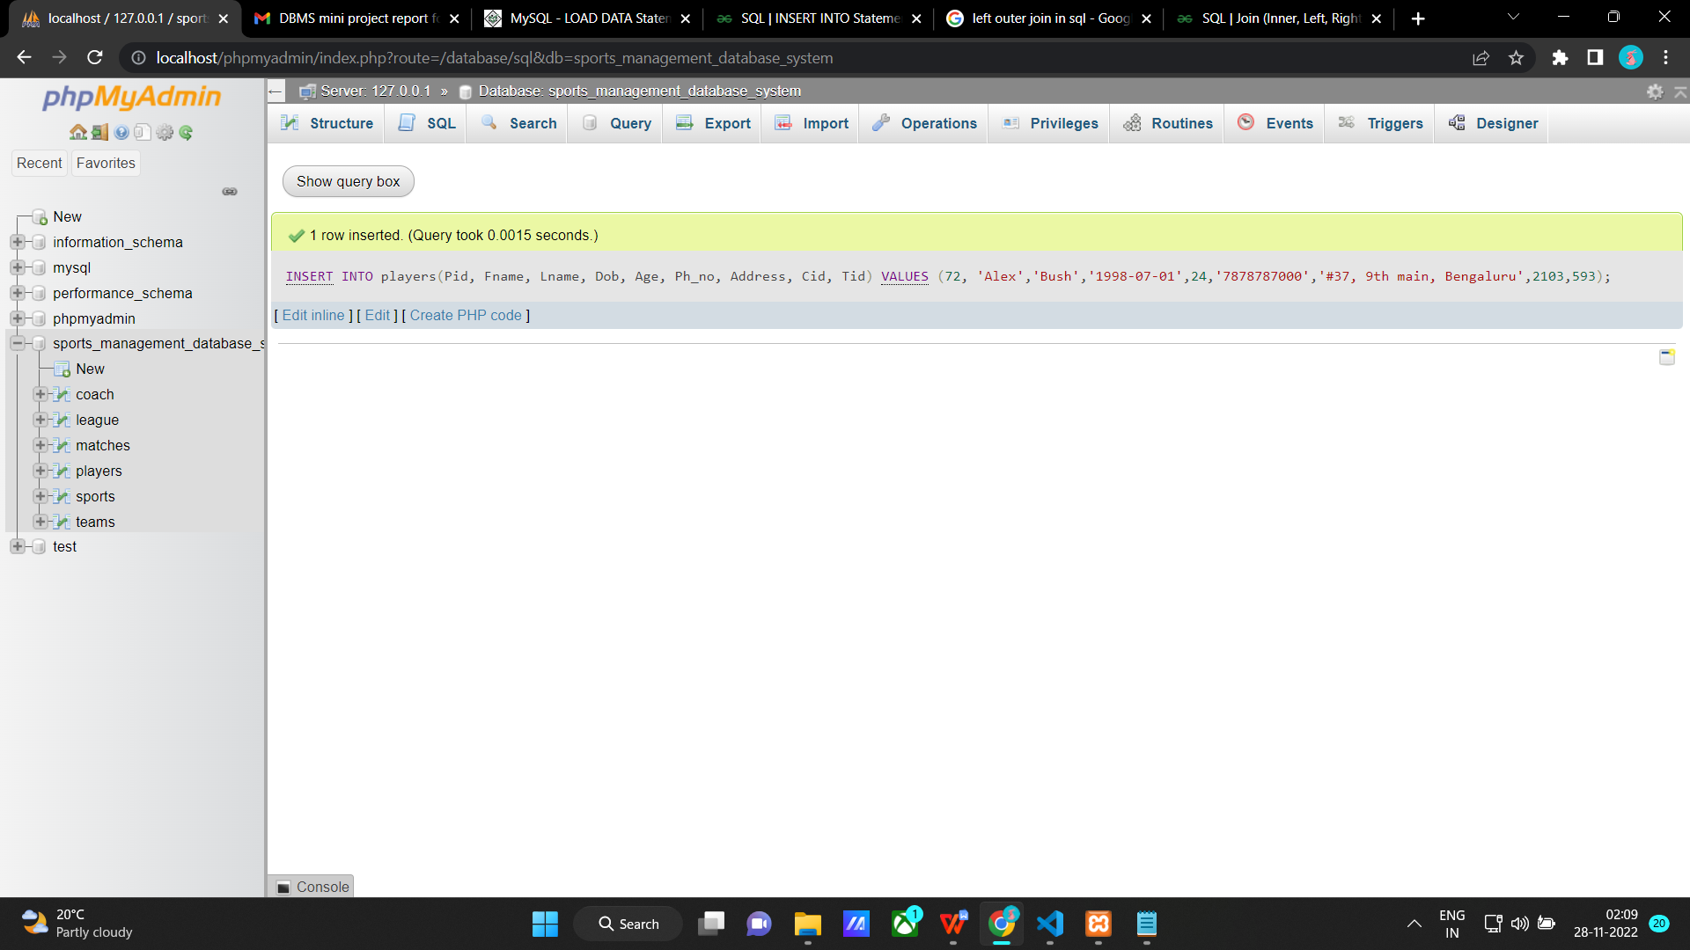

**Invalid input**

INSERT INTO players(Pid, Fname, Lname, Dob, Age, Ph_no, Address, Cid, Tid)

VALUES

(73, 'George','Ray','2008-08-01',14,'7878787000','#17, 8th main, Bengaluru',2103,593);

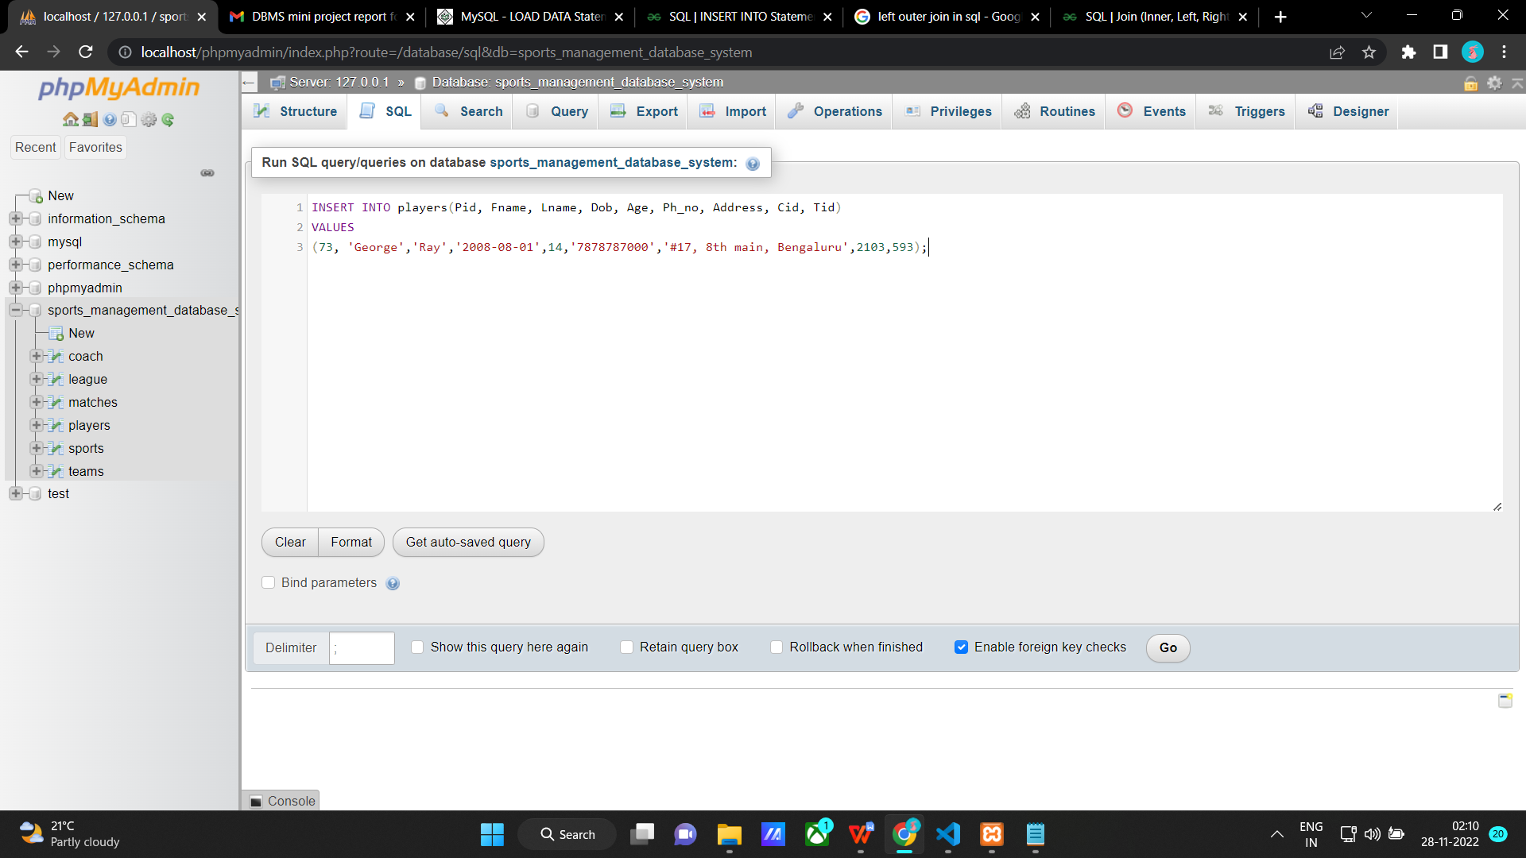

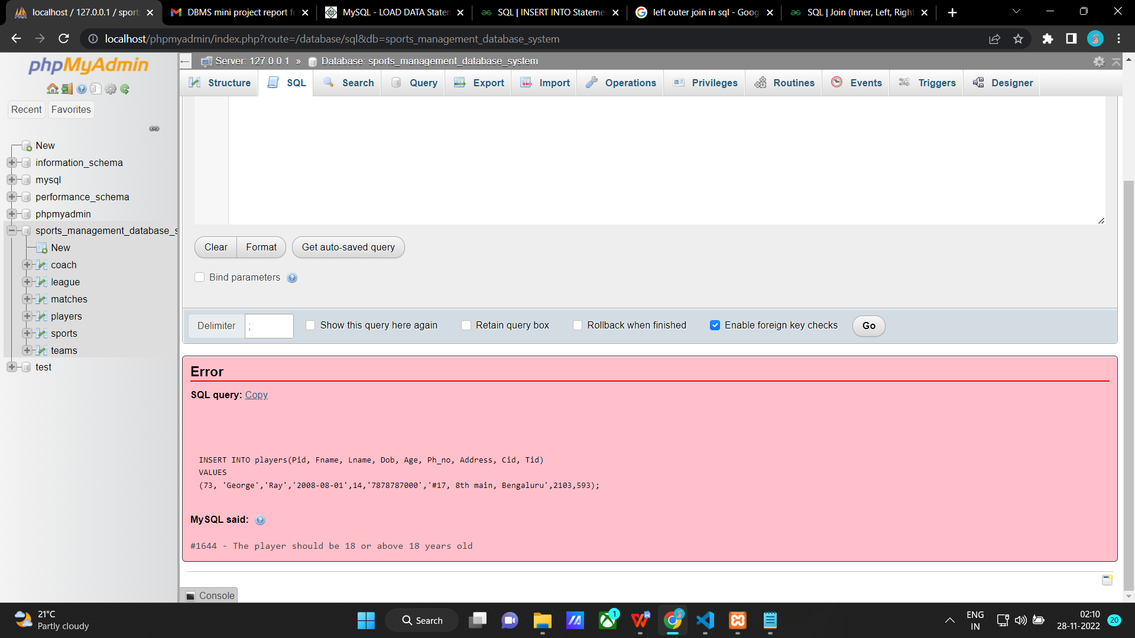

**Cursors**

**Create a cursor to create a Name list of all players**

DELIMITER $$

CREATE PROCEDURE create_name_list (

INOUT nameList varchar(255)

)

BEGIN

DECLARE finished INTEGER DEFAULT 0;

DECLARE name varchar(255) DEFAULT "";

-- declare cursor for player name

DEClARE curName

CURSOR FOR

SELECT Fname FROM players;

-- declare NOT FOUND handler

DECLARE CONTINUE HANDLER

FOR NOT FOUND SET finished = 1;

OPEN curName;

getName: LOOP

FETCH curName INTO name;

IF finished = 1 THEN

LEAVE getName;

END IF;

-- build name list

SET nameList = CONCAT(name,";",nameList);

END LOOP getName;

CLOSE curName;

END$$

DELIMITER ;

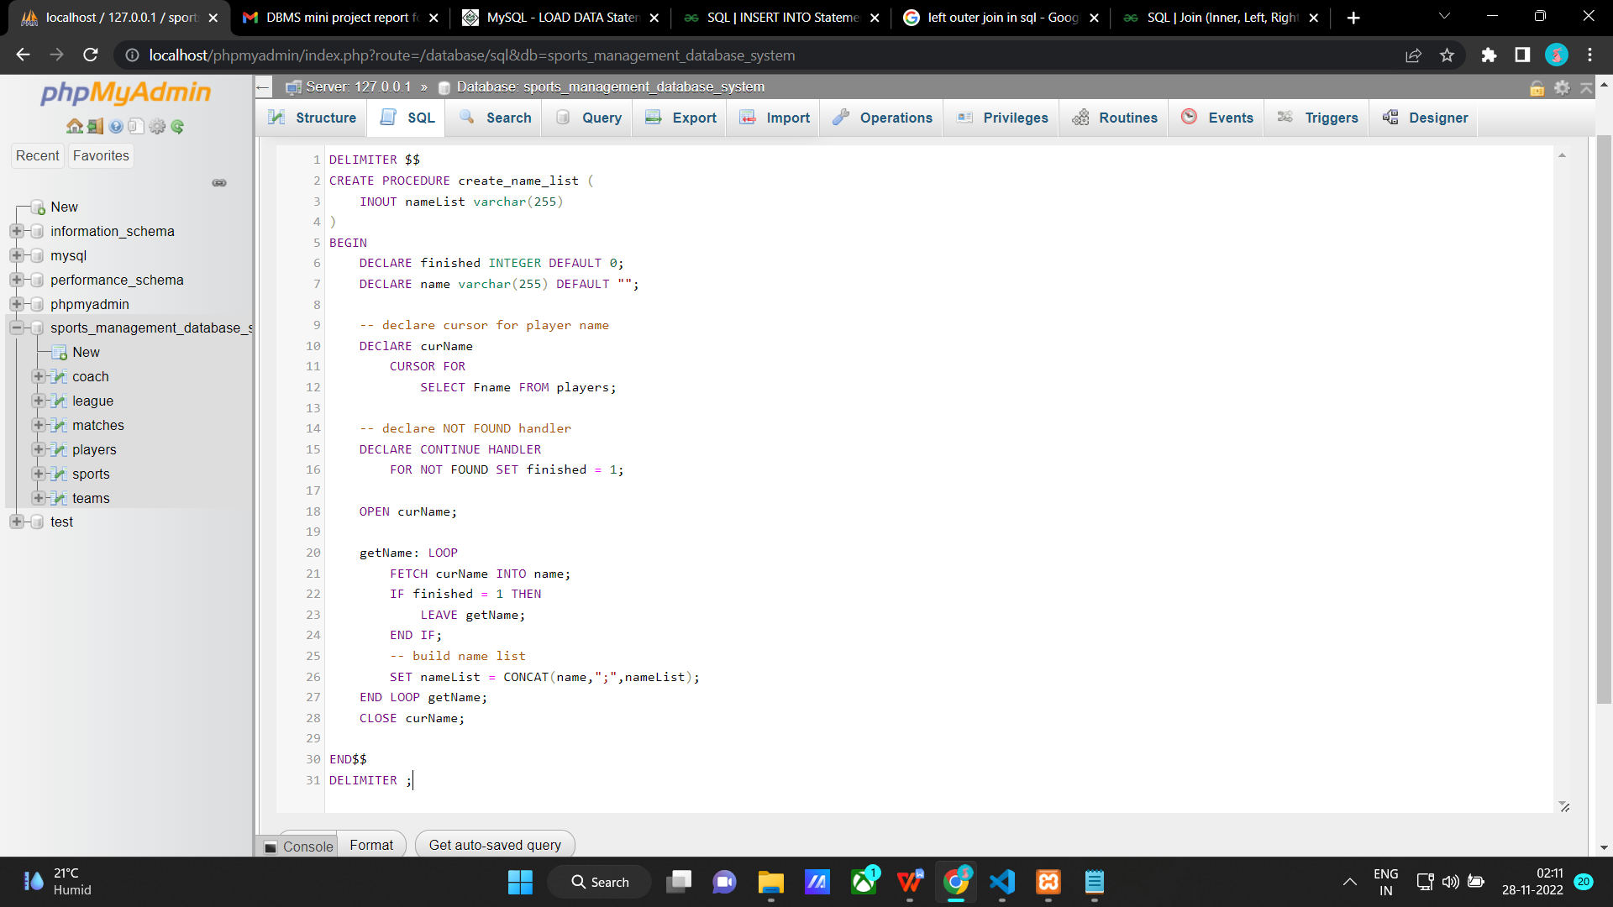

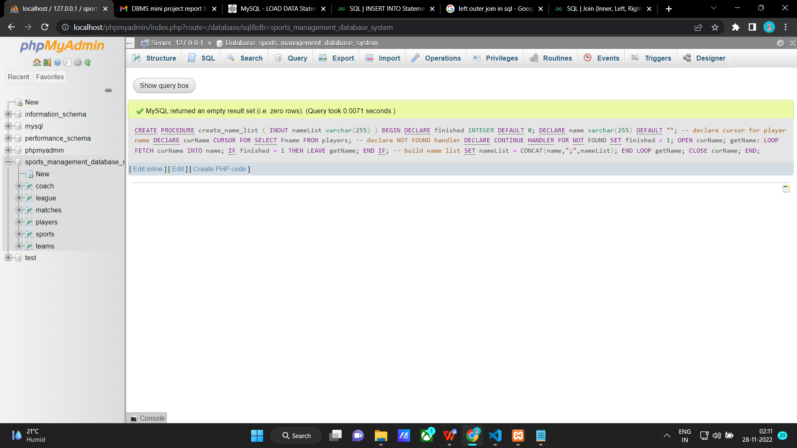

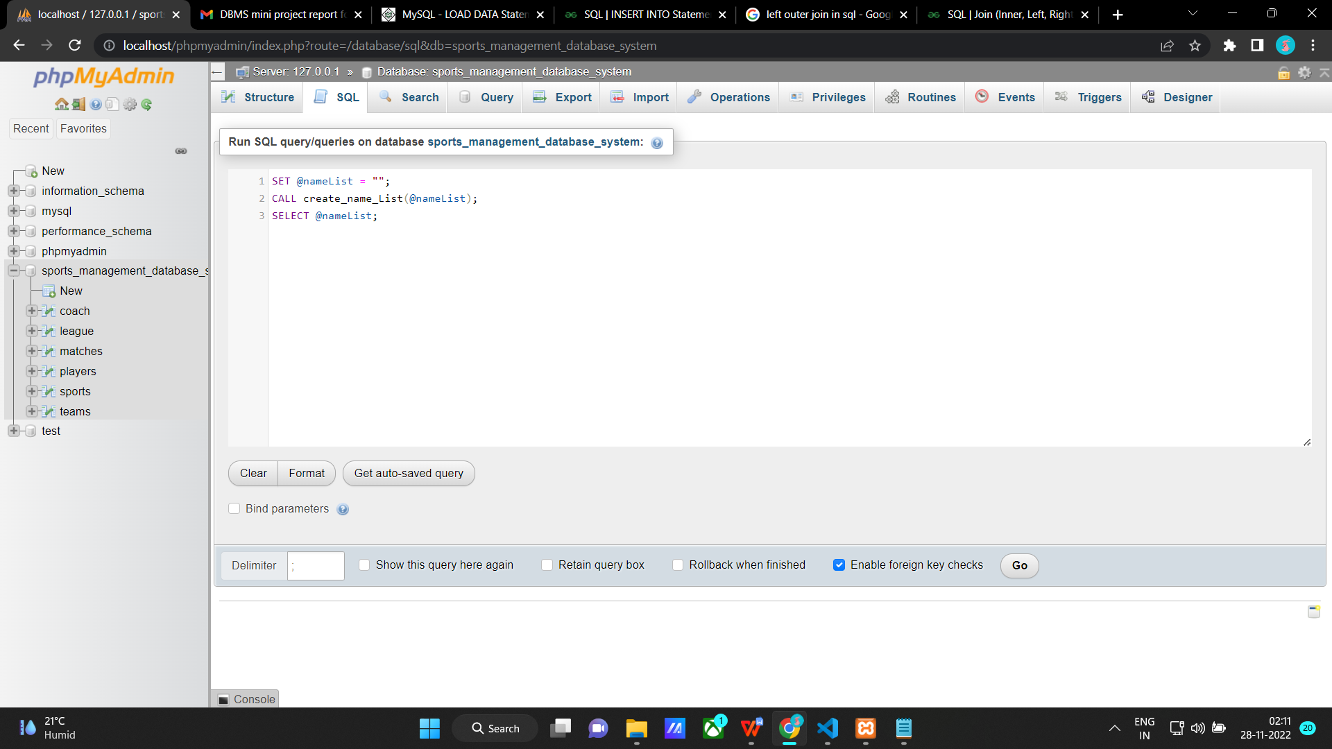

**Enter this to call the cursor**

SET @nameList = "";

CALL create_name_List(@nameList);

SELECT @nameList;

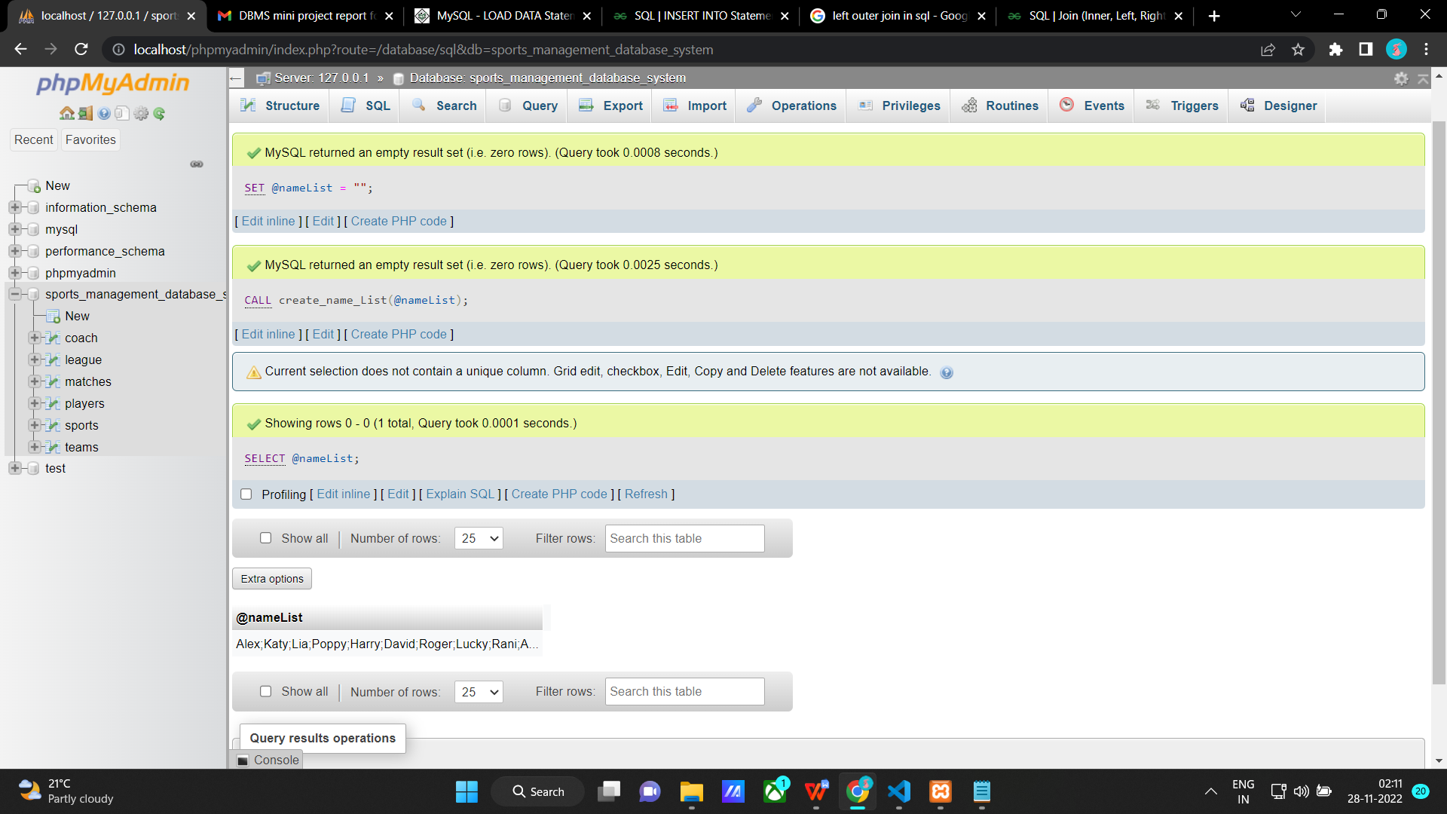

**Developing a Frontend**

The frontend should support

1. Addition, Modification and Deletion of records from any chosen table

2. There should be an window to accept and run any SQL statement and display the result